# Programme Evaluation of Maternal and Child Cash Transfer (MCCT) Programme in Kayah State, Myanmar

### Draft Report

#### 11 October 2019

* Acronyms and abbreviations
* 1 Background
* 2 Study aims and objectives
  + 2.1 Research Questions
  + 2.2 Study Output
* 3 Methods
  + 3.1 Study design
  + 3.2 Data collection
  + 3.3 Training of enumerators
  + 3.4 Survey management and supervision
  + 3.5 Quality control
  + 3.6 Data processing and analysis
* 4 Results
  + 4.1 Population-representative survey
  + 4.2 Maternal nutrition
  + 4.3 Cohort study
* References

# Acronyms and abbreviations

| **Acronym** | **Definition** |
| --- | --- |
| CPI | Community Partners International |
| CSI | Coping strategies index |
| CCSI | Consumption-based coping strategies index |
| DSW | Department of Social Welfare |
| FCS | Food consumption score |
| FCS-N | Food consumption score - nutrition |
| GAD | General Administration Department |
| GAM | Global acute malnutrition |
| HAZ | Height-for-age z-score |
| HFES | Household food expenditure share |
| IYCF | Infant and young child feeding |
| LCSI | Livelihoods-based coping strategies index |
| MAM | Gobal acute malnutrition |
| MCCT | Mother and Child Cash Transfer |
| MMK | Myanmar Kyatt |
| MSWRR | Ministry of Social Welfare, Relief and Resettlement |
| MS-NPAN | Multi-Sector National Plan of Action for Nutrition |
| MUAC | Middle upper arm circumference |
| NNC | National Nutrition Council |
| NSPSP | National Social Protection Strategic Plan |
| ODK | Open Data Kit |
| PPI | Poverty probability index |
| RCT | Randomised controlled trial |
| RD | Regression discontinuity |
| SAM | Severe acute malnutrition |
| SBCC | Social Behavioural Change Communication |
| TEM | Technical error of measurement |
| WASH | Water, sanitation and hygiene |
| WFP | World Food Programme |

# 1 Background

Kayah State remains one of the less developed areas of Myanmar and is home to some of the most remote and isolated communities in the country with decades long armed conflicts between Ethnic Armed Organizations and Myanmat Tatmadaw. As confirmed by Myanmar Demographic and Health Survey conducted in 2015, children in Kayah State are more likely to be malnourished than the average child in Myanmar, with the prevalence of stunting being particularly high (Ministry of Health and Sports - MoHS/Myanmar and ICF 2017). Moreover, certain maternal and child health indicators are among the lowest in Myanmar, specifically concerning contraception prevalence, antenatal care visits as well as immunization rates amongst children 12 and 23 months of age.

Since 2017, the Ministry of Social Welfare, Relief and Resettlement (MSWRR) started rolling out a Maternal and Child Cash Transfer (MCCT) program in Chin, Rakhine, Kayah, and Kayin States through the Department of Social Welfare, in line with the National Social Protection Strategic Plan (NSPSP) and the Multi-Sector National Plan of Action for Nutrition (MS-NPAN). The program aims to improve nutritional outcomes for all mothers and children during the first 1000 days of life by ensuring that pregnant women and mothers have improved practices on nutrition, infant, and young child feeding, and health-seeking behaviors. The program aims to provide universal coverage to social behavior change communication (SBCC) and a maternal and child cash transfer (MCCT) of 15,000 MMK per month for all pregnant women and mothers with children under 2 years of age.

# 2 Study aims and objectives

To provide a basis for measuring and evaluating the outcomes and impact of the MCCT program over time by estimating current levels of indicators related to:

1. Nutrition based on anthropometric measurements of maternal and child weight, height, and mid-upper arm circumference (MUAC) in Kayah State;
2. Behaviors related to nutrition, infant and young child feeding (IYCF), and health-seeking among mothers in Kayah State; and,
3. Knowledge related to health, nutrition, and hygiene among pregnant women and mothers with under five children in Kayah state.

## 2.1 Research Questions

1. What are the current levels of indicators related to nutrition, infant and young child feeding (IYCF), and health-seeking behaviors of mothers and under 5 children in Kayah State?
2. What is the impact of the MCCT program on child stunting in Kayah State?
3. What is the impact of the MCCT program on maternal nutritional status in Kayah State?

## 2.2 Study Output

1. Estimates of the current levels of indicators related to nutrition, IYCF, and health-seeking behaviors among mothers and their children under 5 in Kayah State
2. Estimate of prevalence of childhood stunting in the study cohort of children exposed to the MCCT program and those who are not in Kayah State
3. Estimate of prevalence of maternal nutritional status in the study cohort of mothers exposed to the MCCT program and those who are not in Kayah State

# 3 Methods

## 3.1 Study design

The study included two primary components:

### 3.1.1 Survey of selected households, villages, and townships

This was composed of three surveys.

1. **Representative household survey** - The baseline survey was designed for the measurement and evaluation of outcomes over time by estimating the current levels of indicators related to nutrition, IYCF, and health-seeking behaviors. The baseline study was conducted during the roll-out of MCCT program in Kayah State.
2. **Village profiles** - Village level demographics, assets, and conditions were assessed in each of the selected villages in Kayah State.
3. **Township profiles** - Township profiles were developed from the township-level data collected from all townships in Kayah State from which sampled villages were from.

This component of the study was designed to address research question 1 (Section 2.1). The survey results were used to provide context to the results of the second study component (see Section 3.1.2).

#### 3.1.1.1 Sampling frame

To assess the various outcome indicators for the assessment1, a two-stage cluster sample survey was implemented. The **first stage sample** was a sample of about 75 villages out of the total villages in Kayah State stratified into 1) urban, 2) rural and 3) hard-to-reach areas. The **second stage sample**, also called the within-community sample, was a sample of households from the selected villages with mothers with children less than 5 years old. The second stage sample was selected using the list of household with children under 5 years of age from each village as identified by township General Administrative Unit (GAD) whenever possible.

A total of about 14 households with pregnant mothers and mothers with children less than 5 years were sampled in each village. If a small community was selected that was likely to have fewer than the required number of eligible respondents, all eligible households and persons in that community are sampled by moving door-to-door. If a household had more than one mother with children less than 5 years of age, mother with children less than 2 years of age was prioritized for data collection. If there were more than one mother with children less than 2 years of age, one of these mothers was selected randomly. Only the under 5 children of the index mother were included in the anthropometric measurements if there were more than one mother with under 5 children in the same household. In addition, all pregnant mothers present in the household of the respondents were measured for middle upper arm circumference (MUAC).

#### 3.1.1.2 Sample size estimation

Using childhood stunting as index indicator for sample size calculations, the sample size needed to detect a change of mean HAZ from 1.432 in Kayah State2 to -0.932 with a calculated standard deviation 1.144063 was calculated. This is an equivalent drop in stunting prevalence of about 10%. This equates to a sample size of 137 children less than 5 years old. Assuming a design effect for a cluster survey of 2, this sample size was inflated to 274. A sample size of 274 respondents was needed for each strata (urban, rural and hard-to-reach) in Kayah State giving a total of 822 respondents in total. Assuming a non-response rate of 20% overall, a total of 330 respondents was the target sample for each strata in Kayah State.

As described in the sampling frame above, a total of 25 villages per strata and 14 respondent mothers with children less than 5 years old were the target number of samples and a total of 350 respondents in each strata was the overall target in order to achieve at least 274. In Kayah state, a total of 1050 respondents was the overall target. This is anticipated to be more than enough sample size as per calculations above. For the selected respondents who were not present at the time of data collection, two revisits were conducted with the respondent classified as a non-responder after two unsuccessful attempts.

### 3.1.2 Quasi-experimental cohort study

As part of a longitudinal, quasi-experimental evaluation design, the baseline survey included a cohort of mothers and their children selected through specific study eligibility criteria based on eligibility and receipt of the services and benefits of the MCCT program. Once recruited, this cohort was assessed on appropriate indicators related to nutrition, IYCF and health-seeking behaviours at baseline. This same cohort will then be assessed at endline on the same set of appropriate and relevant indicators to detect any difference between those receiving benefits from the MCCT from those who are not based on a regression discontinuity analytical approach (see Section 3.6.3).

This component of the study provides a statistically robust comparison between those exposed to the MCCT program and those who are not hence detecting the possible impact that the programme has on a specific set of impact indicators.

Given the universal nature of the MCCT program and the need to create effective treatment and comparison groups to detect program impact, this study component used a similar regression discontinuity (RD) design as was developed and used for the MCCT evaluation in Chin State, but with distinct changes that address limitations of the latter (Ministry of Social Welfare, Relief and Resettlement and Livelihoods and Food Security Trust Fund 2018). This design was made possible by the fact that there is a specific cut-off point for programme eligibility. Ultimately, the programme (treatment) effect can be detected as a discontinuity in the regression line around this cut-off which in this case is a specific date that determines eligibility. The design is quasi-experimental, since treatment and comparison groups were not selected at random but based on predefined characteristics.

#### 3.1.2.1 Eligibility criteria

Eligibility criteria depended on three factors:

* Date of start of recruitment into the MCCT program (1st October 2018)
* Date when the recruitment for study participants will occur (6th August 2019)
* Receipt of MCCT benefits

The optimal bandwidth of ages of the children to include in the study needed to be as close to the cut-off date as possible such that the ages of the children in the control and intervention groups will be roughly similarly distributed. This meant up to one month before and after the recruitment date of 1st October 2018. Given this, the following eligibility criteria were applied:

**Control group**

Following are the criteria for eligibility to the control group of the study:

1. Women who gave birth on/after 1 September 2018 but before 1 Oct 2108 (i.e. 1 month before the MCCT registration cut-off)
2. Women who were pregnant/gave birth after 1 Oct 2018 but have not been recruited into program

**Intervention group**

The criteria for eligibility to the intervention group of the study was women who were pregnant on or after 1 Oct 2018 and have been recruited into the program.

#### 3.1.2.2 Sample size and selection

The RD design effect was factored in for sample size calculations. This design effect was used to inflate standard randomized controlled trials (RCT) sample sizes in order to account for the RD design. The RD design effect was primarily influenced by the distribution of characteristics of the cut-off variable (i.e. running variable) (Bor et al. 2014). Previous literature advise that if the running variable is normally distributed around the cut-off, then the design effect is approximately 2.75. If the running variable is uniformly distributed around the cut-off, the design effect is 4, and if it is bimodal in distribution, then the design effect can go up to 5 (Schochet 2009).

Given that the running variable for this study is the start date of registration in relation to pregnancy, it was expected that there would be various peaks in number of pregnancies at specific time points following a general seasonal pattern not necessarily related to the cut-off date. The distribution is therefore likely multi-modal. So an assumption of at least 5 design effect for this RD design was taken into account.

Using prevalence of stunting as the index indicator for calculating sample size and using mean change in height-for-age z-score (HAZ) as the specific variable to use for assessing change, the same sample size calculation as in the survey was arrived at which was 137 for controls and 137 for intervention (total of 274) for each state. However, given the very narrow bandwidth of inclusion into the study used (one month before and after the programme start), it is likely that the universe population from which to select the cohort is quite small and that the total sample size of 274 is likely requiring an exhaustive sampling of all children born within the specified periods above. In this case, the inflation factor to account for design effect was not considered to be relevant given that an exhaustive sample will be drawn to begin with. Hence the 274 sample size for Kayah State was set as the target sample size.

#### 3.1.2.3 Sample recruitment

Sample recruitment utilised a full list or registry of births one month before and after the 1st of October 2018. As an exhaustive sample was needed, all fforts were undertaken to identify and recruit into the study including engagement with the DSW in listing out and finding these births across Kayah state.

## 3.2 Data collection

Data was collected using an electronic data entry system based on the **Open Data Kit (ODK)** standard that runs on the Android operating software (OS) platform for mobile devices. The study instrument was encoded into the electronic data entry system platform and was served out of a secure aggregate server hosted by ONA4. Each data collector was provided with a tablet running on Android OS that was configured with the ODK application that receives the electronic data form. All measurements and answers by respondents were then recorded on the tablets and transmitted to the remote server whenever there was a mobile and/or wireless internet signal. This data collection system was not reliant on internet connection as the data collection could be performed offline, with the completed e-questionnaires saved on the interviewers’ tablets. An internet connection was needed only when finalized encoded forms were ready to submit to the remote server, and this submission was done at regular intervals and timed when there was available internet connection for the data collectors. The survey teams aimed to submit forms on a daily basis.

### 3.2.1 Questionnaire design:

Structured questionnaires for the household survey, village profiles, and township profiles were in English and translated into local languages. For the household survey, all questions and responses were translated into written Myanmar, Pwo Karen, and Sgaw Karen. The data collector had the option to switch from one language to another on the tablet. The household survey also included anthropometric measurements for weight, height and MUAC for all pregnant women, mothers who have recently given birth, and every child up to five years of age in selected households. A separate form was developed for the anthropometric measurements.

The village profile questionnaire assessed various village level characteristics relevant to the study such as number of and distances to nearby markets, education, and health facilities; presence of community groups (e.g., Village Health Committees) and their functionality; presence of community volunteers (e.g., auxiliary midwives and community health workers); access and quality of water and sanitation facilities; and general agricultural practices.

The township profile questionnaire collected data on the township’s population, geography, and governance, with summaries of key nutrition indicators.

All approved questionnaires were back-translated into English to ensure that appropriate translation was done with discrepancies between language versions discussed and resolved between the study team and translators. Prior to the start of data collection, the household survey questionnaire was pilot tested to understand how well the wording and content, context effects, and interface design of the instruments performed in an actual survey setting and were revised as necessary. Respondents for field testing were purposively sampled from the same population as the baseline assessment (e.g., mothers from the study area, village leaders). The recommended minimum of 32 respondents were recruited for field testing of the household questionnaire. Field testing was iterative with changes to the data collection instruments implemented immediately and the revised instrument was re-tested. Field testing involved feedback from the following three sources:

* Respondents: During field testing of the questionnaire, respondents were asked first to respond to the questions and then to re-interpret each question in their own words to learn how respondents understood the question and how they came up with their answers. The study team members probed for potential sources of ambiguity/confusion including word choice and translation, as well as the relevance and comprehensiveness of responses options to each question.
* Interviewers: The study team members provided feedback on the questionnaire content to confirm that questions and responses were clear in the context of data collection. Field testing also examined how well the e-questionnaire and tablet functioned in the field. Senior study team members collected data from enumerators for the purpose of field testing using a standardized debriefing questionnaire.
* Design and content experts: Members of the study team reviewed the data collected during the field testing phase to check whether the responses correspond to the meaning of individual questions and the overall goals of the study.

## 3.3 Training of enumerators

Different trainings were conducted based on the skill that was being trained on and the type of personnel that was being trained.

### 3.3.1 Anthropometric Training

Recruited anthropometrists received an intensive 5-day training from an expert anthropometric measurement trainer with supervision by National Nutrition Center (NNC) and nutrition advisor(s). The training covered an introduction to the purpose of the study, nutritional indicators , anthropometry, accuracy and validity of measurements, utilization and equipment of the measurement tools (e.g., MUAC tape, weighing scales, measuring board), and electronic data entry. The training emphasized practice and standardization of the anthropometric measurements to be used during the study according to methods adapted from the [WHO’s Multicentre Growth Reference Study](https://www.who.int/childgrowth/mgrs/en/) (Onis et al. 2004) and [INTERGROWTH-21 Project](https://intergrowth21.tghn.org) (Ismail et al. 2013) anthropometric training protocols.

During the training, women of reproductive age and children under five years of age were invited to participate as subjects, and each subject was measured twice by the expert trainer serving as gold standard and twice by each trainee. To assess inter- and intra-rater precision, the technical error of measurement (TEM) was calculated, with an acceptable TEM for an individual trainee defined as no more than twice that of the expert (Ulijaszek and Kerr 1999). Accuracy was assessed by calculating mean differences between the gold standard trainer and the trainee. Only participants who meet the required standard for accuracy and precision were selected for anthropometric data collection during the baseline assessment. The training was conducted in Myanmar language.

### 3.3.2 Interviewer and Supervisor Training

All supervisors and enumerators received an intensive 5-day training from study team members that covered the purposes of the study, informed consent procedures, the questionnaire guides and responses, electronic data entry, referral protocols for severe acute malnutrition, roles and responsibilities of all field staff, data quality assurance procedures, problem-solving, and conflict-sensitive approaches to data collection. The performance of trainees were assessed post-training using a written assessment based on didactic lessons, as well as performance during practice sessions. Separate trainings were conducted for the supervisors and interviewers in Kayah State.

### 3.3.3 Additional Supervisor Training

All supervisors received an additional 3 days of training from study team members that covered screening, random sampling method to identify respondents, quality control in the field, quality control of data entry and uploading, team management, and logistics.

## 3.4 Survey management and supervision

During data collection, 1 field supervisor supervised 1 team each composed of 4 enumerators and 2 anthropometrists. Each team was expected to complete 14 household interviews and one village profile per day depending on feasibility. Community Partners International worked with the Central NNC and State/Region Nutrition Teams and nutrition experts in developing a referral guideline and standard operating procedures to ensure that any women or children who were measured during the study and suspected of having severe acute malnutrition (SAM) were immediately referred to an appropriate health provider. Survey teams were provided with contact information of the nearest health providers to ensure timely referral. Alerts to refer women and children were programmed into the e-questionnaire on the ODK platform, based on WHO criteria for SAM.

## 3.5 Quality control

Quality control procedures throughout the assessment design, implementation, and analysis included:

* Translation, back-translation, and pilot testing as described above;
* Development of standard operating procedures and training manuals. CPI developed and distributed guidelines on data collection procedures, including the questionnaire and anthropometry methods, to all members of the data collection team;
* Training of data collectors where supervisors, enumerators, and anthropometrists practiced administering the questionnaire and checking and correcting questionnaires for accuracy and completeness. The performance of anthropometrists and data collectors were assessed in terms of confidence, independence, and reliability during practice sessions during the trainings, and based on results of an evaluation at the end of the training period;
* Anthropometric devices were calibrated and supervisors re-assessed some of the anthropometric measurements at intervals. Maintenance and quality check of all the other devices were done regularly as per the manufacturer’s instructions. Data collection was coordinated and continuously supervised by field supervisors and senior researchers.
* The data collection tool was designed in such a way that any potential errors related to data entry were minimized by programmatically adding data entry checks that raise appropriate prompts to the data collector based on the potential error detected. The data collector was not allowed by the system to continue to the next field until the error has been corrected. For the anthropometric measurements, a test for the feasibility of the measurements taken based on the child’s age and sex was implemented. If the measurement was above or below a certain threshold of feasible values, the system prompted the data collector to check their recording of the measurement, and to perform the measurement again. This approach was expected to pick up at least 90% of possible errors due to data entry and measurement errors. to complement this, an algorithm was added to randomly ask the data collector to repeat the measurement, even if the result of the first measurement was plausible. This approach was expected to pick up at least 90% of possible errors due to data entry and measurement errors.
* The Data Manager reviewed the data in real-time as they were uploaded to the server. This was done using a purpose-built application called myanmarMCCTchecks5 that allows for routine data checks automatically. In most cases, the error was detected and corrected immediately due to the data quality assurance measures built into the ODK platform, but if necessary, the interviewer was requested to revisit the respondent. In this case, the corrected questionnaire was uploaded and the wrong one deleted, so that only correct, checked records were stored in the database.

## 3.6 Data processing and analysis

### 3.6.1 Tools and methods

Data handling, processing, analysis and reporting were done using **version 3.6.1** of the [R Language for Statistical Computing](https://cran.r-project.org)6 (R Core Team 2019). The R package **myanmarMCCTdata** was developed to support the handling, processing and analysis of data collected for the study. The package includes functions to retrieve data from the [ONA](https://ona.io) server database, to appropriately structure datasets, to check and clean data, to recode data to respective indicator sets, to estimate indicators and to perform appropriate comparative analysis specified by the analysis7 (Guevarra and Goza 2019). The package uses several other R packages that provide additional functions for data processing, analysis and reporting8.

The main motivation for using R was to achieve transparent and reproducible research between the study collaborators and with external reviewers and/or readers. Developing the **myanmarMCCTdata** R package is the first step towards this aim of transparency and reproducibility as any collaborator and/or reviewer can easily retrieve the same codebase for data handling, processing and analysis used by the primary researchers. The second step was writing reports (including this report) using R itself using a seamless integration between data anlysis and reporting. This was achieved using R Markdown (Xie, Allaire, and Grolemund 2018) for producting reports which included code chunks of how the data processed using **myanmarMCCTdata** functions were analysed to produce the results reported here. This report and the analysis herein, can be reviewed and reproduced by collaborators and reviewers by following instructions given [here](https://github.com/validmeasures/myanmarMCCTkayah).

### 3.6.2 Indicator estimation

Data was processed and recoded based on standard and established indicator definitions whenever available. For some indicators, modifications to standard definitions were made based on information requirements by stakekholders or study-specific definitions were established in order to achieve analysis requirements. Several recode functions were developed in R through the **myanmarMCCTdata** package for this purpose. The following indicator sets were assessed:

#### 3.6.2.1 Poverty probability index (PPI)

The [Poverty Probability Index (PPI)](https://www.povertyindex.org) is a poverty measurement tool that is statistically-sound, yet simple to use. The answers to 10 country-specific questions about a household’s characteristics and asset ownership are scored to compute the likelihood that the household is living below a certain poverty line or definition(Innovations for Poverty Action 2019). PPI is used to identify households who are most likely to be poor or vulnerable to poverty.

The Myanmar MCCT survey collected answers to the 10 Myanmar-specific questions on household characteristics and asset ownership responses which were used to determine the household’s PPI score based on the Myanmar national poverty line. The household’s PPI score was then matched to poverty line/definition-specific lookup tables to determine the household’s poverty probability. The matching of the PPI score to lookup tables was facilitated using the PPI lookup tables for Myanmar from the ppitables package (Guevarra 2019b) for R.

#### 3.6.2.2 Water, sanitation and hygiene

Recoding for indicators for water, sanitation and hygiene (WASH) were based on standard indicator definitions provided by WHO and UNICEF (WHO/UNICEF Joint Monitoring Programme for Water Supply and Sanitation 2018; World Health Organization 2006).

The following drinking water access indicators were assessed:

* Access to improved drinking water sources (regardless of collection time9)
* Access to unimproved drinking water sources only (unprotected dug well and unprotected spring)
* Drinking water from surface water (directly from a river, dam, lake, pond, stream, canal/irrigation canal)
* Probably safe drinking water based on appropriate water treatment method applied to water

These drinking water access indicators have been assessed for each of the three seasons (summer, rainy and winter season) experienced in Kayin and Kayah states.

In addition to drinking water access, the following drinking water use and storage behaviour was also assessed:

* Use of a water container/pot that is clean, covered and with a cup and handle

The following indicators on access to sanitation facilities were assessed:

* Access to improved sanitation facilities that are not shared with other households10
* Access to improved sanitation facilities that are shared with other households11
* Access to unimproved sanitation facilities
* Use of open defecation

The following indicators on access to handwashing facilities were assessed:

* Access to handwashing facility on premises with soap and water12
* Access to handwashing facilities on premises without soap and water13
* No handwashing facilities

In addition, handwashing practices and behaviours were also assessed.

#### 3.6.2.3 Food consumption score (FCS)

The **Food Consumption Score (FCS)** is an index developed by the World Food Programme (WFP) in 1996 (Vulnerability Assessment and Mapping World Food Programme 2008). The **FCS** is a household level indicator that aggregates food group diversity and frequency over the past 7 days. These food groups are then weighted according to their relative nutritional value. This means that food groups that are nutritionally-dense such as animal products are given greater weight than those containing less nutritionally dense foods such as tubers. The weights are then added up to come up with a household score which are then used to classify households into either poor, borderline, or acceptable food consumption. The **FCS** is a measure of quantity of caloric intake.

A brief questionnaire was used to ask respondents about the frequency of their households’ consumption of eight different food groups over the previous seven days. The eight food groups are: main staples; pulses; vegetables; fruit; meat/fish; milk; sugar; and, oil. The frequency of consumption of these different food groups consumed by a household during the 7 days before the survey was then used to calculate a weighted diet diversity score for each household using the food group weights (Table 3.1) by multiplying the reported 7-day frequencies with the food group weights.

| Table 3.1: FCS food groups and weights | | | |
| --- | --- | --- | --- |
|  | **Food items** | **Food groups** | **Weight** |
| 1 | Maize , maize porridge, rice, sorghum, millet pasta, bread and other cereals Cassava, potatoes and sweet potatoes, other tubers, plantains | Main staples | 2 |
| 2 | Beans, peas, groundnuts and cashew nuts | Pulses | 3 |
| 3 | Vegetables, leaves | Vegetables | 1 |
| 4 | Fruits | Fruits | 1 |
| 5 | Beef, goat, poultry, pork, eggs and fish | Meat and fish | 4 |
| 6 | Milk yoghurt and other diary | Milk | 4 |
| 7 | Sugar and sugar products, honey | Sugar | 0.5 |
| 8 | Oils, fats and butter | Oil | 0.5 |
| 9 | Spices, tea, coffee, salt, fishpowder, small amounts of milk for tea. | Condiments | 0 |

All the weighted consumption frequencies were then summed up per household to arrive at the FCS for the specific household. Then, Using the appropriate thresholds (Table 3.2), each household is classified accordingly based on their FCS.

| Table 3.2: FCS classification thresholds | |
| --- | --- |
| **FCS** | **Profiles** |
| 0 - 21 | Poor |
| 21.5 - 35 | Borderline |
| \(>\) 35 | Acceptable |

#### 3.6.2.4 Food consumption score nutrition quality analysis

In addition to the standard FCS, WFP has devices a set of nutritional adequacy indicators that assess the nutrition quality of the household diet using the data provided by a slightly modified FCS questionnaire that disaggregates some of the food groups into sub-food groups known to contain vitamin A, protein and heme-iron. This is called the Food Consumption Score Nutrition Quality Analysis or FCS-N (World Food Programme 2015). The FCS-N focuses on three nutrients - vitamin A, iron and protein - to assess the nutrition adequacy of a household’s diet. The FCS-N was calcualted by first aggregating the individual food groups into nutrient-rich food groups shown in Table 3.3.

| Table 3.3: Food groups classified by nutrients-of-interest for FCS-N | |
| --- | --- |
| **Nutrients** | **Food Groups** |
| Vitamin A-rich foods | Dairy, organ meat, eggs, orange vegetables, green leafy vegetables and orange fruits |
| Protein-rich foods | Pulses, dairy, flesh meat, organ meat, fish and eggs |
| Heme iron-rich foods | Flesh meat, organ meat, fish |

Households were then classified by their frequency of consumption of the three nutrients of interest.

| Table 3.4: FCS-N categories based on nutrient-rich food groups consumption | |
| --- | --- |
| **Category** | **No. of days of consumption** |
| Never | 0 days |
| Sometimes | 1-6 days |
| At least daily | 7 or more days |

#### 3.6.2.5 Coping strategy index

The coping strategy index or CSI is a simple indicator that reveals how households manage or cope with shortfalls in food consumption. It is based on a list of possible behaviours that households may use as strategies for coping with conditions of having little or no food to eat (Maxwell and Caldwell 2008). The CSI combines the frequency by which a behaviour is utilised and the severity of each strategy used. There are two variations of the CSI. One assesses food consumption behaviours or strategies employed by the household in response to food insecurity (consumption-based CSI) while the other looks into the longer term, livelihoods-based strategies employed by households (livelihoods-based CSI).

The consumption-based coping strategy index (CCSI) used in this study was based on the reduced CSI questionnaire in order to allow for comparability between results for states and over time. The reduced CSI is based on 5 behaviours and corresponding severity weights for each as shown below.

| Table 3.5: Reduced CSI strategies/behaviours and their corresponding severity weights | |
| --- | --- |
| **Behaviours/Strategies** | **Severity Weights** |
| Rely on less preferred and less expensive food | 1 |
| Borrow food or rely on help from a relative or friend | 2 |
| Limit portion size at mealtimes | 1 |
| Restrict consumption by adults in order for small children to eat | 3 |
| Reduce number of meals eaten in a day | 1 |

The CCSI was calculated by multiplying the reported frequency of utilising a coping behaviour by the corresponding severity weight shown in Table 3.5 and then taking the aggregate of these weighted scores. The CCSI is a continuous variable and the mean CCSI is used to describe the level of utilisation of coping strategies by households.

The livelihoods based coping strategies index or LCSI was used to better understand a household’s longer term coping capacity to food insecurity. The respondent was asked to recall whether in the past 30 days their household has engaged in any of a set of 10 coping behaviours/strategies due to a lack of food or lack of money to buy food. These behaviours/categories were categorised into stress strategies, crisis strategies and emergency strategies. Based on the respondent’s responses, their household was classified into the most severe strategy reported.

#### 3.6.2.6 Household food expenditure share

Taking household expenditure as a proxy of income, the proportion of this expenditure spent on food is an indicator of household food security. A household that is more food insecure spends a bigger proportion of income on food. This indicator was calculated from the various monetary values of household spending grouped into food and non-food items. The share of household expenditure on food was estimated as follows:

\[ \text{Household food expenditure share} ~ = ~ \frac{\sum{\text{Household expenditure on food}}}{\sum{\text{Total household expenditure}}} ~ \times ~ 100 \]

The following (see Table 3.6) commonly used thresholds for classifying household food insecurity based on its food expenditure share were used:

| Table 3.6: Commonly used HFES thresholds | |
| --- | --- |
| **HFES** | **Food insecurity classification** |
| > 75% | Very vulnerable |
| 65-75% | High food insecurity |
| 50-65% | Medium food insecurity |
| < 50% | Low food insecurity |

#### 3.6.2.7 Child health

The child health indicators of the Myanmar MCCT Programme Evaluation include the following:

* Immunisation coverage;
* Period prevalence of childhood illnesses;
* Treatment-seeking behaviour for childhood illnesses; and,
* Prevalence of low birthweight

**Immunisation coverage**

Coverage of the expanded programme on immunisation (EPI) in Myanmar was based on the 2016 revised routine vaccination schedule when the pneumococcal and inactivated polio vaccine injection was introduced (Central Expanded Programme on Immunization, Ministry of Health, Republic of the Union of Myanmar 2016) (see Table 3.7).

| Table 3.7: Myanmar EPI Schedule 2016 | |
| --- | --- |
| **Dose/Age** | **Vaccine** |
| At birth | BCG |
| Hepatitis B |
| First Dose (2nd month) | BCG |
| DPT, Hepatitis B, HiB |
| Pentavalent 1 |
| Pneumococcal Conjugate Vaccine 1 |
| Oral Polio Vaccine 1 |
| Second dose (4th month) | DPT, Hepatitis B, HiB |
| Pentavalent 2 |
| Pneumococcal Conjugate Vaccine 2 |
| Oral Polio Vaccine 2 |
| Inactivated Polio Vaccine |
| Third dose (6th month) | DPT, Hepatitis, HiB |
| Pentavalent 3 |
| Pneumococcal Conjugate Vaccine 3 |
| Oral Polio Vaccine 3 |
| Fourth dose (9th month) | Measles - Rubella |
| Fifth dose (18th Month) | Measles |

**Period prevalence of childhood illnesses and treatment-seeking**

Mothers’ report of their children’s illness specifically diarrhoea, fever14 or cough15 in the past 2 weeks provides the data for assessing the period prevalence of these childhood illnesses. Then, for those whose children has been ill, mothers’ reported on whether treatment was sought, where it was sough and whether payment for treatment was required are used to assess treatment-seeking.

**Child birthweight**

Child birthweight was assessed based on either mother’s report of child’s birthweight or by recorded birthweight on child’s health card. However, for purposes of accuracy, only the recorded birthweight on a health card was used to determine whether child was born with low birth weight. Children with birthweight of less than 2500 grams were classified as being born with low birthweight (Woertman et al. 1993; Kelly et al. 1997).

#### 3.6.2.8 Child nutrition

The Myanmar MCCT Programme evaluation assessed the following child nutrition indicators:

**Childhood undernutrition**

Respective childhood undernutrition indices for childhood stunting, childhood wasting and childhood underweight were assessed. The height-for-age z-scores (HAZ), weight-for-height z-scores (WAZ) and weight-for-age z-scores of each 6-59 month old child in the sample were calculated using the using the R package **zscorer**16 (Myatt and Guevarra 2019). Once z-score values were calculated, implausible z-score values were flagged using the WHO Growth Standards flagging criteria (World Health Organization (WHO) 2006). This was facilitated through the **nutricheckr** R package17 (Guevarra 2019a). Further anthropometric data quality checks were performed using **nipnTK**18 (Myatt 2019) R package which is based on an anthropometric data quality check toolkit developed and produced by the [National Information Platforms for Nutrition (NIPN)](http://www.nipn-nutrition-platforms.org) and funded by the European Union.

**Infant and young child feeding**

Infant and young child feeding indicators were assessed based on standard WHO and UNICEF definitions (World Health Organization 2008). The following indicators were assessed:

* Exclusive breastfeeding
* Early initiation of breastfeeding
* Minimum meal frequency
* Minimum dietary diversity
* Minimum acceptable diet

#### 3.6.2.9 Maternal health

A standard set of maternal health indicators covering family planning, antenatal care, birth/delivery, postnatal care and newborn care were assessed.

#### 3.6.2.10 Maternal nutrition

The following maternal nutrition indicators were assessed:

**Maternal undernutrtion**

Maternal undernutrition was assessed based on MUAC. No consensus on MUAC cut-offs to determine maternal acute undernutrition have been identified and currently used cut-offs are specifically for pregnant and lactating women (PLW). Current research suggest that a cut-off of 23 cms as most appropriate for PLW (Ververs et al. 2013) instead of the commonly used 18.5 and 21 cms cutoffs in supplementation programmes for PLW. Given that the Myanmar MCCT dataset has data for women of reproductive age and not only PLW, the 18.5 and 21 cms cutoffs were used to assess levels of acute undernutrition in mothers (see Table 3.8).

| Table 3.8: MUAC cut-offs for maternal acute undernutrition | |
| --- | --- |
| **MUAC cut-offs** | **Classification** |
| < 21 | Global acute undernutrition |
| 18.5 to 21 | Moderate acute undernutrition |
| < 18.5 | Severe acute undernutrition |

**Minimum dietary diversity for women**

Minimum dietary diversity for women or MDD-W is a dichotomous indicator of whether or not women 15–49 years of age have consumed at least five out of ten defined food groups the previous day or night. The proportion of women 15–49 years of age who reach this minimum in a population can be used as a proxy indicator for higher micronutrient adequacy, one important dimension of diet quality.

The indicator is calculated as follows:

\[ \text{MDD-W} = \frac{\text{Women 15-49 years of age who consumed 5 out of 10 food groups in the previous day or night}}{\text{Women 15-49 years of age}} \]

The ten food groups are:

1. Grains, white roots and tubers, and plantains
2. Pulses (beans, peas and lentils)
3. Nuts and seeds
4. Dairy
5. Meat, poultry and fish
6. Eggs
7. Dark green leafy vegetables
8. Other vitamin A-rich fruits and vegetables
9. Other vegetables
10. Other fruits

A fully reproducible data processing report can be reviewed [here](https://github.com/validmeasures/myanmarMCCTprocessing).

Using the the recoded data for indicators, population-level estimates with 95% confidence limits of these indicators were calculated using standard classical estimation techniques. Proportion-type indicators were estimated by getting the proportion of those having the indicator of interest out of the total sample. The 95% confidence limits for a proportiont-type indicator was estimated using the following formula:

\[ \begin{aligned} \text{95\% confidence limits} & ~ = ~ p ~ \pm ~ 1.96 ~ \times ~ \sqrt{\frac{p ~ \times ~ (1 ~ - ~ p)}{n ^ 2}} \\ \\ where: & \\ \\ p & ~ = ~ \text{proportion estimate} \\ n & ~ = ~ \text{sample size} \end{aligned} \]

Indicators requiring the calculation of the population mean were estimated by calculating the mean of the sample for the indicator of interest. The 95% confidence limits for a population mean indicator was estimated using the following formula:

\[ \begin{aligned} \text{95\% confidence limits} & ~ = ~ \sigma ~ \pm ~ 1.96 ~ \times ~ \frac{SD}{\sqrt{n}} \\ \\ where: & \\ \\ \sigma & ~ = ~ \text{sample mean} \\ SD & ~ = ~ \text{standard deviation} \\ n & ~ = ~ \text{sample size} \end{aligned} \]

Indicator estimation was performed on the dataset for respondents for the population-based survey component of the study.

### 3.6.3 Regression discontinuity

Using data from respondents who quality for eligibility to the second component of the study, outcome nutrition indicators for chlidren and mothers were plotted by date of birth of the index child to demonstrate whether a regression discontinuity on the indicators of interest were demonstrable between those who are not benefitting from the MCCT programme (on the basis of being born up to a month before the start of the programme) and those who are (born up to a month after start of the programme). Discontinuity was detected visually through the plot and statistically by testing any difference between the regression line of those in the control group to the regression line of those in the treatment group.

# 4 Results

## 4.1 Population-representative survey

### 4.1.1 Poverty Probability Index

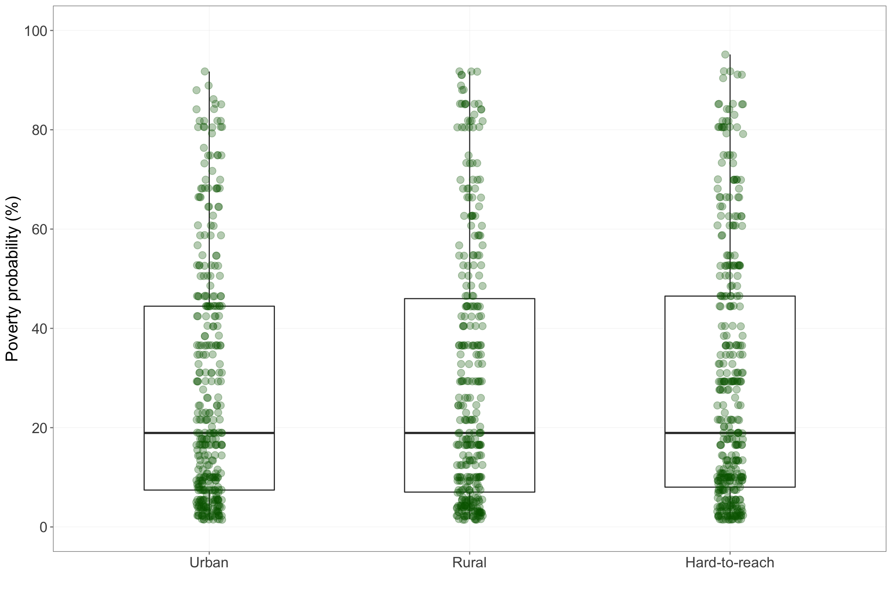

Figure 4.1: Poverty probability index by location type

Poverty probability of households across different locations in Kayah state show high variability ranging from as low as 1.4% to as high as a little over 95%. This distribution of poverty is roughly similar across urban, rural and hard-to-reach areas as seen in Figure 4.1 above.

The poverty probabilities was primarily used to classify households into wealth quintiles which was subsequently used for wealth stratification of indicator results.

### 4.1.2 Food consumption score

| Table 4.1: Food consumption score | | | | | |
| --- | --- | --- | --- | --- | --- |
|  |  |  |  |  |  |
| **Geographic** | | | | | |
| Kayah | Rural | 66.0 | 0.0 | 2.8 | 97.2 |
| Urban | 75.6 | 0.0 | 0.6 | 99.4 |
| Hard-to-reach | 43.2 | 4.9 | 28.1 | 67.0 |
| **Wealth** | | | | |
| Wealthiest | 77.1 | 0.0 | 0.0 | 100.0 |
| Wealthy | 72.0 | 0.0 | 0.0 | 100.0 |
| Medium | 63.0 | 0.0 | 6.7 | 93.3 |
| Poor | 52.4 | 1.5 | 16.8 | 81.6 |
| Poorest | 40.1 | 6.3 | 32.7 | 61.0 |  |

Table 4.1 presents FCS results by geographic location and by wealth quintiles. There is a clear geographic and wealth gradient with FCS as shown in Figure 4.2 and Figure **??**. Poor FCS is at 4.90463215258856% in hard-to-reach areas whilst it is only 0% and 0% in urban and rural areas respectively. In the poor and poorest households, poor FCS is at 1.53061224489796% and 6.34146341463415% respectively compared to no households with poor FCS in medium, wealthy and wealthiest households.

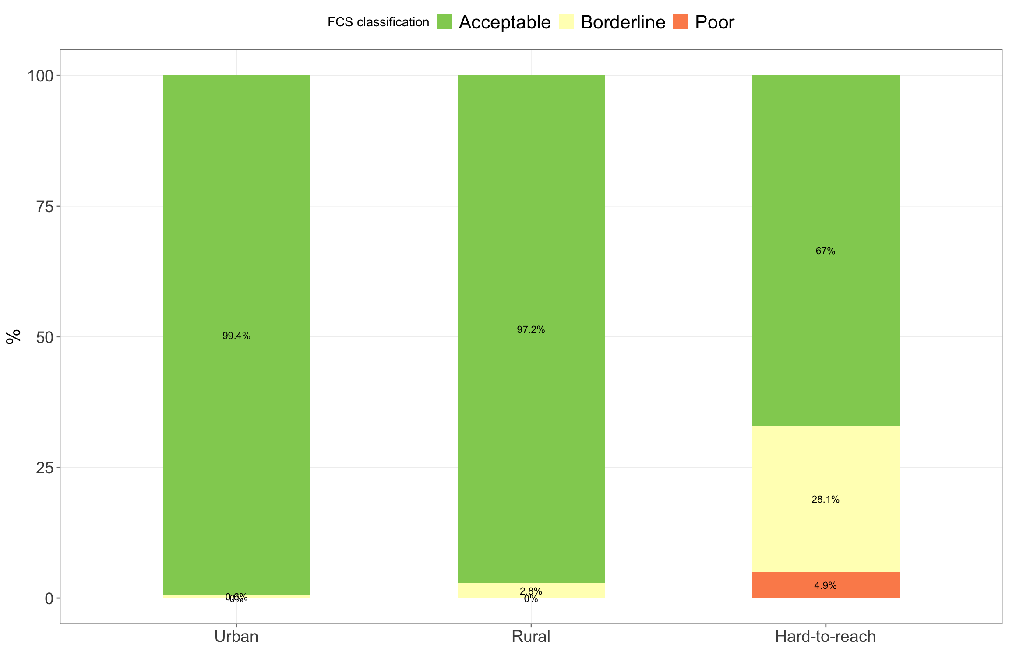

Figure 4.2: Food consumption score classification by location type

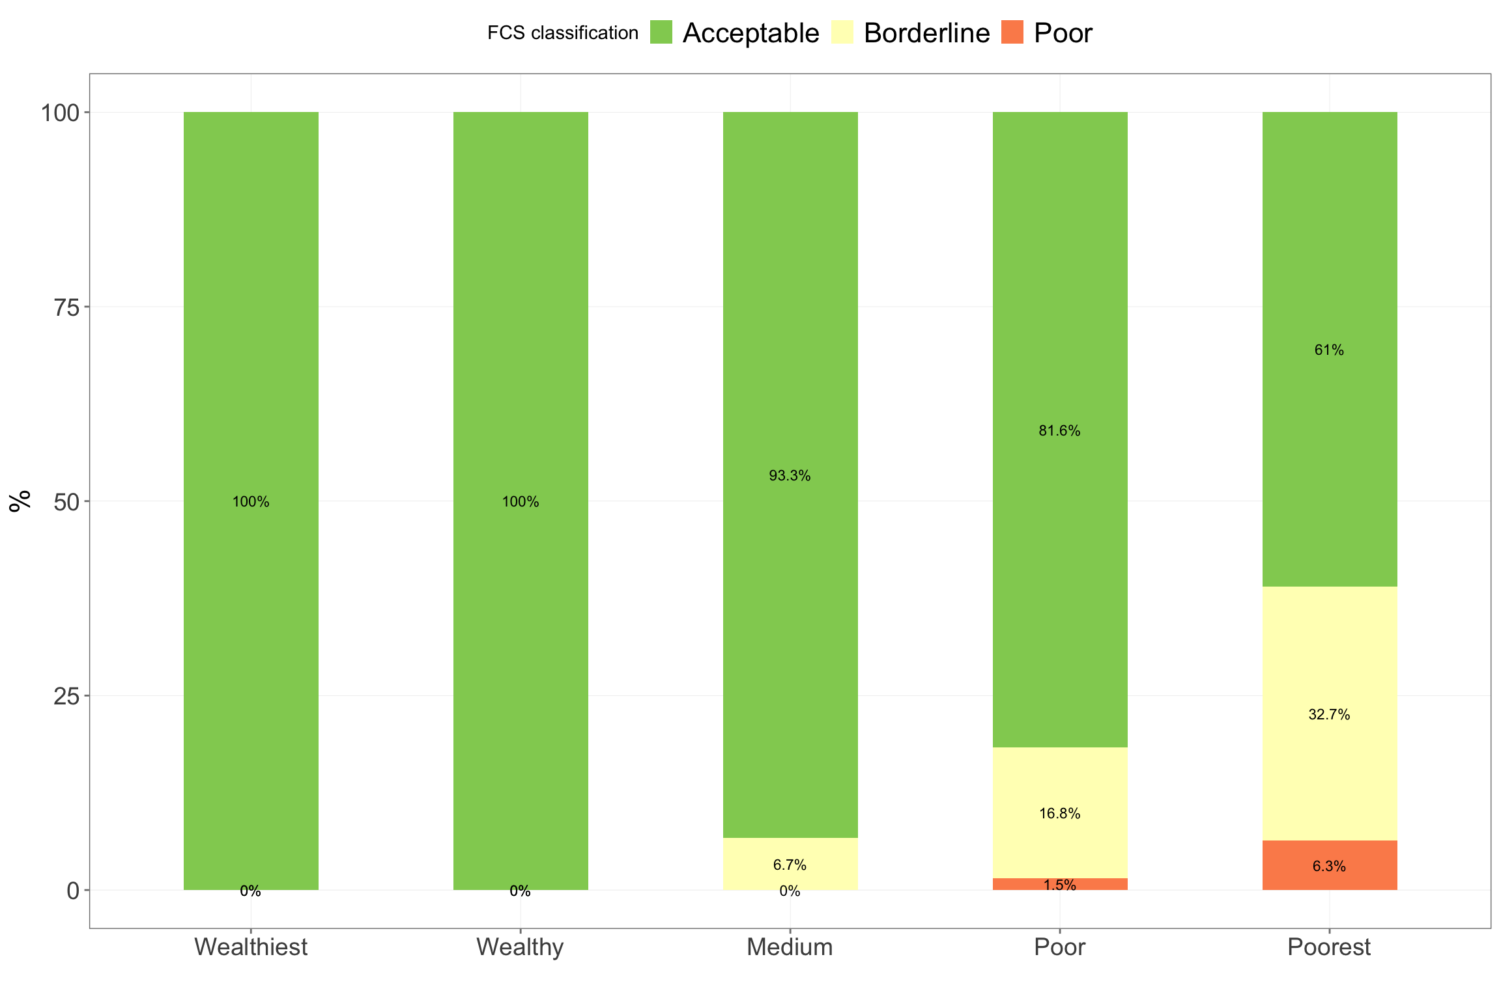

Figure 4.3: Food consumption score classification by wealth quintiles

### 4.1.3 Food consumption score - nutrition

Household consumption of vitamin A-, protein- and heme iron-rich foods indicate the quality of the household diet. In Kayah State, frequency of consumption of these nutrient-rich foods is generally high with vitamin A- and protein-rich foods consumed more frequently than heme iron-rich foods. In addition, frequency of household consumption of these nutrients is influenced by geographic location and wealth. Vitamin A-rich foods are consumed at least daily by 94.2% and 95.9% of households in urban and rural areas respectively and then drops to as low as 65.9% in hard-to-reach areas (see Figure 4.4). The same decreasing pattern of frequency of vitamin A-rich foods consumption is noted when households are grouped by wealth quintiles with majority of the wealthiest and the wealthy consuming vitamin A-rich foods at least daily while poor and poorest households consumed vitamin A-rich foods at least daily only 77% and 66.8% of the times respectively (see Figure 4.5). This same trend is noted with frequency of household consumption of protein-rich foods (see Figure 4.6 and Figure 4.7) and frequency of household consumption of heme iron-rich foods (see Figure 4.8 and 4.9) but to a lesser magnitude.

| Table 4.2: Food consumption score - nutrition | | | | | | | | | | |
| --- | --- | --- | --- | --- | --- | --- | --- | --- | --- | --- |
|  | | **Vitamin A-rich foods** | | | **Protein-rich foods** | | | **Heme iron-rich foods** | | |
|  |  |  |  |  |  |  |  |  |  |  |
| **Geographic** | | | | | | | | | | |
| Kayah | Rural | 0.0 | 4.1 | 95.9 | 0.3 | 15.0 | 84.6 | 8.5 | 61.1 | 30.4 |
| Urban | 0.0 | 5.8 | 94.2 | 0.3 | 4.1 | 95.6 | 0.6 | 49.7 | 49.7 |
| Hard-to-reach | 3.0 | 31.1 | 65.9 | 10.9 | 53.1 | 36.0 | 20.4 | 69.5 | 10.1 |
| **Wealth** | | | | | | | | | |
| Wealthiest | 0.0 | 5.2 | 94.8 | 0.0 | 3.0 | 97.0 | 0.4 | 47.6 | 51.9 |
| Wealthy | 0.0 | 3.2 | 96.8 | 0.0 | 8.6 | 91.4 | 1.1 | 54.8 | 44.1 |
| Medium | 0.5 | 11.5 | 88.0 | 1.0 | 19.1 | 79.9 | 6.2 | 67.9 | 25.8 |
| Poor | 1.5 | 21.4 | 77.0 | 4.1 | 38.3 | 57.7 | 12.8 | 71.9 | 15.3 |
| Poorest | 2.4 | 30.7 | 66.8 | 14.6 | 58.0 | 27.3 | 29.8 | 61.5 | 8.8 |  |

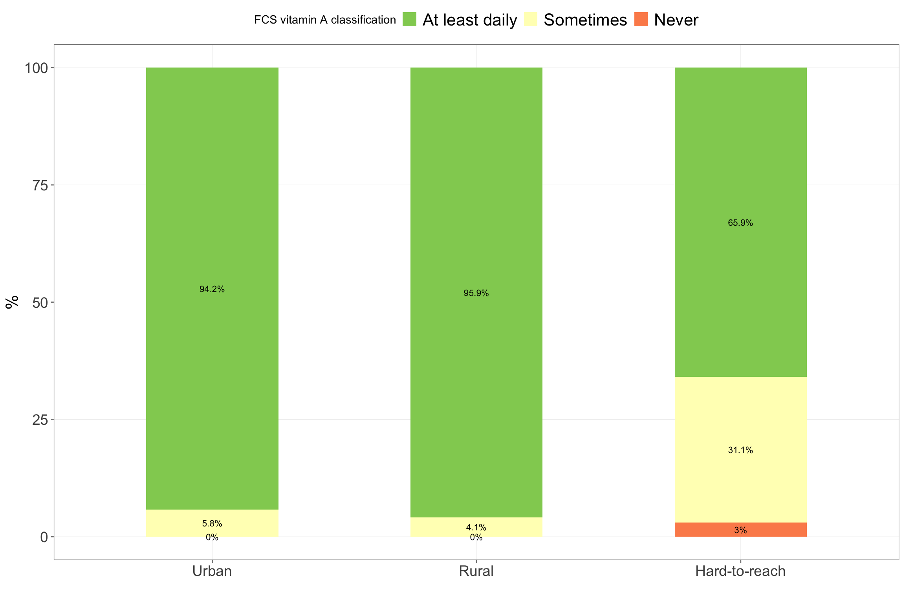

Figure 4.4: Vitamin A food consumption score classification by location type

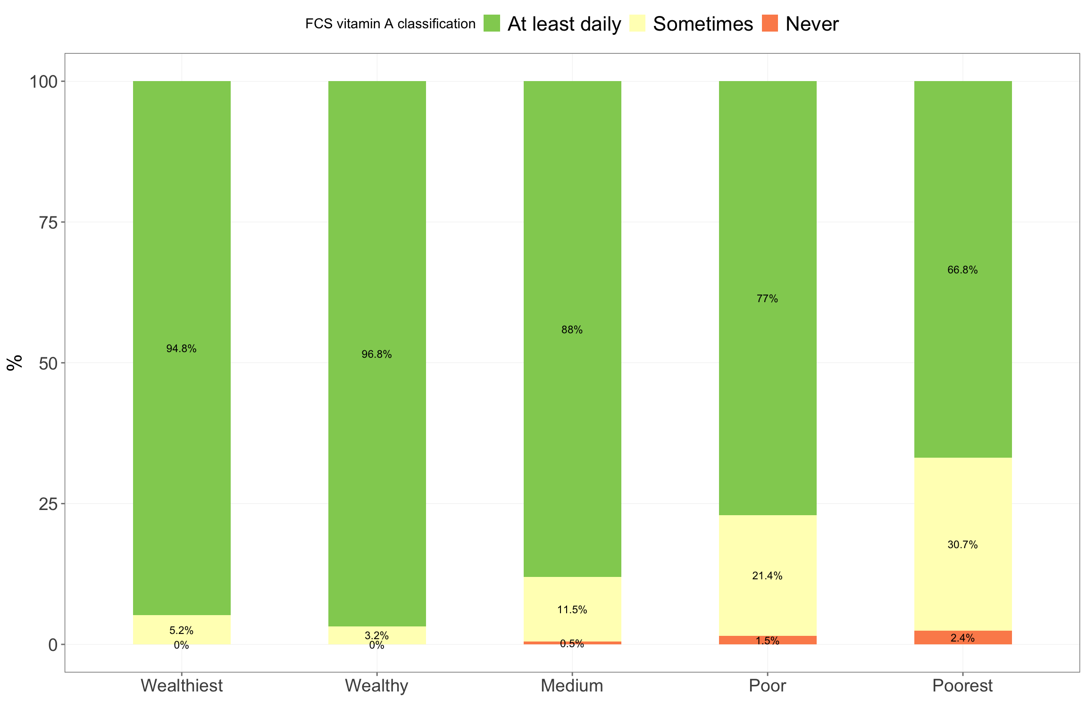

Figure 4.5: Vitamin A food consumption score classification by wealth quintiles

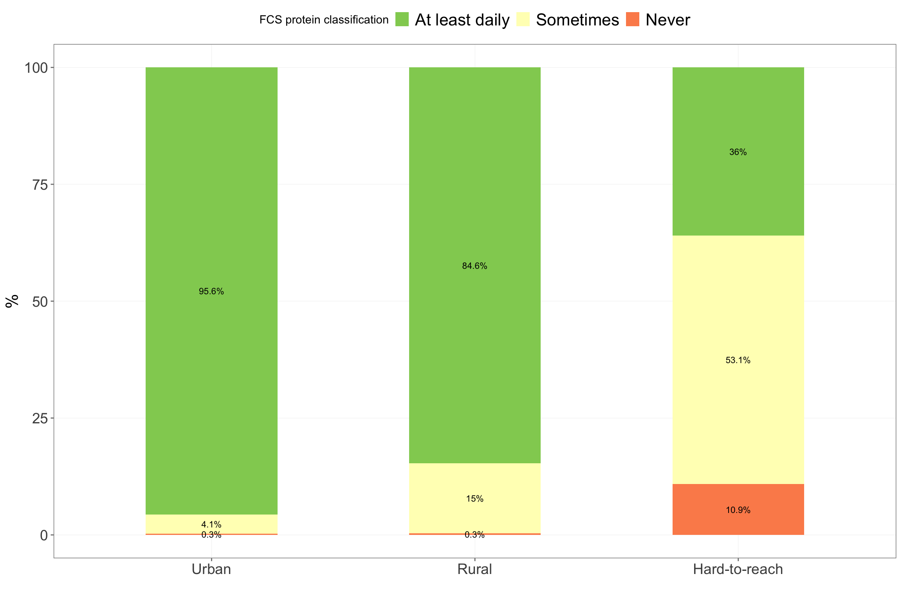

Figure 4.6: Protein food consumption score classification by location type

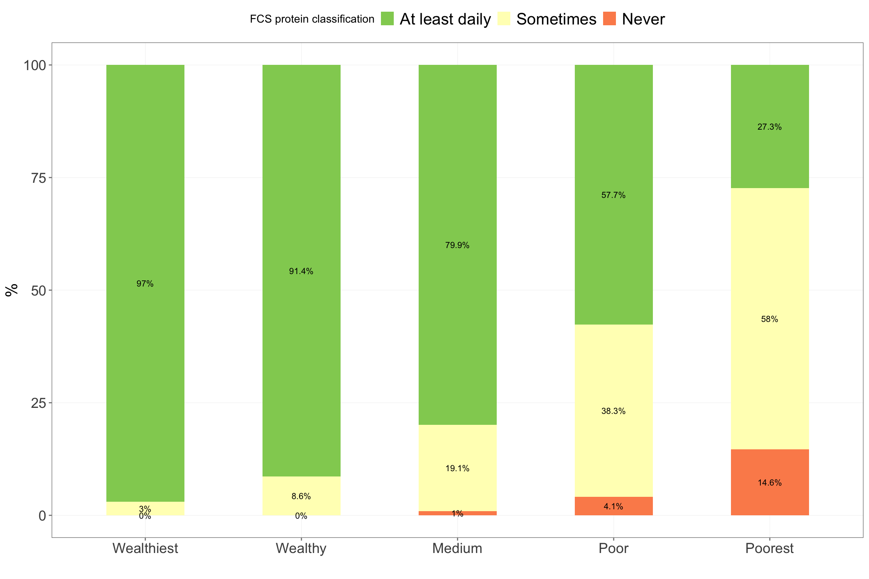

Figure 4.7: Protein food consumption score classification by wealth quintiles

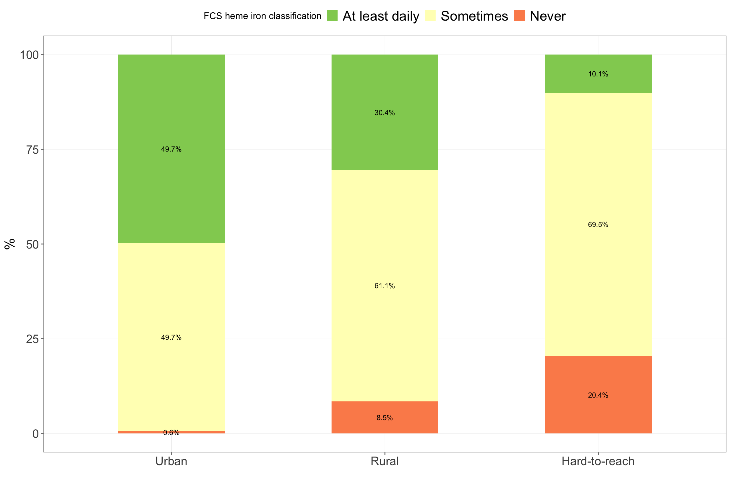

Figure 4.8: Heme iron-rich food consumption score classification by location type

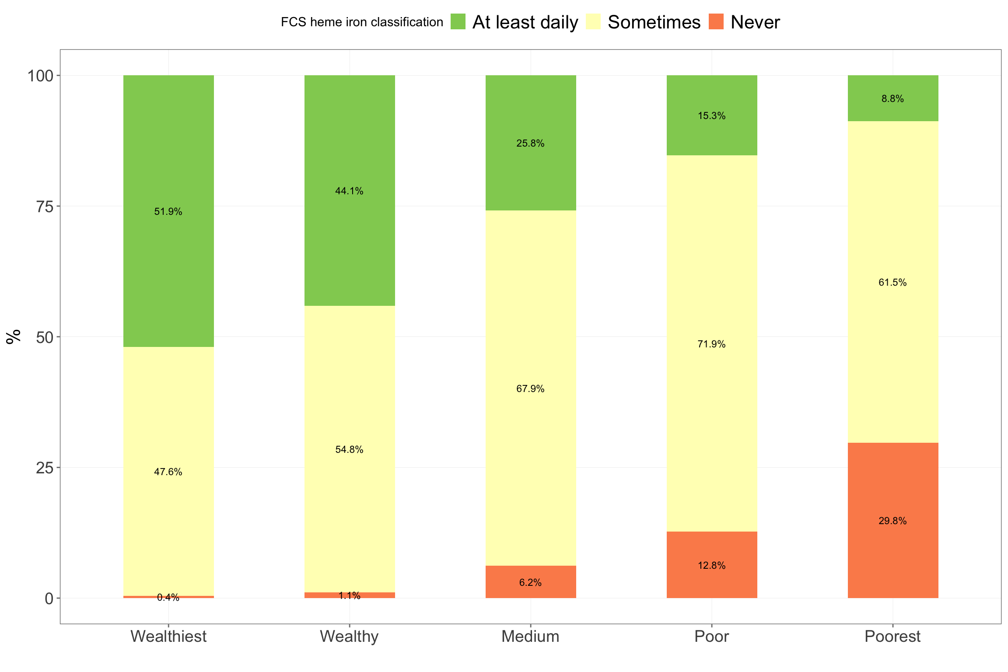

Figure 4.9: Protein food consumption score classification by wealth quintiles

### 4.1.4 Coping strategies index

#### 4.1.4.1 Consumption-based coping strategies index

| Table 4.3: Consumption-based Coping Strategies Index | | |
| --- | --- | --- |
|  |  | **Mean CSI** |
| **Geographic** | | |
| Kayah | Rural | 4.8 |
| Urban | 3.6 |
| Hard-to-reach | 4.0 |
| **Wealth** | |
| Wealthiest | 2.2 |
| Wealthy | 4.2 |
| Medium | 4.8 |
| Poor | 5.2 |
| Poorest | 4.6 |  |

Households in Kayah state are employing very few consumption-based coping strategies (see Table 4.3). Use of consumption-based coping strategies is higher in households in hard-to-reach areas (4) compared to households in urban and rural areas (3.6 and 4.8 respectively) as shown in Figure 4.10 and Figure 4.11.

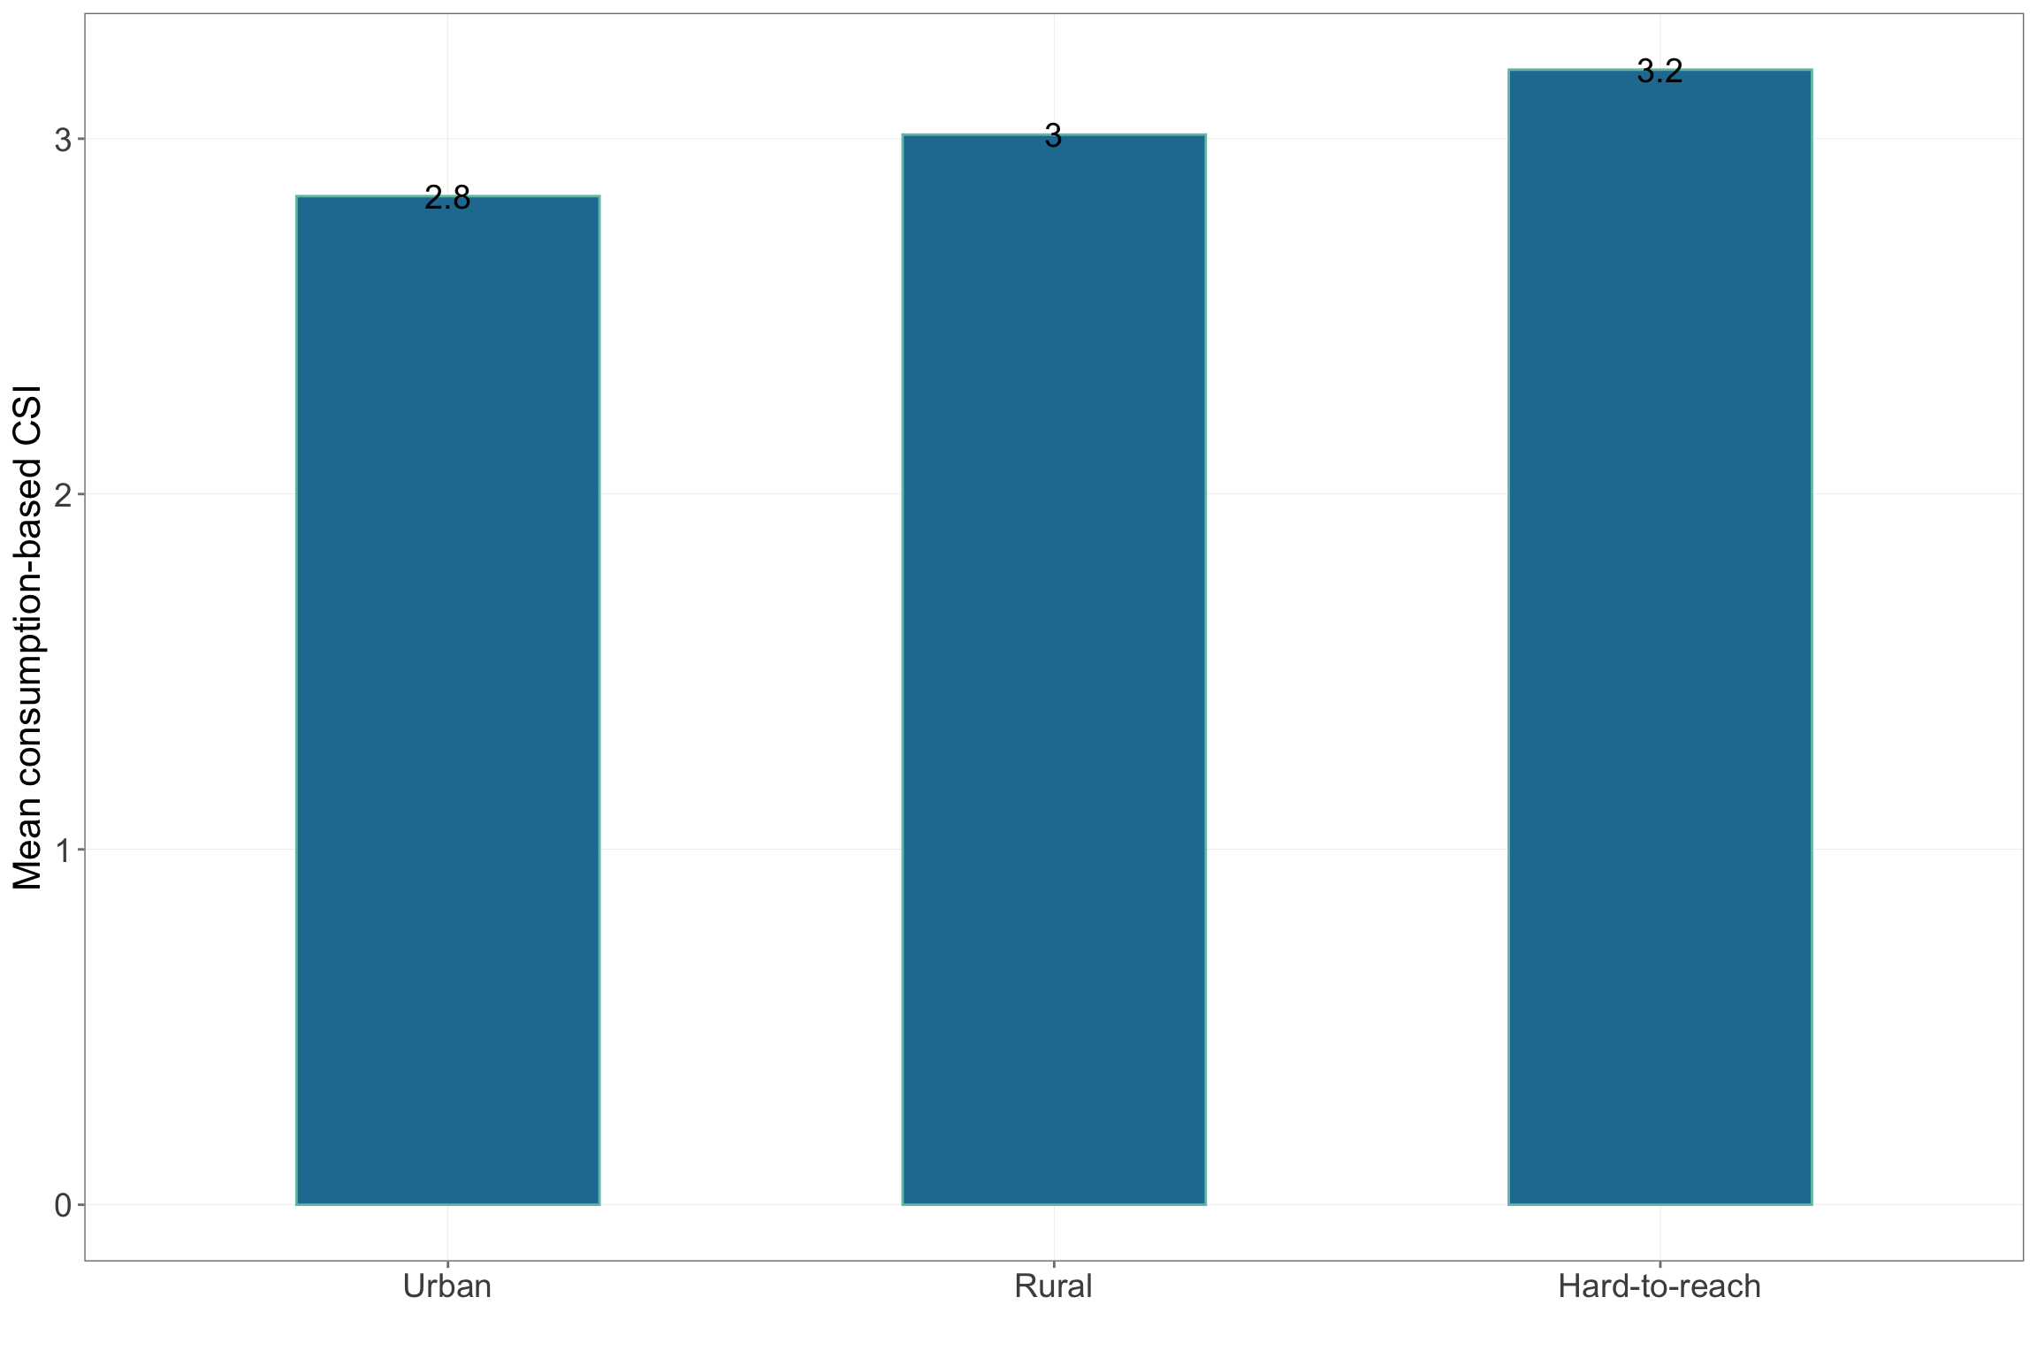

Figure 4.10: Consumption-based coping strategies index by location type

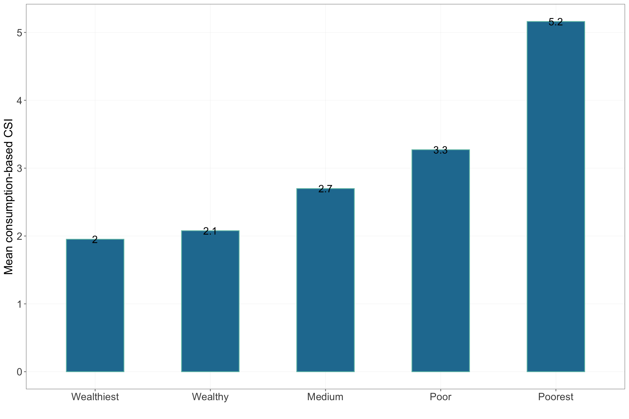

Figure 4.11: Consumption-based coping strategies index by wealth quintiles

#### 4.1.4.2 Livelihood-based coping strategies index

The use of a few consumption-based coping strategies by households in Kayah state can be partly explained by close to 50% of households being relatively food secuire in that they are not requiring longer-term livelihoods-based coping strategies. However, up to 40% of households across Kayah state utilise stress type of livelihoods coping strategies in the longer term. There is not as clear a geographical or wealth gradient for livelihoods-based coping strategies. Houeholds in rural areas employ the most crisis and emergency type of livelihood coping strategies although households hard-to-reach areas use more emergency type of strategies (see Figure 4.12). Poor and poorest households employ the most emergency type livelihoods coping strategies although households who are wealthy or medium have the highest combined usage of crisis and emergency type livelihoods strategies (see Figure 4.13).

| Table 4.4: Livelihoods-based coping strategies index | | | | | |
| --- | --- | --- | --- | --- | --- |
|  |  |  |  |  |  |
| **Geographic** | | | | | |
| Kayah | Rural | 40.8 | 38.9 | 17.2 | 3.1 |
| Urban | 49.4 | 37.8 | 9.9 | 2.9 |
| Hard-to-reach | 44.4 | 46.9 | 3.5 | 5.2 |
| **Wealth** | | | | |
| Wealthiest | 49.8 | 36.8 | 10.4 | 3.0 |
| Wealthy | 43.0 | 40.9 | 12.4 | 3.8 |
| Medium | 43.5 | 40.2 | 14.4 | 1.9 |
| Poor | 41.3 | 44.9 | 7.7 | 6.1 |
| Poorest | 45.9 | 45.4 | 4.4 | 4.4 |  |

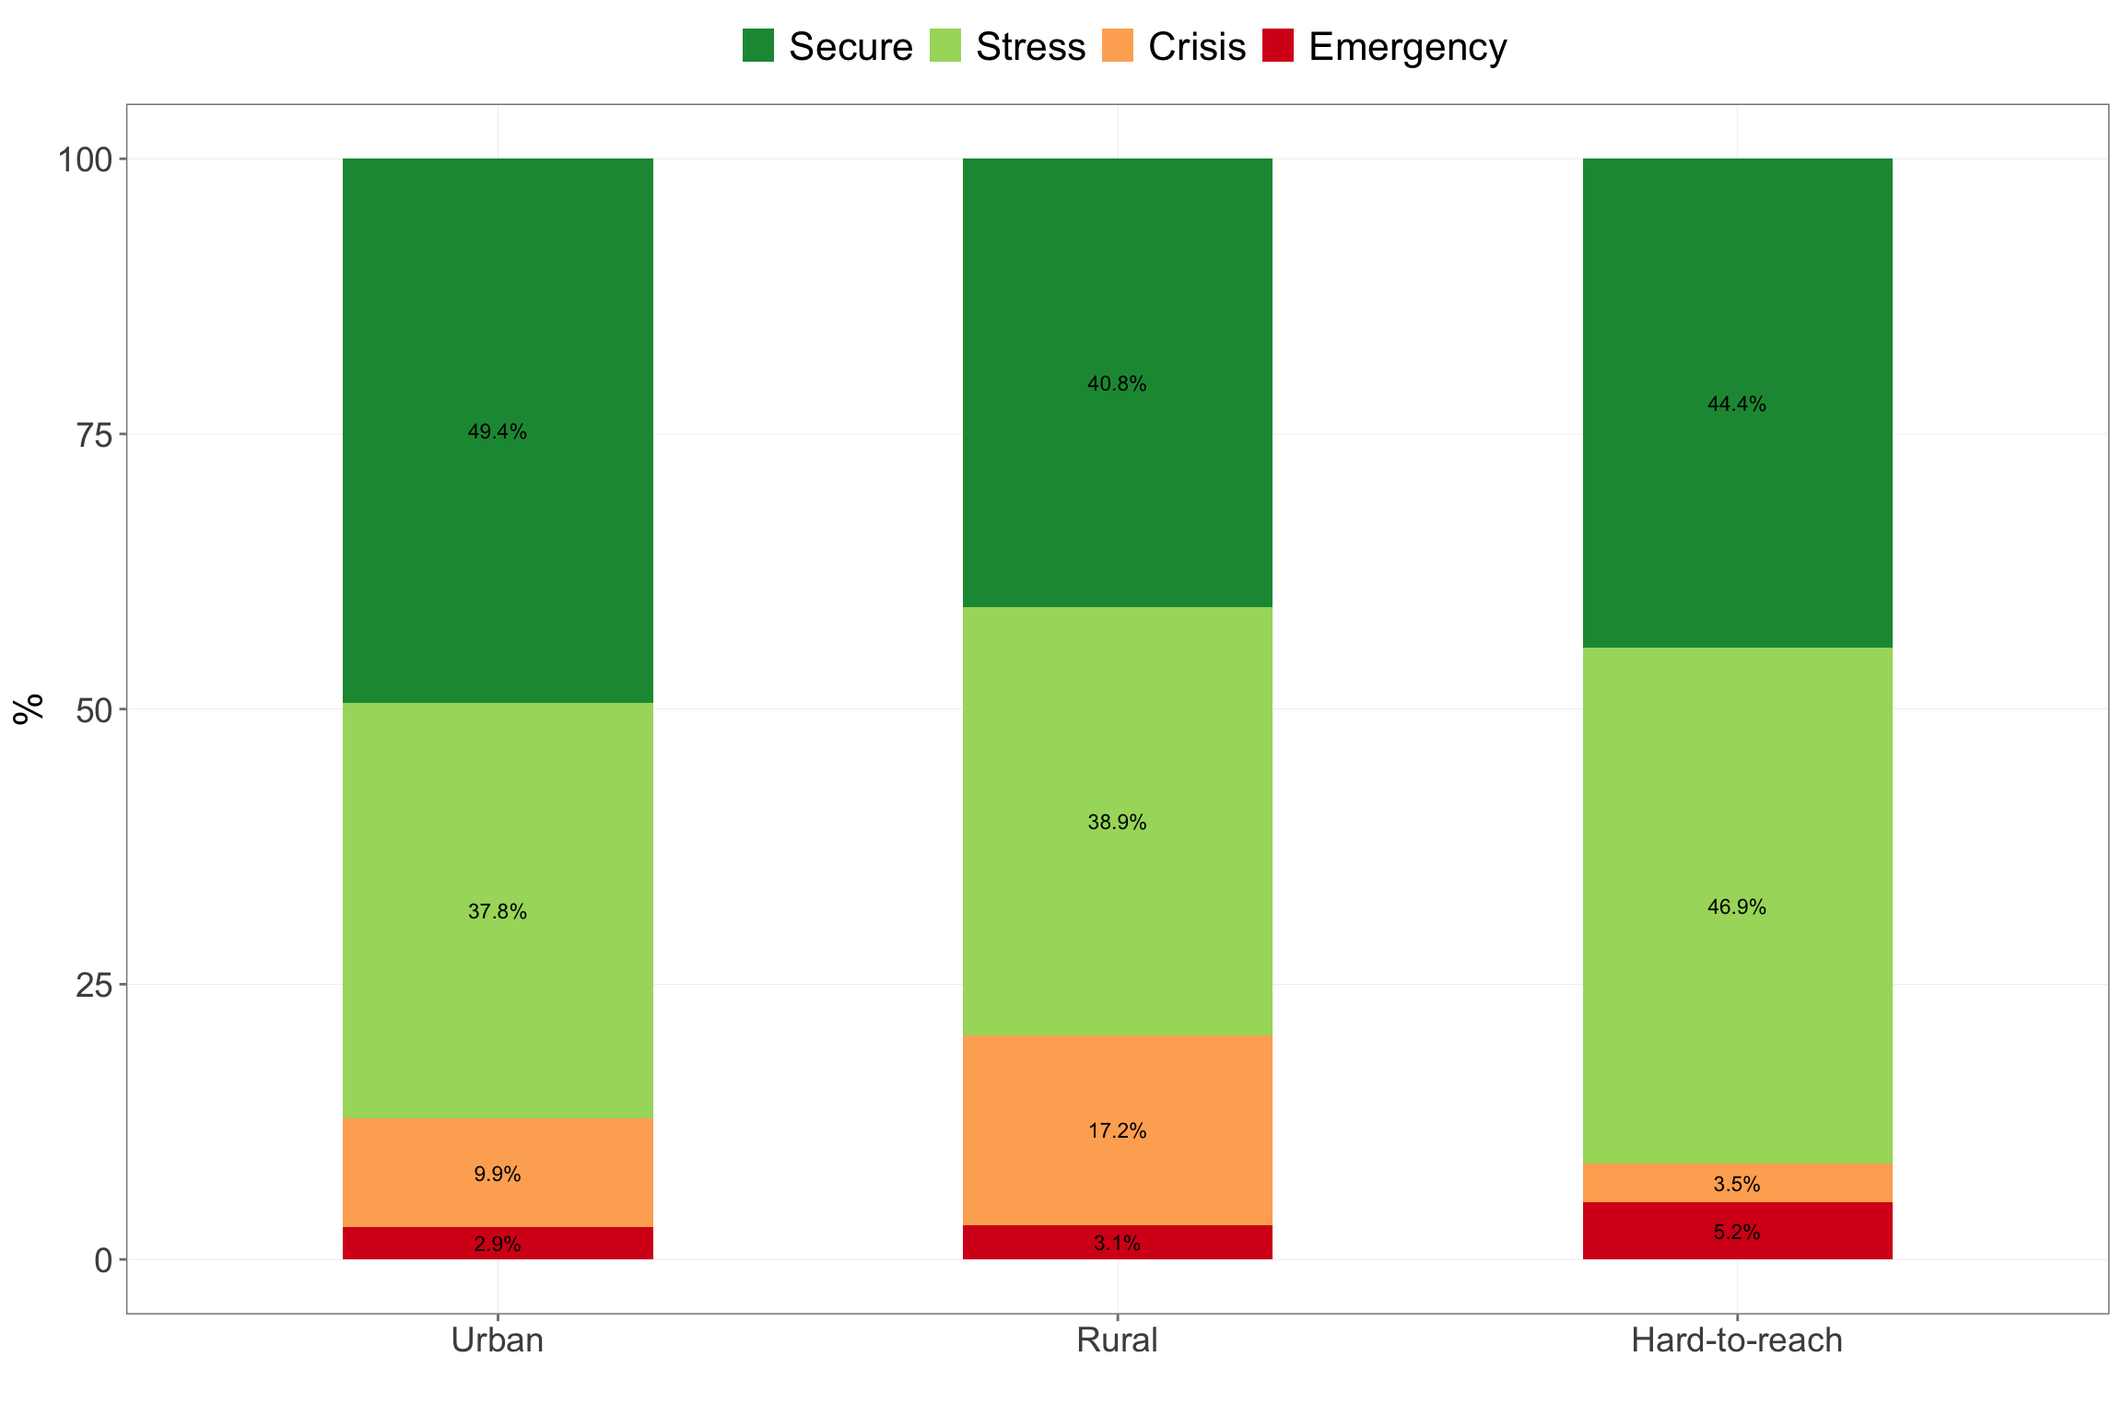

Figure 4.12: Livelihoods-based coping strategies index by location type

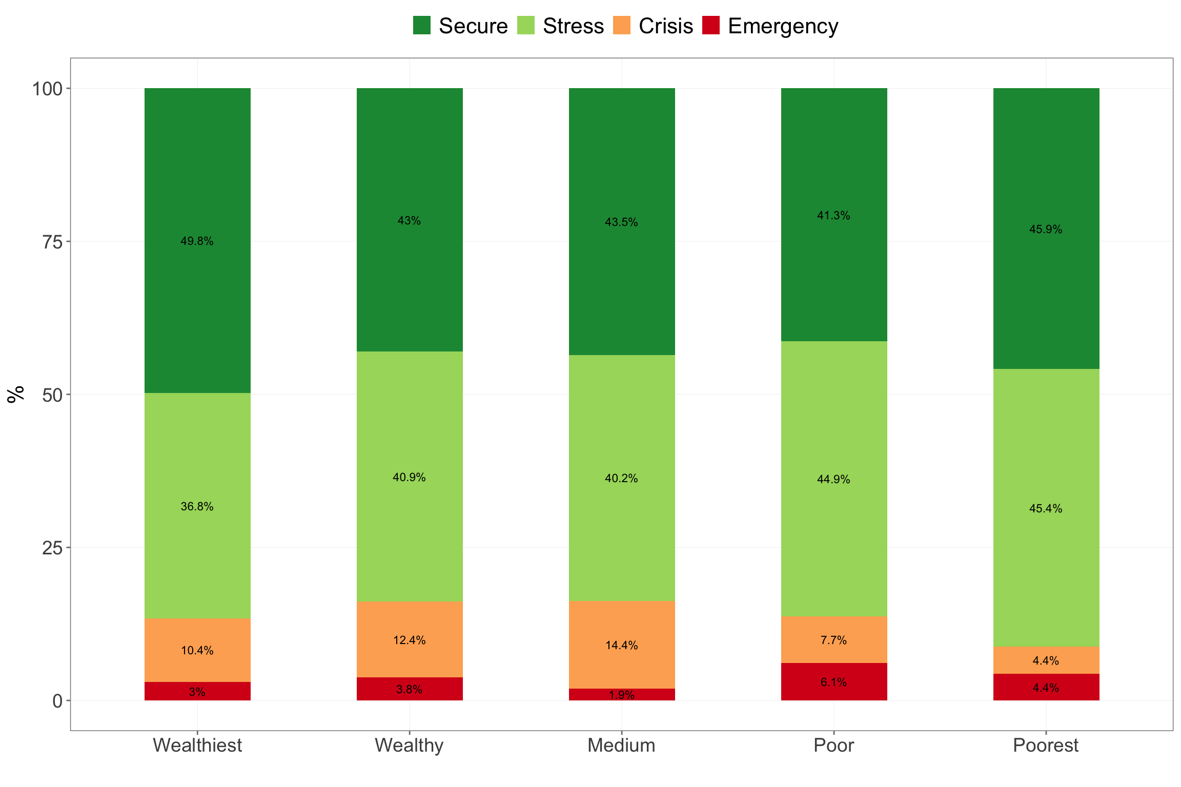

Figure 4.13: Livelihoods-based coping strategies index by wealth quintiles

### 4.1.5 Household food expenditure share

Majority of households accress Kayah state have low food insecurity (see Table 4.5). However, there are pockets of households in mostly hard-to-reach areas and households who are poor and poorest that are highly food insecure or vulnerable (see Figure 4.14 and Figure 4.15).

| Table 4.5: Household food expenditure share | | | | | |
| --- | --- | --- | --- | --- | --- |
|  | | **Food Insecurity by HFES** | | | |
|  |  |  |  |  |  |
| **Geographic** | | | | | |
| Kayah | Rural | 0.3 | 0.0 | 0.0 | 99.7 |
| Urban | 0.0 | 0.0 | 0.3 | 99.7 |
| Hard-to-reach | 6.3 | 0.5 | 1.4 | 91.8 |
| **Wealth** | | | | |
| Wealthiest | 0.0 | 0.0 | 0.4 | 99.6 |
| Wealthy | 0.5 | 0.0 | 0.0 | 99.5 |
| Medium | 0.5 | 0.0 | 0.0 | 99.5 |
| Poor | 3.6 | 0.5 | 0.0 | 95.9 |
| Poorest | 7.3 | 0.5 | 2.4 | 89.8 |  |

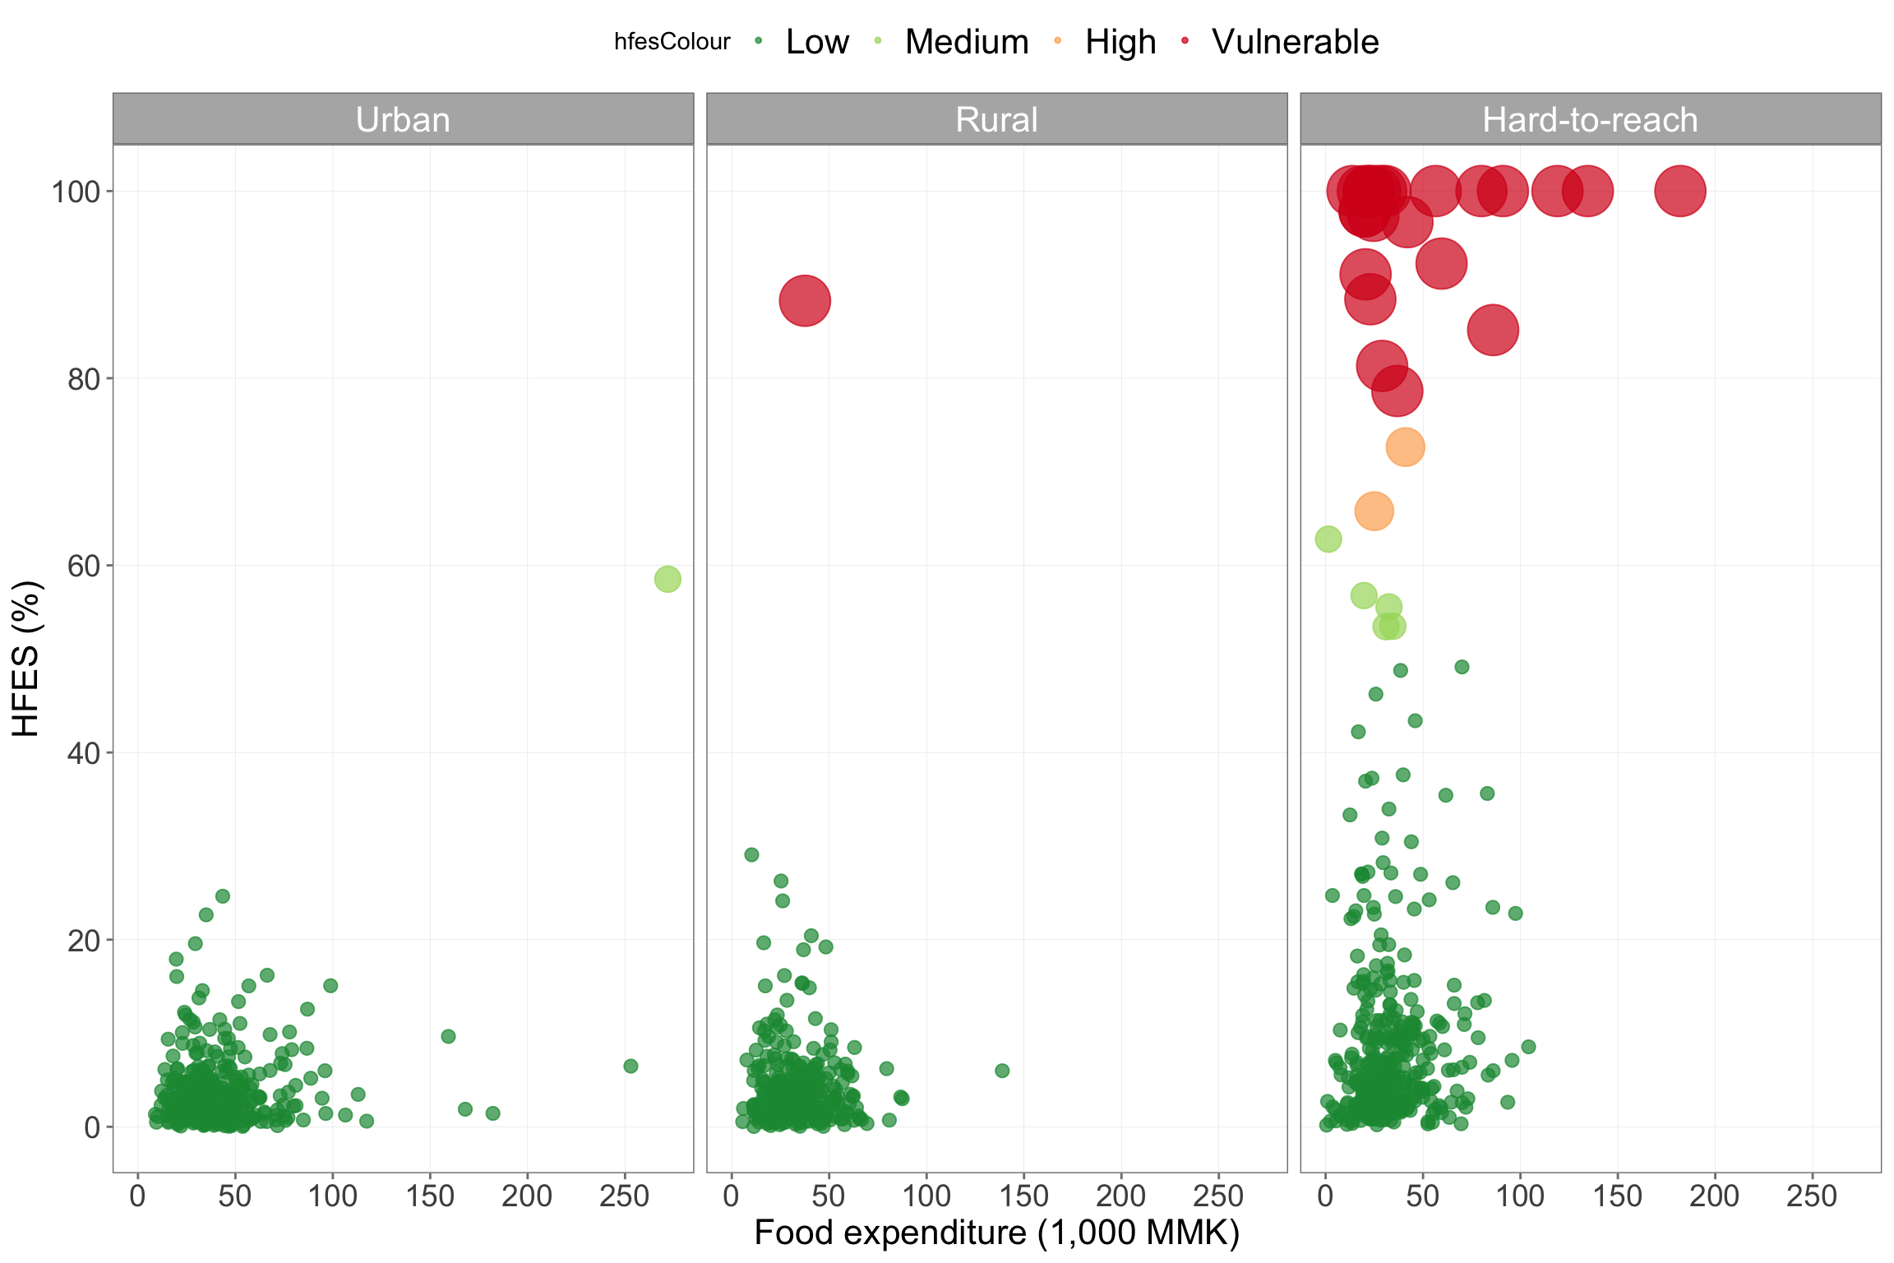

Figure 4.14: Household food expenditure share by location type

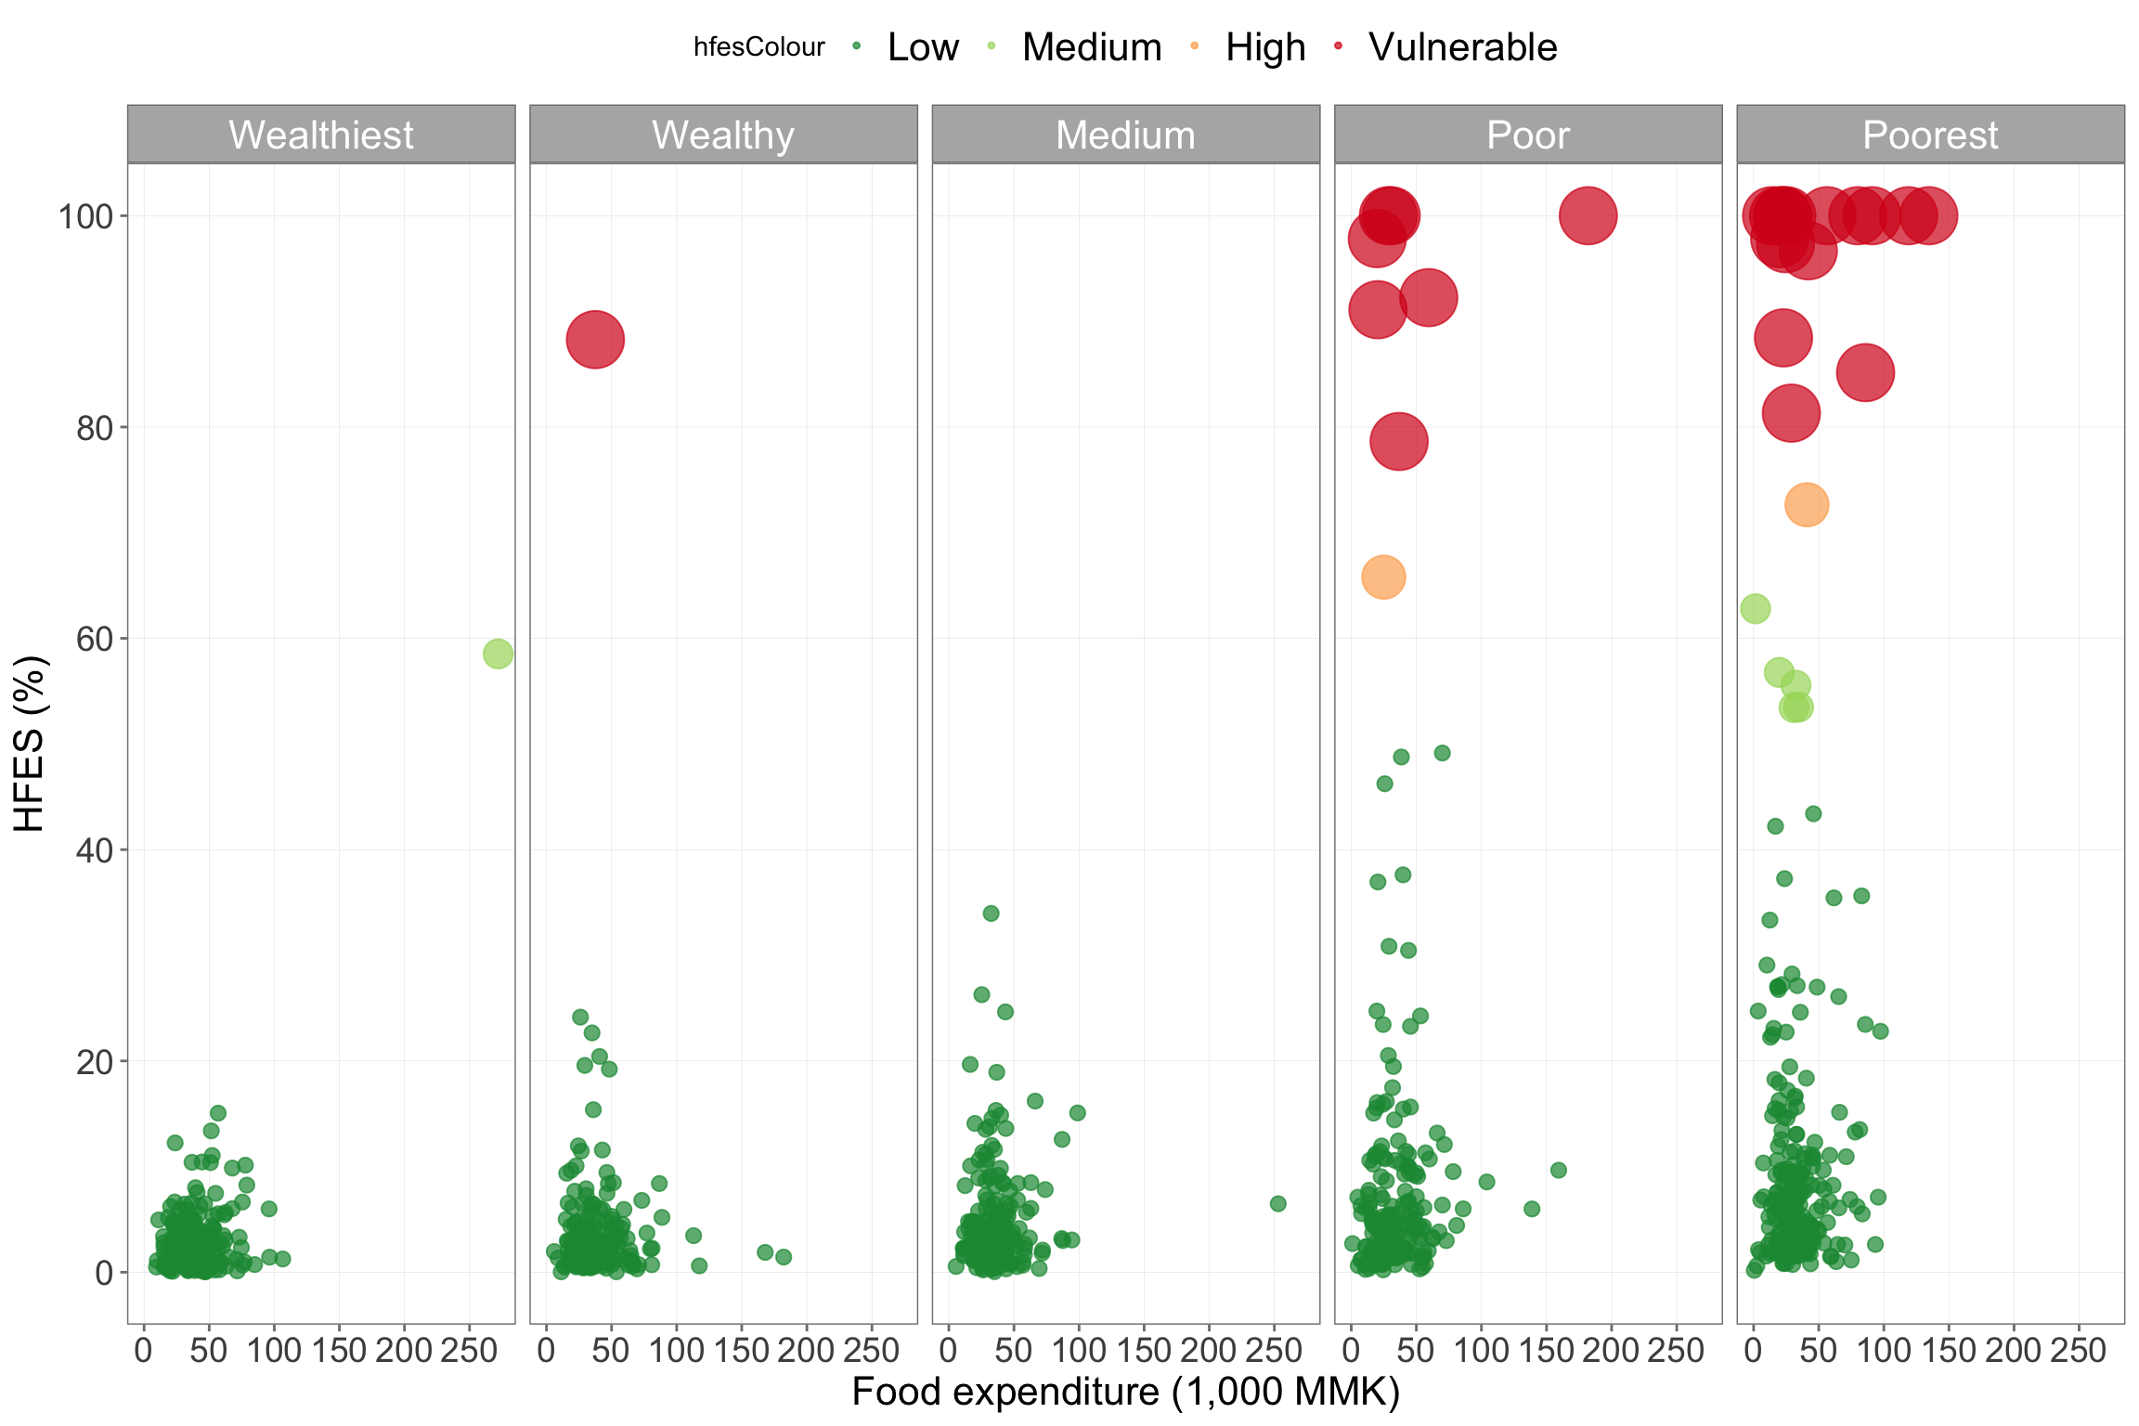

Figure 4.15: Household food expenditure share by wealth quintiles

### 4.1.6 Water, sanitation and hygiene

#### 4.1.6.1 Water services ladder

There is minimal seasonal variation in households’ access to drinking water with majority of households able to get water from improved sources of drinking water whole year round (see 4.6). However, up to 17% of households in hard-to-reach areas use surface water as their drinking water source (see Figure 4.16). Interestingly, in urban areas, up to 5% still access driking water from surface water. Figure **??** show that the poorer the houshold gets, the higher the probability that the household is accessing drinking water from surface water.

| Table 4.6: Water service ladders | | | | | | | | | | |
| --- | --- | --- | --- | --- | --- | --- | --- | --- | --- | --- |
|  | | **Summer Season** | | | **Rainy Season** | | | **Winter Season** | | |
|  |  |  |  |  |  |  |  |  |  |  |
| **Geographic** | | | | | | | | | | |
| Kayah | Rural | 74.6 | 7.8 | 17.6 | 80.3 | 10.7 | 9.1 | 74.9 | 7.5 | 17.6 |
| Urban | 89.5 | 4.9 | 5.5 | 89.0 | 5.5 | 5.5 | 89.8 | 4.9 | 5.2 |
| Hard-to-reach | 63.8 | 17.0 | 19.2 | 68.8 | 17.0 | 14.2 | 64.1 | 16.7 | 19.2 |
| **Wealth** | | | | | | | | | |
| Wealthiest | 90.0 | 3.0 | 6.9 | 92.6 | 2.2 | 5.2 | 90.5 | 2.6 | 6.9 |
| Wealthy | 84.9 | 4.3 | 10.8 | 83.9 | 6.5 | 9.7 | 85.5 | 3.8 | 10.8 |
| Medium | 67.5 | 11.5 | 21.1 | 73.7 | 12.4 | 13.9 | 67.0 | 12.0 | 21.1 |
| Poor | 64.8 | 12.8 | 22.4 | 71.9 | 14.8 | 13.3 | 65.8 | 12.8 | 21.4 |
| Poorest | 70.2 | 19.5 | 10.2 | 71.7 | 21.0 | 7.3 | 70.2 | 19.0 | 10.7 |  |

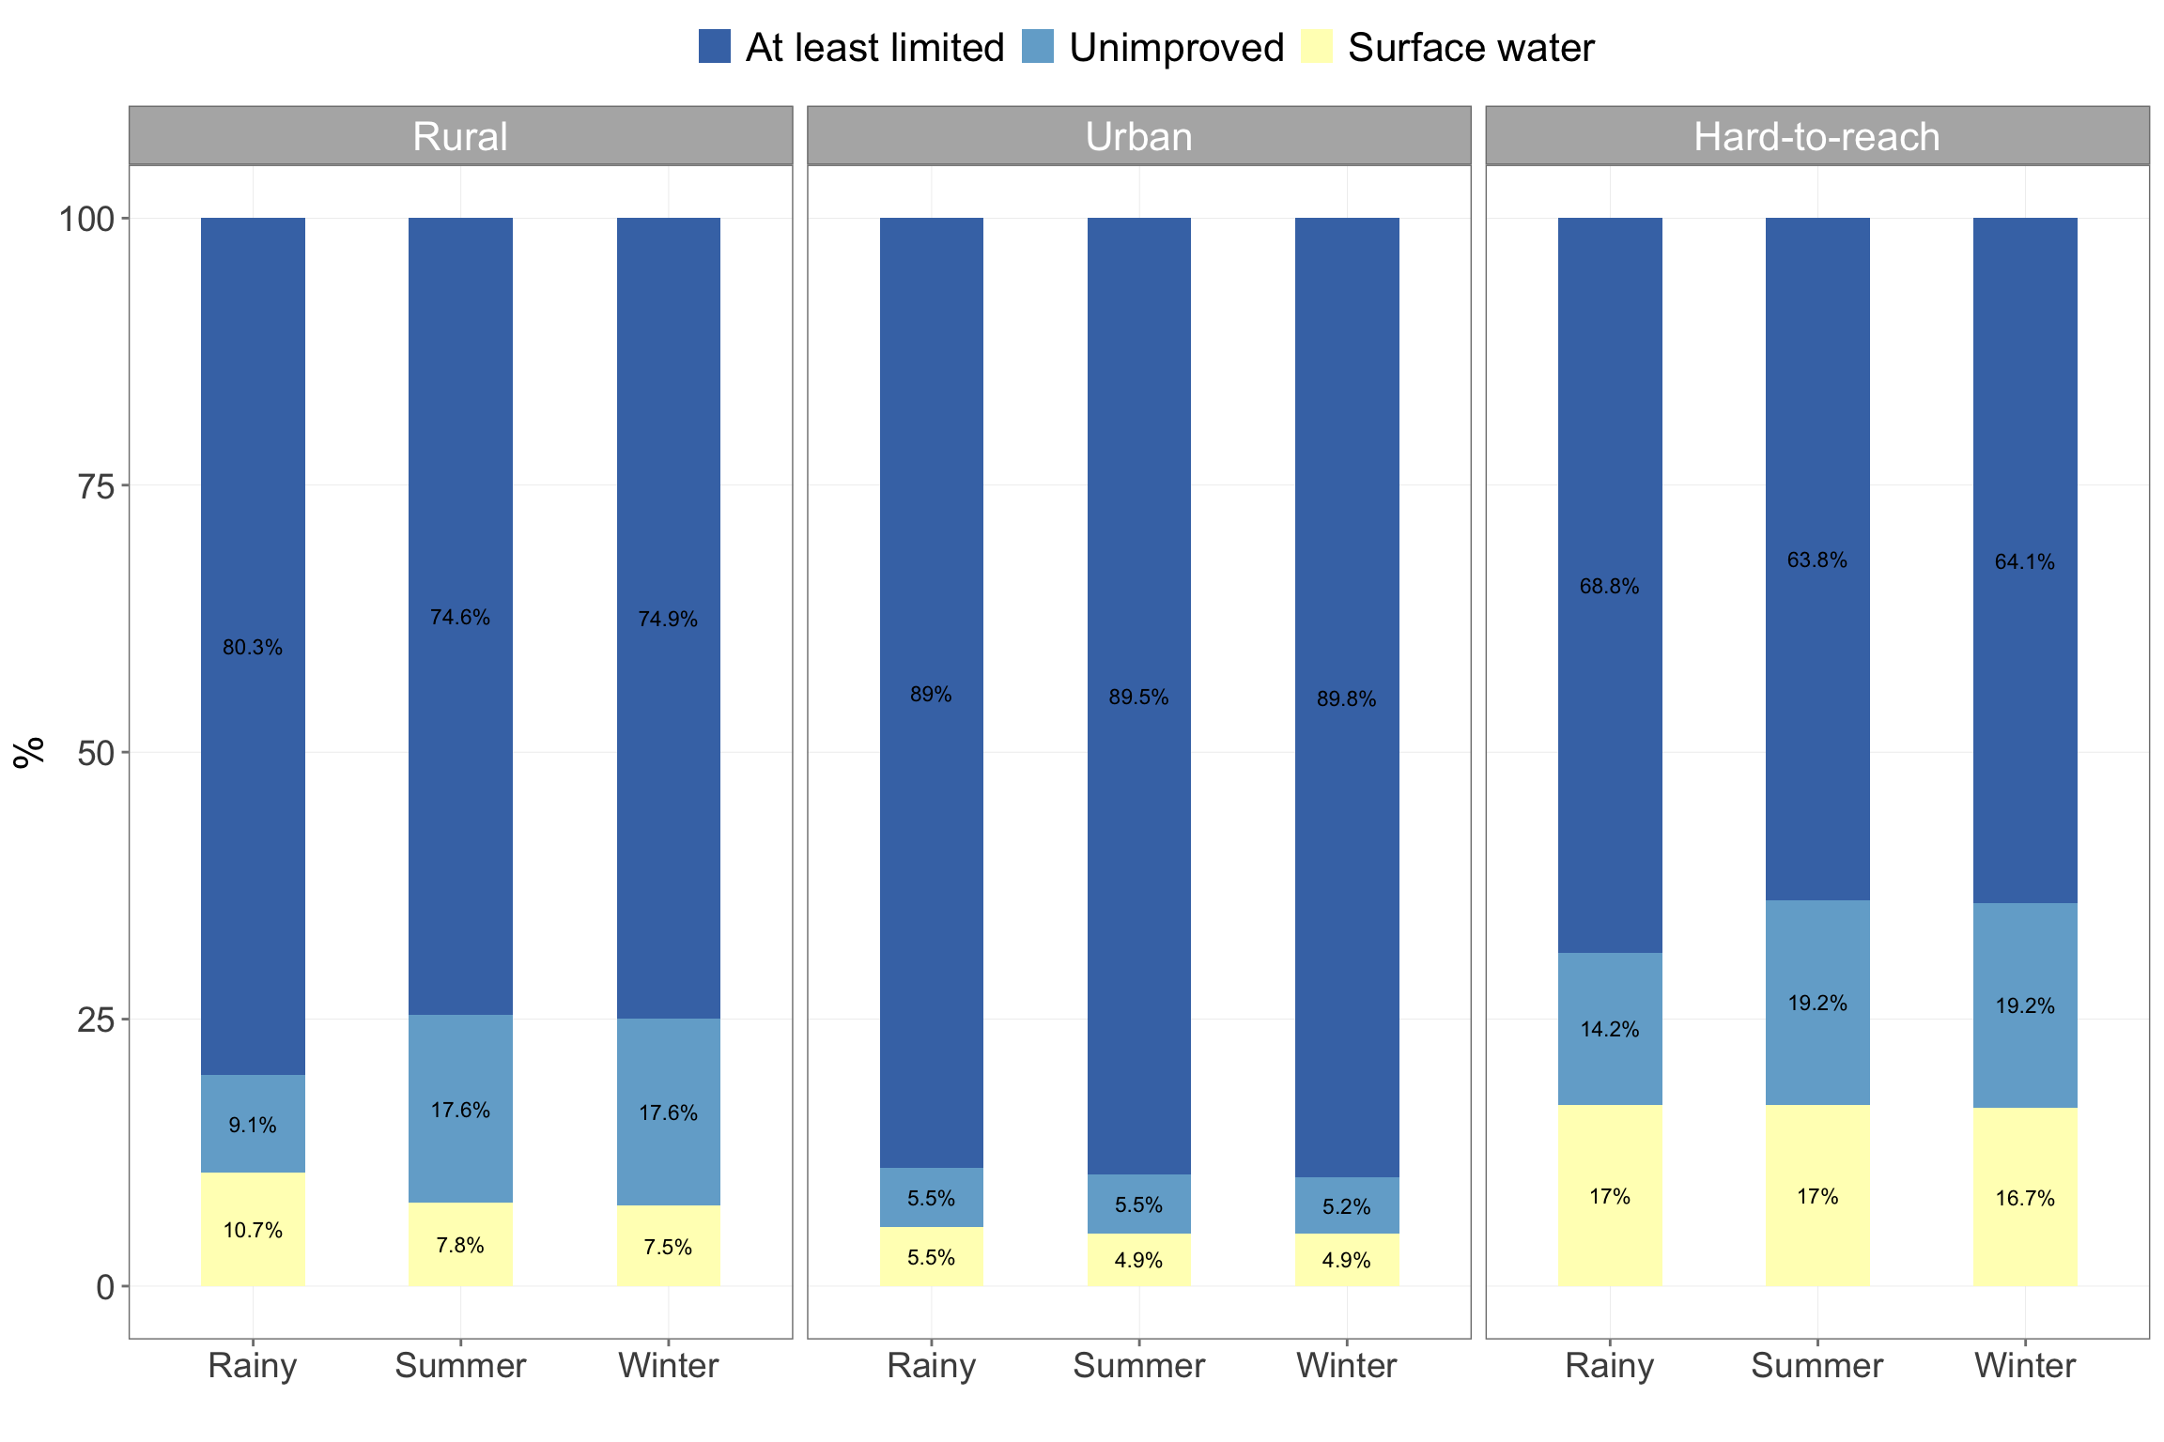

Figure 4.16: Water services ladder by location type

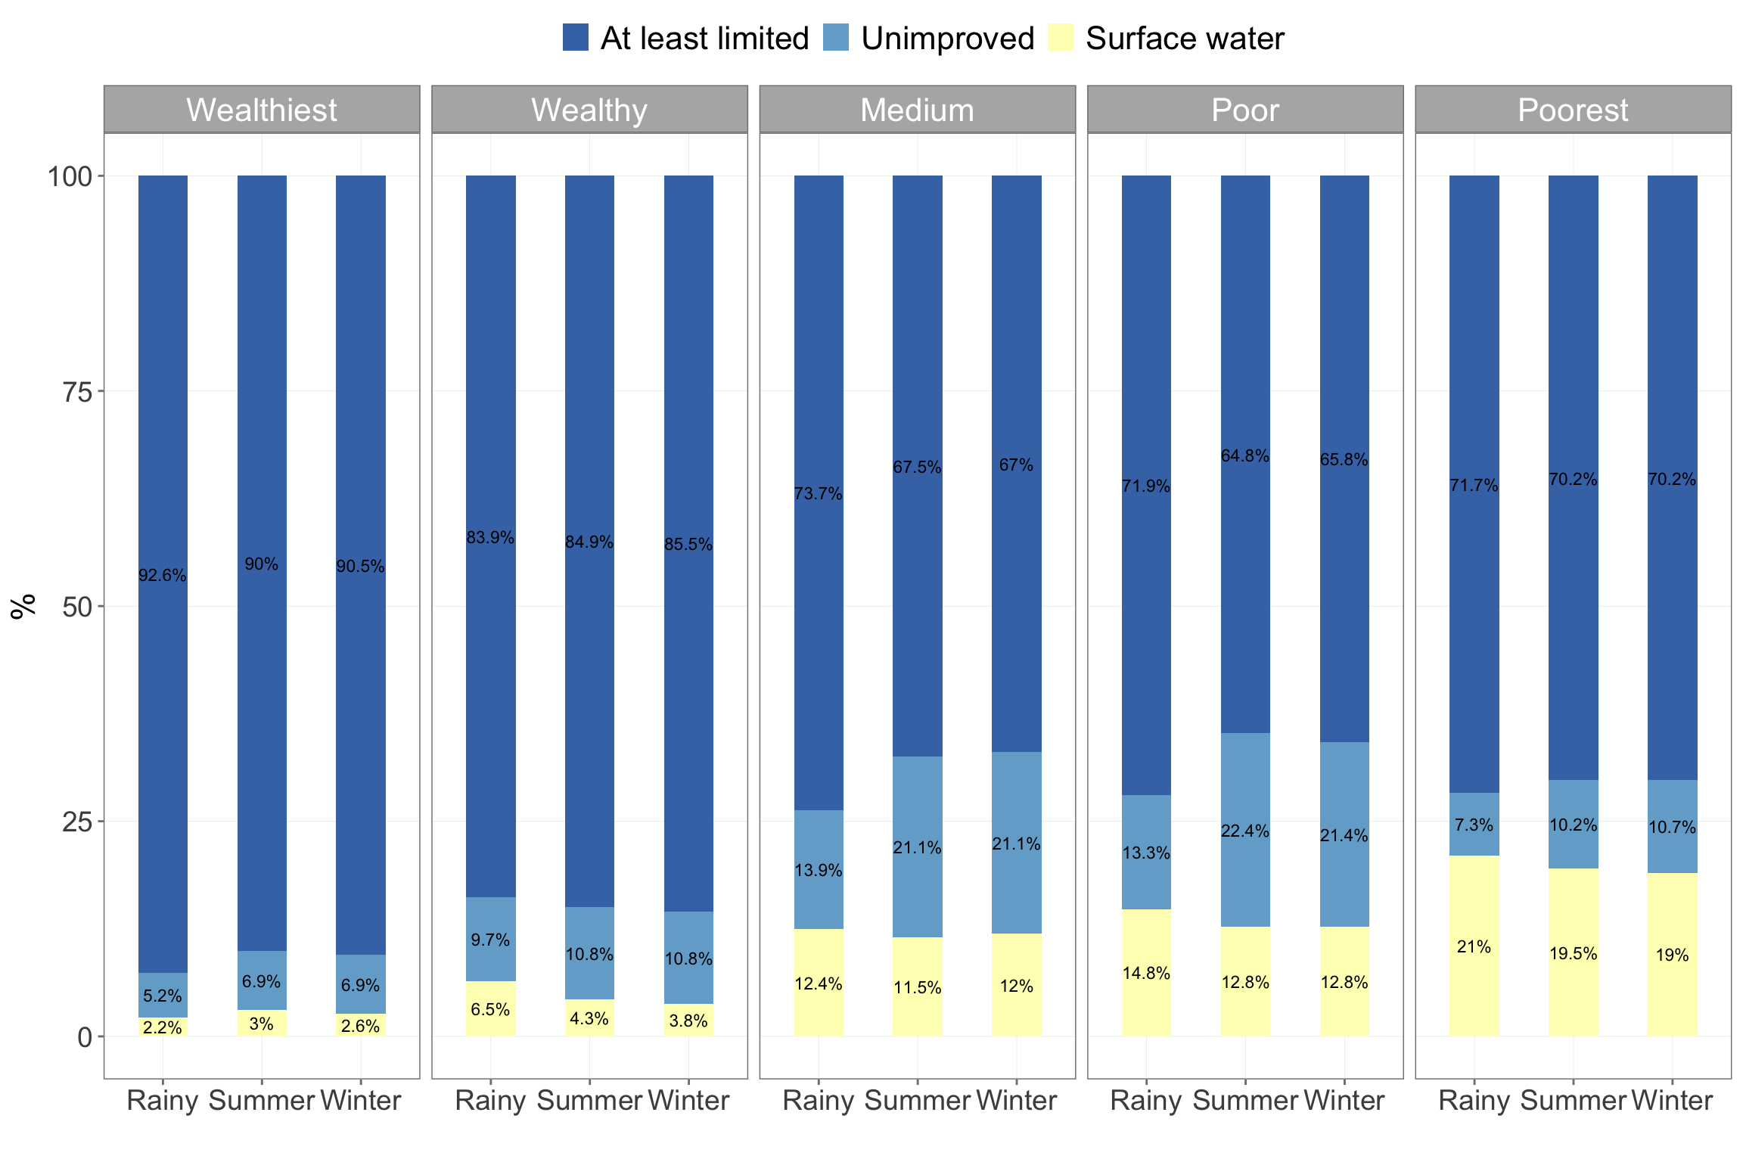

Figure 4.17: Water services ladder by wealth quintiles

#### 4.1.6.2 Sanitation services ladder

Up to 50% of households in Kayah state have at least a limited (improved toilet facility but shared with other households) or basic (improved sanitation facility and not shared with other households) sanitation facilities (see Table 4.7). On the other hand, unimproved sanitation facilities and open defection are used by more households in hard-to-reach areas (see 4.18) and increasingly used as households get poorer (see Figure 4.19). Up to 16% of wealthiest households and 36.6% of wealthy households have unimproved sanitation facialities.

| Table 4.7: Sanitation service ladders | | | | | |
| --- | --- | --- | --- | --- | --- |
|  |  |  |  |  |  |
| **Geographic** | | | | | |
| Kayah | Rural | 7.5 | 42.9 | 49.2 | 0.3 |
| Urban | 26.2 | 47.4 | 25.6 | 0.3 |
| Hard-to-reach | 4.1 | 27.4 | 47.7 | 20.0 |
| **Wealth** | | | | |
| Wealthiest | 26.8 | 56.3 | 16.0 | 0.0 |
| Wealthy | 17.2 | 46.2 | 36.6 | 0.0 |
| Medium | 8.6 | 34.9 | 53.6 | 2.9 |
| Poor | 5.1 | 31.1 | 56.6 | 6.6 |
| Poorest | 3.4 | 23.9 | 44.4 | 27.3 |  |

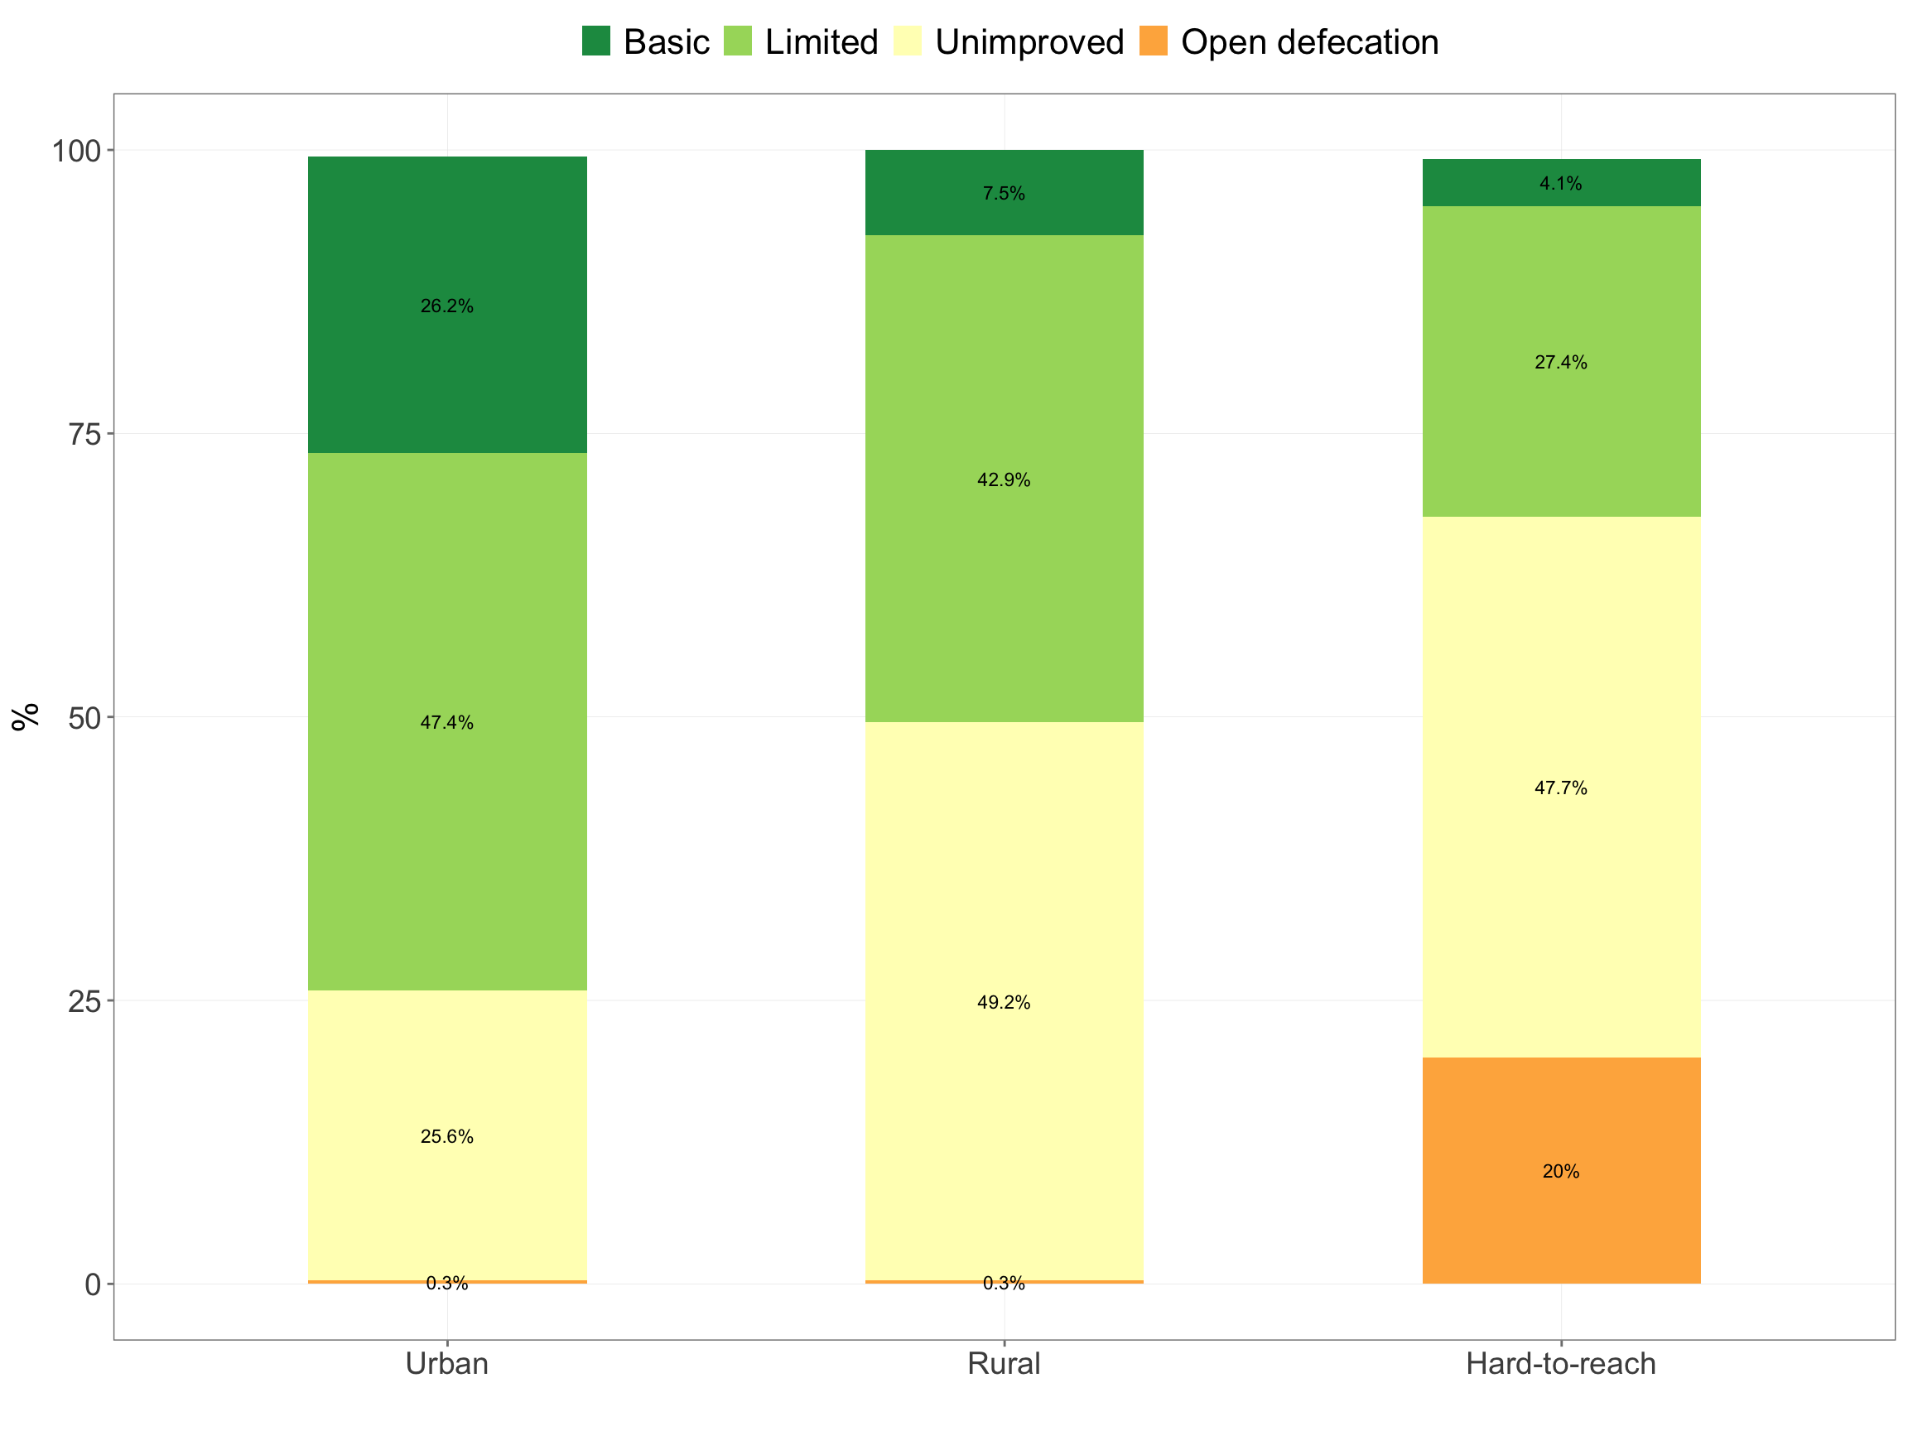

Figure 4.18: Sanitation services ladder by location type

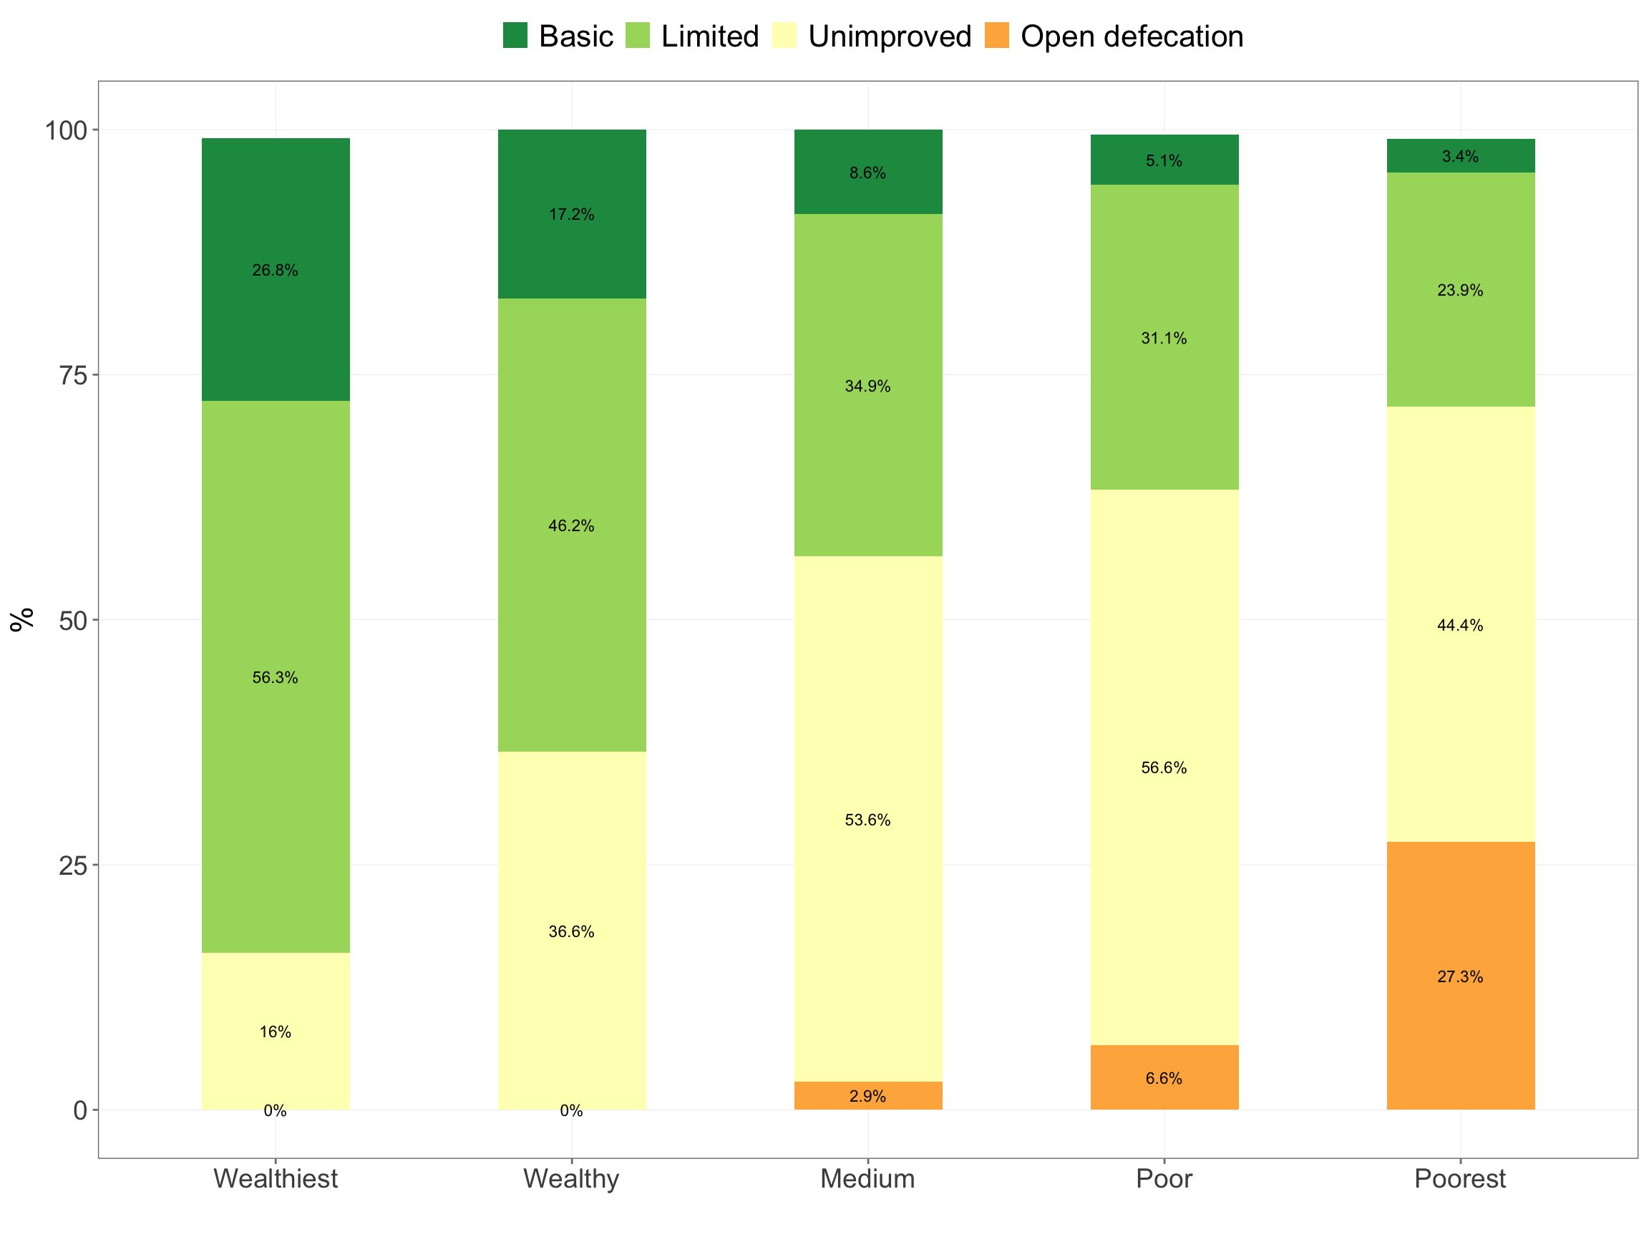

Figure 4.19: Water services ladder by wealth quintiles

#### 4.1.6.3 Handwashing service ladders

Access to basic (handwashing facilities with water and soap) handwashing facilities is as high as 89.8% in urban areas and 86.2% in rural areas. Hard-to-reach areas on the other hand have much lower access to basic facilities and with the highest proportion of households with no facilities at all (see Figure 4.20). The same trend exists as households get poorer with the poorest households having low levels of access to basic handwashing facilities and highest levels of no handwashing facilities (see Figure 4.21).

| Table 4.8: Handwashing service ladders | | | | |
| --- | --- | --- | --- | --- |
|  |  |  |  |  |
| **Geographic** | | | | |
| Kayah | Rural | 86.2 | 0.0 | 4.7 |
| Urban | 89.8 | 0.0 | 2.9 |
| Hard-to-reach | 38.4 | 2.7 | 10.6 |
| **Wealth** | | | |
| Wealthiest | 90.9 | 0.0 | 4.3 |
| Wealthy | 91.4 | 0.0 | 3.2 |
| Medium | 81.3 | 1.0 | 2.9 |
| Poor | 58.7 | 1.0 | 7.1 |
| Poorest | 28.8 | 2.9 | 13.7 |  |

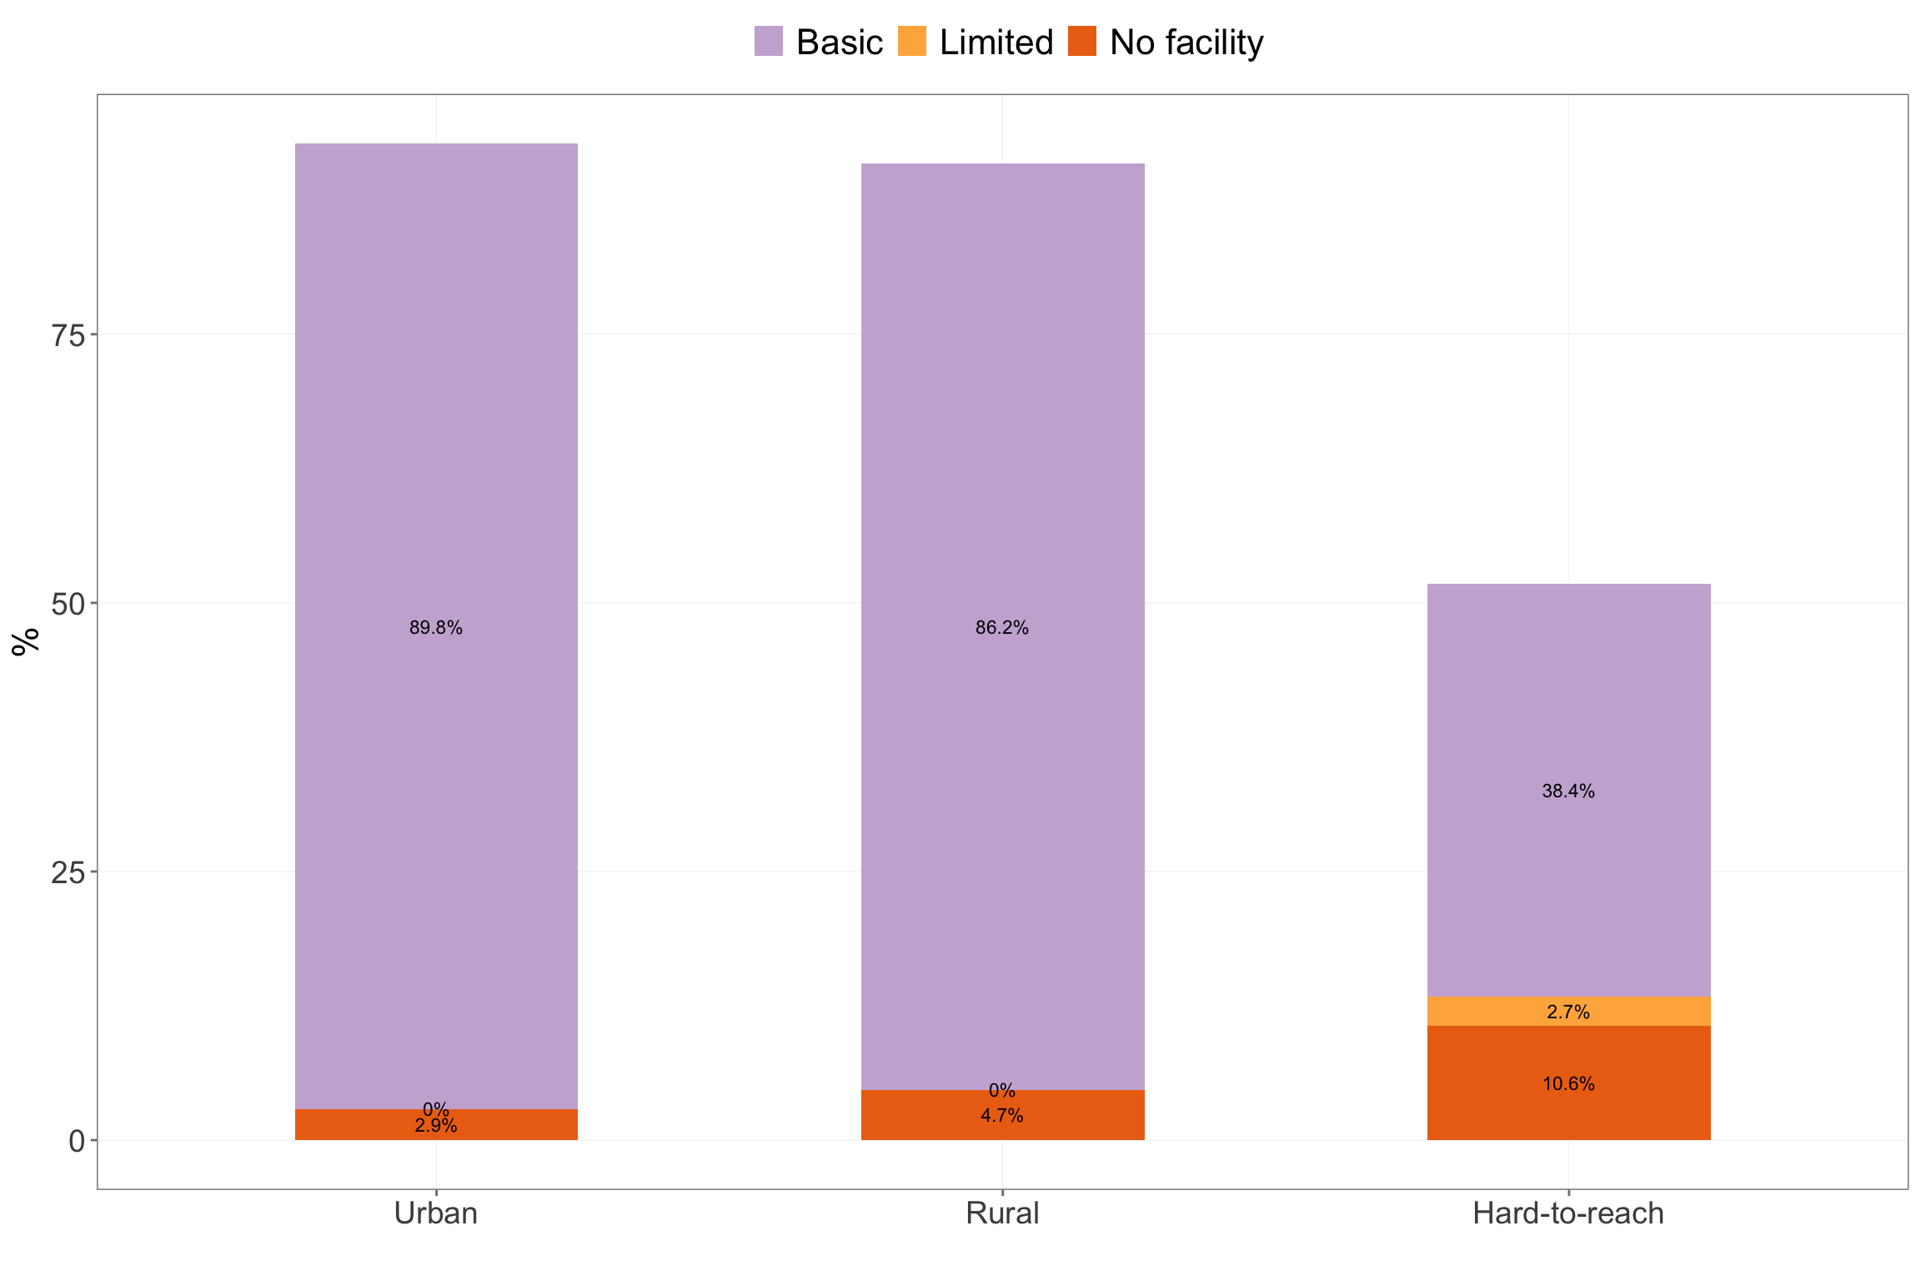

Figure 4.20: Handwashing services ladder by location type

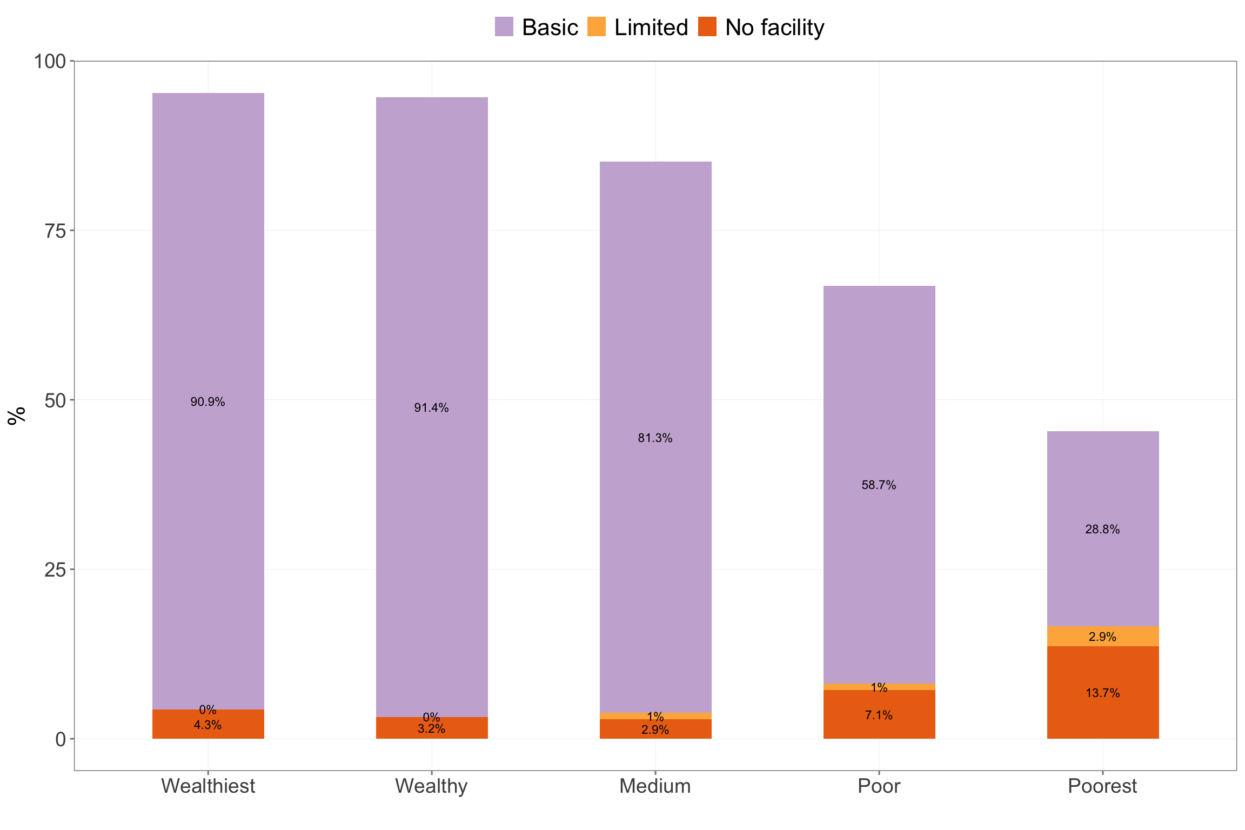

Figure 4.21: Handwashing services ladder by wealth quintiles

### 4.1.7 Child health

#### 4.1.7.1 Immunisation coverage

Immunisation coverage in Kayah state tells a story of good initial access to immunisation services with hight rates of BCG vaccination. However, utilisation of immunisation services (as proxied by children getting all required pentavalent vaccinations) begins to drop particularly in hard-to-reach areas and then full immunisation coverage drops significantly in all areas but more significantly in hard-to-reach areas (see Figure 4.22).

Per vaccination type coverage is significantly low across the whole of Kayah state (see Table 4.10) with households in hard-to-reach areas and poor and poorest households with the lowest per vaccine type coverage (see Figure 4.24 and Figure 4.25).

Coverage of vitamin A supplementation, a service that is usually delivered together with immunisation, is relatively higher going up to about 70% in urban and rural areas but much lower in hard-to-reach areas (see Figure 4.26) and and lower in poor and poorest households (see Figure 4.27). Deworming coverage is low at only up to 30% in urban and rural areas and considerably lower in hard-to-reach areas (see Figure 4.26) and poor and poorest households (see Figure 4.27).

| Table 4.9: Immunisation coverage | | | | | | | |
| --- | --- | --- | --- | --- | --- | --- | --- |
|  |  |  |  |  |  |  |  |
| **Geographic** | | | | | | | |
| Kayah | Rural | 100.0 | 89.7 | 97.1 | 83.8 | 32.4 | 56.8 |
| Urban | 100.0 | 92.3 | 93.4 | 87.9 | 34.1 | 72.8 |
| Hard-to-reach | 89.7 | 49.0 | 86.3 | 32.5 | 8.5 | 21.3 |
| **Wealth** | | | | | | |
| Wealthiest | 100.0 | 93.2 | 93.2 | 90.9 | 36.4 | 72.3 |
| Wealthy | 100.0 | 92.2 | 95.3 | 85.9 | 29.7 | 58.8 |
| Medium | 100.0 | 60.0 | 98.0 | 52.0 | 24.0 | 50.4 |
| Poor | 89.8 | 72.7 | 82.0 | 56.0 | 12.0 | 23.7 |
| Poorest | 87.9 | 51.0 | 86.2 | 31.0 | 10.3 | 21.2 |  |

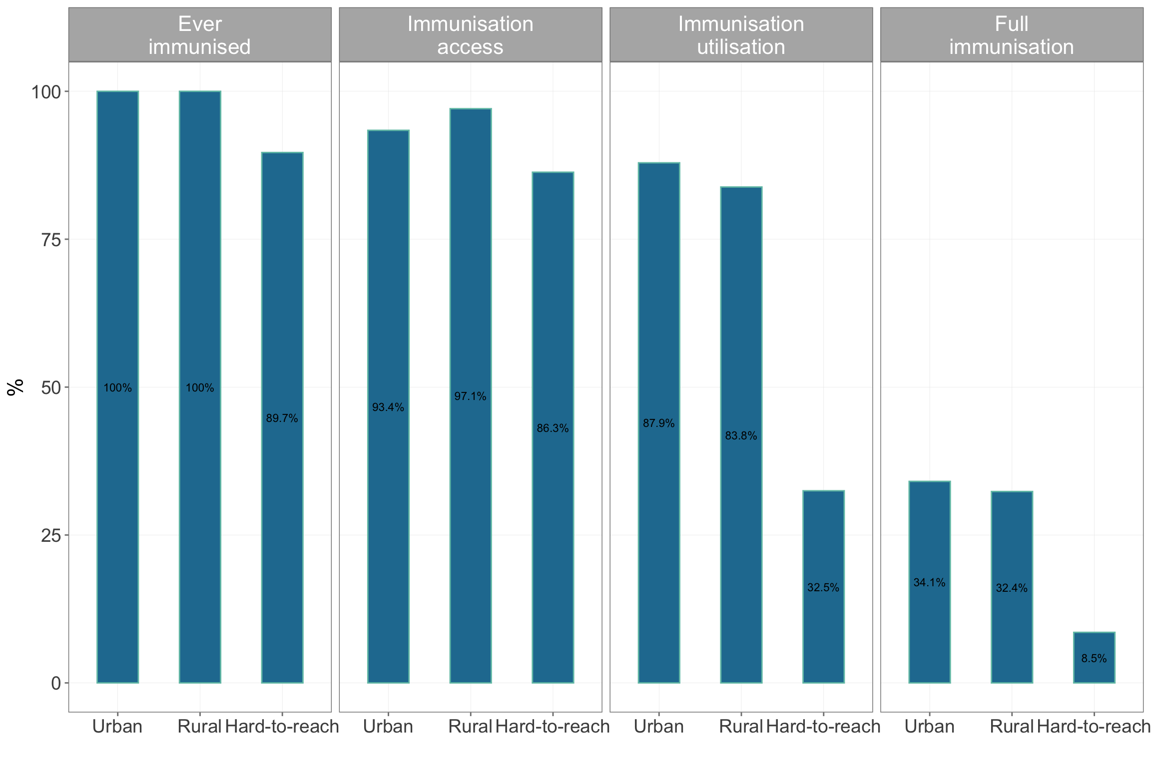

Figure 4.22: Immunisation coverage by location type

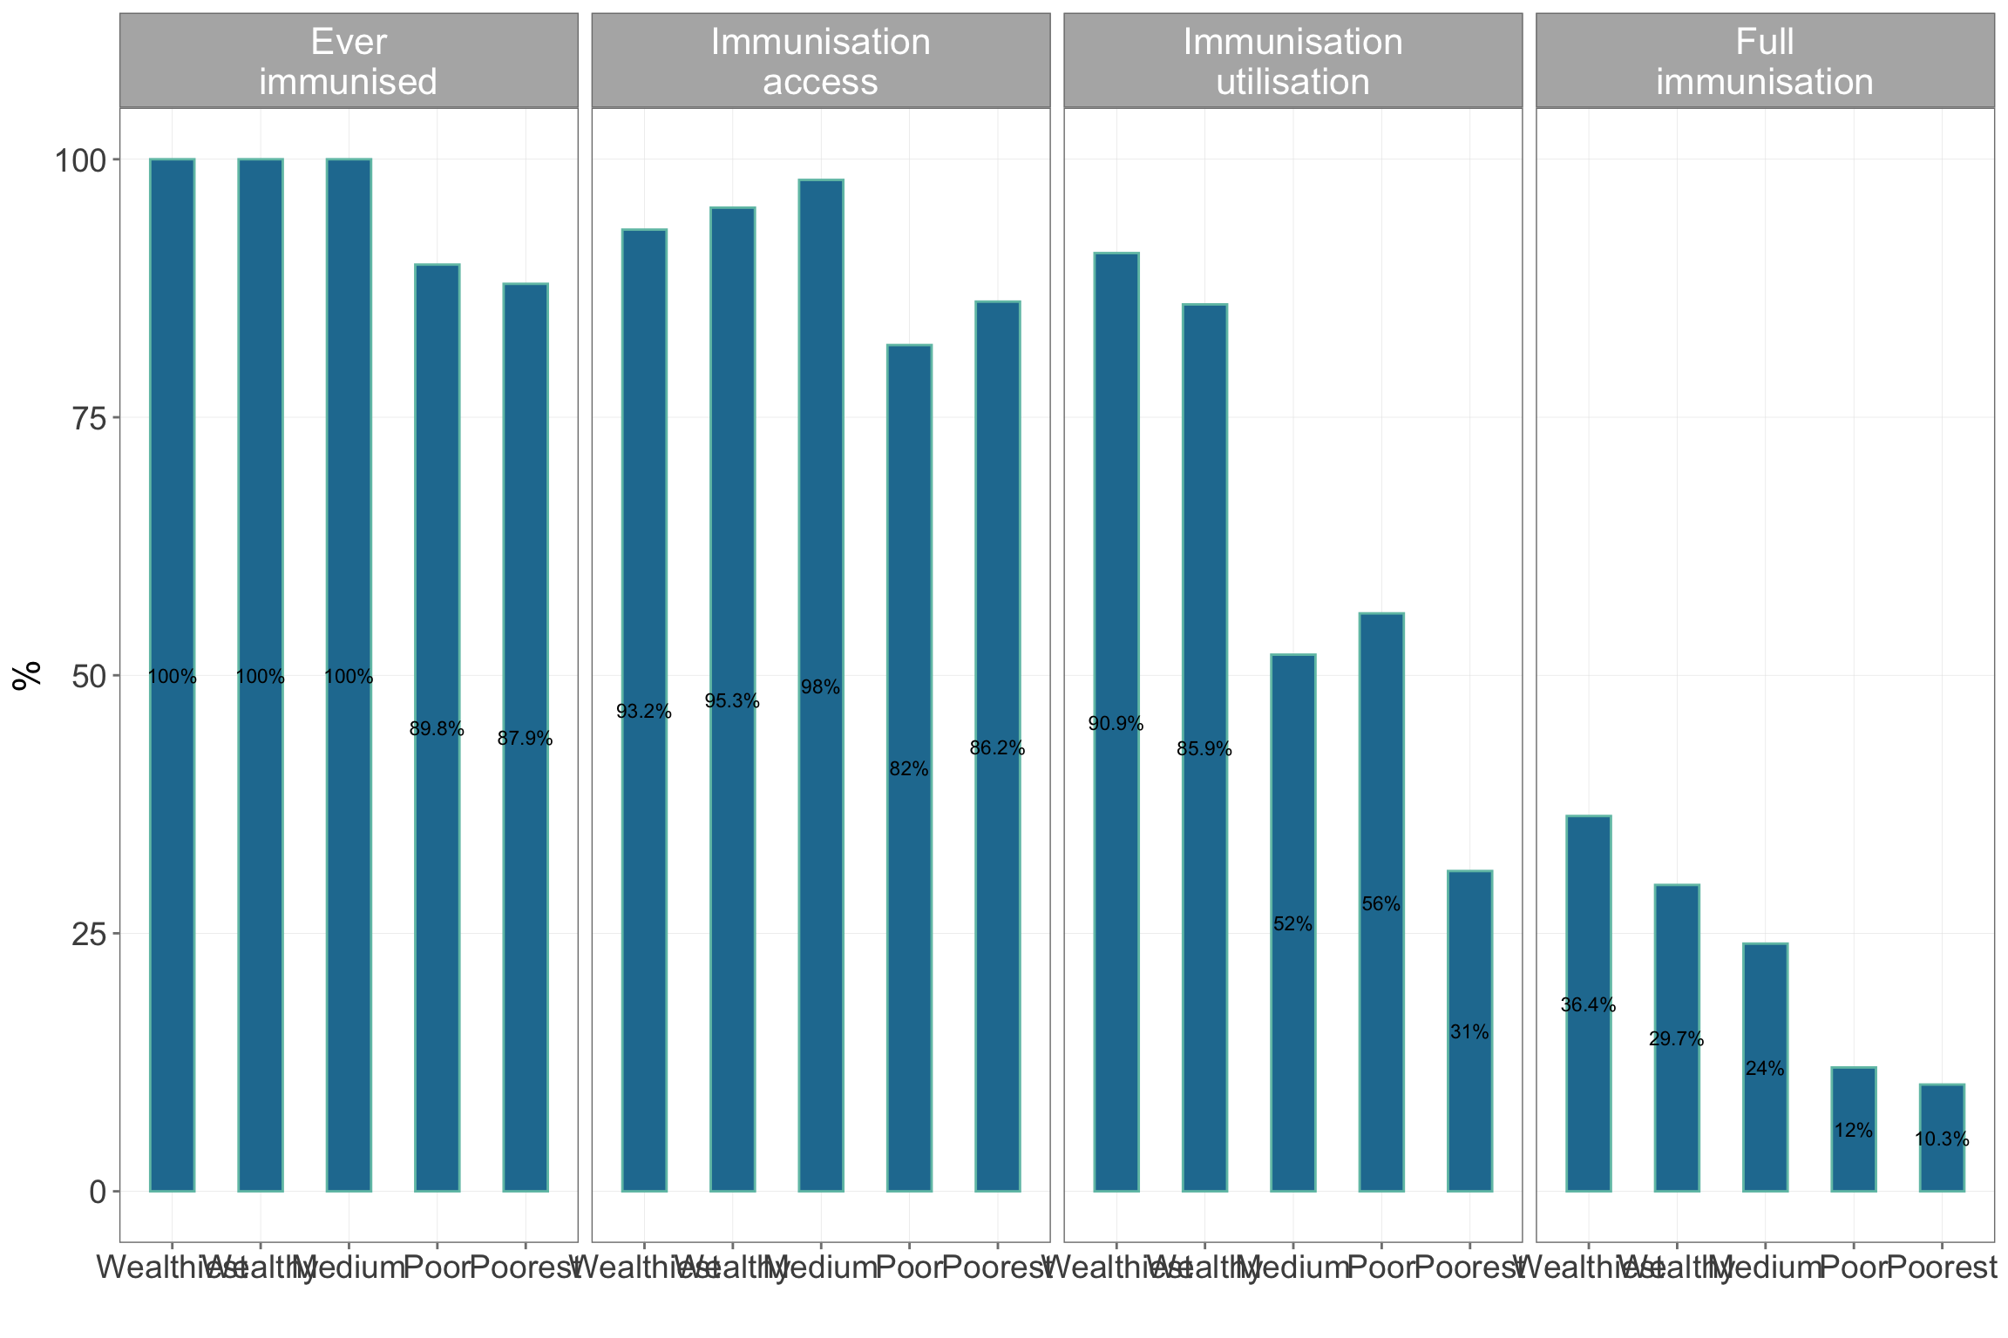

Figure 4.23: Immunisation coverage by wealth quintiles

| Table 4.10: Immunisation coverage per vaccine type | | | | | | | | | | | | | | |
| --- | --- | --- | --- | --- | --- | --- | --- | --- | --- | --- | --- | --- | --- | --- |
|  |  |  |  |  |  |  |  |  |  |  |  |  |  |  |
| **Geographic** | | | | | | | | | | | | | | |
| Kayah | Rural | 17.1 | 11.9 | 15.2 | 15.8 | 15.2 | 15.5 | 15.8 | 14.7 | 15.2 | 15.5 | 7.2 | 14.5 | 11.1 |
| Urban | 20.6 | 16.2 | 20.1 | 20.1 | 19.6 | 20.1 | 19.1 | 18.6 | 19.9 | 17.9 | 10.9 | 14.5 | 15.3 |
| Hard-to-reach | 18.6 | 6.1 | 7.9 | 7.7 | 7.4 | 8.1 | 7.6 | 6.5 | 7.7 | 6.6 | 4.8 | 8.5 | 5.7 |
| **Wealth** | | | | | | | | | | | | | |
| Wealthiest | 17.7 | 14.7 | 17.7 | 17.7 | 17.3 | 17.7 | 16.5 | 15.6 | 17.3 | 16.0 | 9.1 | 13.9 | 12.6 |
| Wealthy | 22.8 | 17.2 | 21.3 | 22.1 | 21.3 | 22.1 | 21.7 | 20.2 | 22.1 | 20.6 | 12.0 | 16.1 | 17.2 |
| Medium | 16.4 | 7.4 | 9.7 | 9.7 | 9.0 | 9.0 | 9.0 | 8.7 | 9.0 | 8.7 | 5.4 | 9.0 | 7.0 |
| Poor | 17.2 | 7.9 | 12.1 | 12.1 | 11.7 | 12.6 | 13.0 | 11.7 | 12.1 | 10.9 | 5.4 | 10.9 | 6.3 |
| Poorest | 18.8 | 6.4 | 7.9 | 7.5 | 7.5 | 8.3 | 7.1 | 6.4 | 7.9 | 7.1 | 5.3 | 9.8 | 7.5 |  |

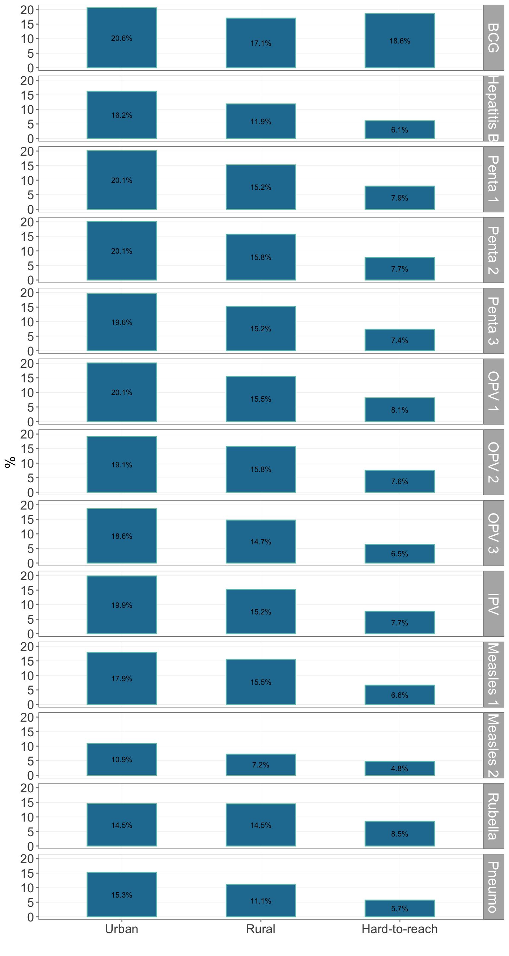

Figure 4.24: Immunisation coverage per vaccine by location type

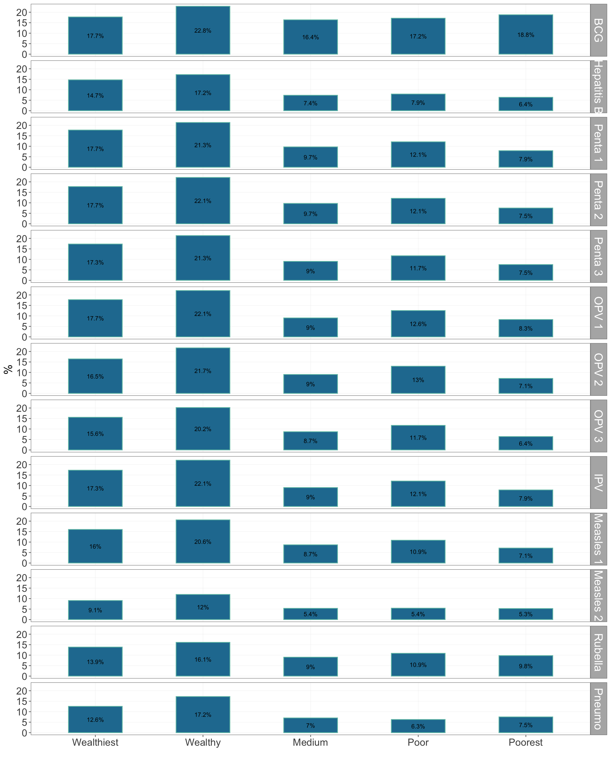

Figure 4.25: Immunisation coverage per vaccine by wealth quintiles

| Table 4.11: Coverage of immunisation-associated services | | | |
| --- | --- | --- | --- |
|  |  |  |  |
| **Geographic** | | | |
| Kayah | Rural | 72.6 | 28.1 |
| Urban | 71.7 | 27.2 |
| Hard-to-reach | 47.3 | 16.7 |
| **Wealth** | | |
| Wealthiest | 68.3 | 21.8 |
| Wealthy | 71.1 | 34.2 |
| Medium | 67.3 | 16.8 |
| Poor | 52.7 | 22.6 |
| Poorest | 45.8 | 20.3 |  |

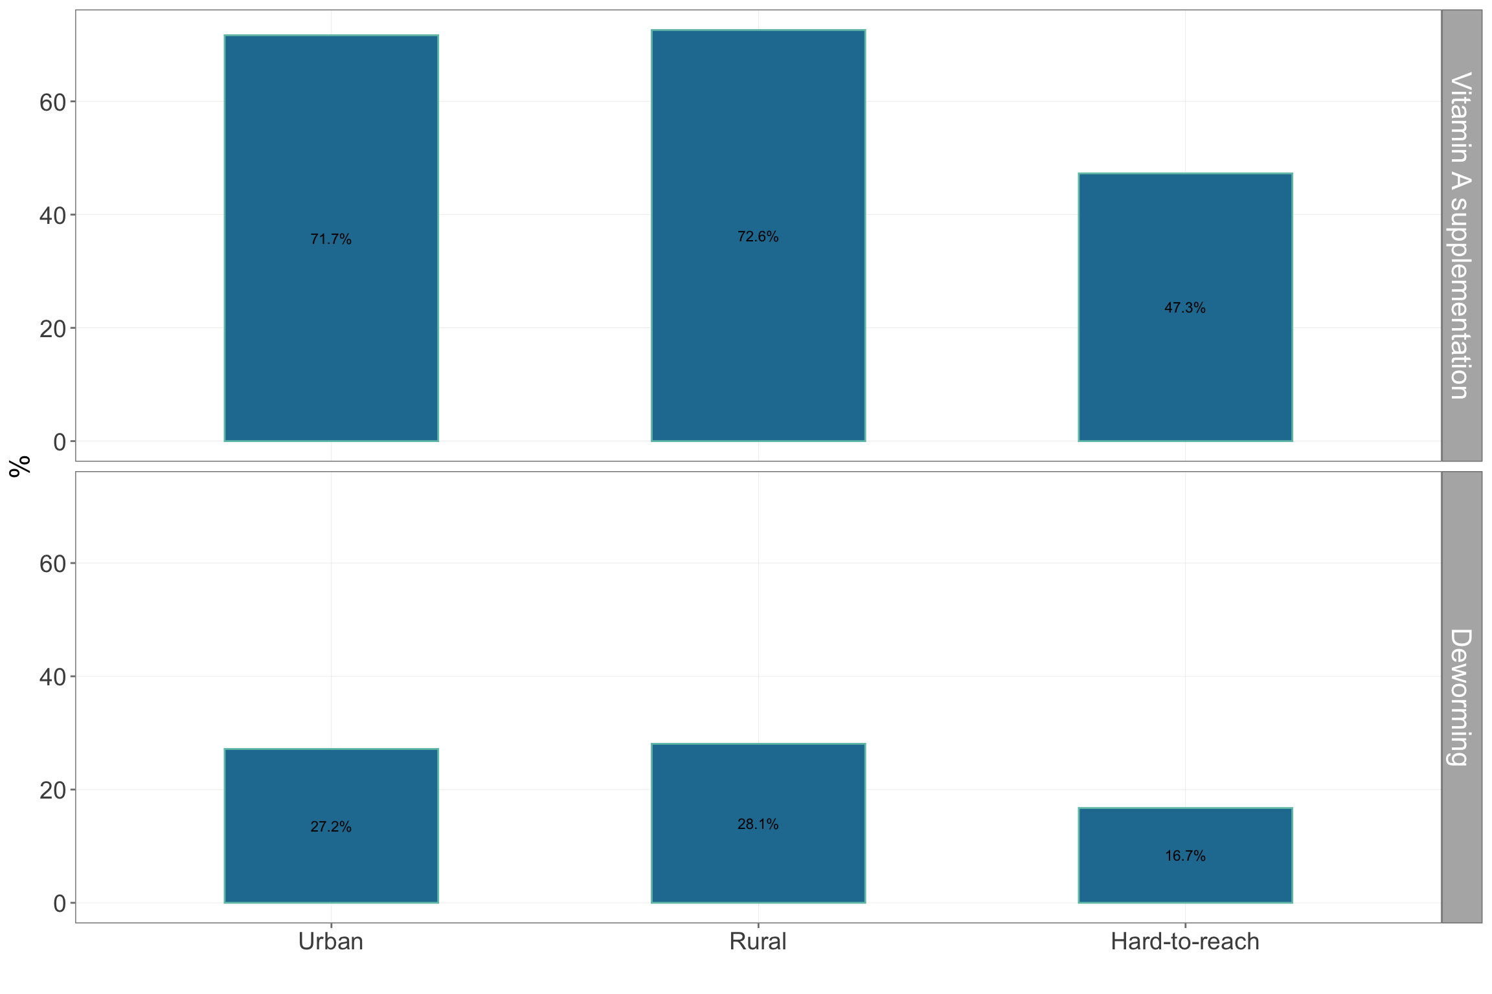

Figure 4.26: Immunisation-associated services coverage by location type

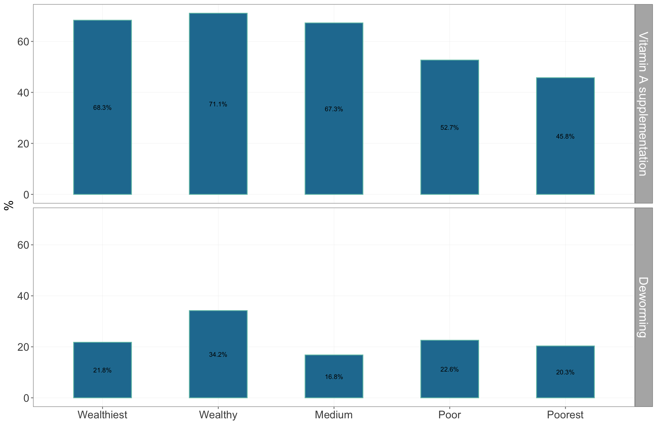

Figure 4.27: Immunisation-associated services coverage by wealth quintiles

### 4.1.8 Period prevalence of childhood illnesses

Fever is the most self-reported illness in children 6-59 months old with 22% of mothers reporting fever in their children in the past 2 weeks in urban areas and by 15% of mothers in rural and hard-to-reach areas (see Figure 4.28). The wealtheir households also report fever the most at 17.8% for wealthiest and 22.6 for wealthy households compared to 13.6% for poor and 15.3 for poorest households (see Figure 4.29).

Diarrhoea is the next most self-reported illness in children 6-59 months old with 16.6% of mothers in rural areas and 15.6% in hard-to-reach areas reporting diarrhoea in their children in the past 2 weeks (see Figure 4.28. The poorer the household, the more mothers report dirrhoea in their children (see Figure 4.29).

ARI is the least self-reported illness in children 6-59 months old with 2% and 1.5% of mothers in urban and rural areas reporting cough in their children in the past 2 weeks. Those in hard-to-reach areas report ARI the most at 6.5% (see Figure 4.28. The poorest households reported the most ARI in children at 9.2% (see Figure 4.29).

| Table 4.12: Period prevalence of childhood illnesses | | | | |
| --- | --- | --- | --- | --- |
|  |  |  |  |  |
| **Geographic** | | | | |
| Kayah | Rural | 1.5 | 16.6 | 15.7 |
| Urban | 1.9 | 10.1 | 21.5 |
| Hard-to-reach | 6.5 | 15.6 | 15.6 |
| **Wealth** | | | |
| Wealthiest | 1.9 | 12.2 | 17.8 |
| Wealthy | 0.9 | 13.7 | 22.6 |
| Medium | 3.8 | 15.2 | 18.6 |
| Poor | 2.5 | 14.6 | 13.6 |
| Poorest | 9.2 | 15.7 | 15.3 |  |

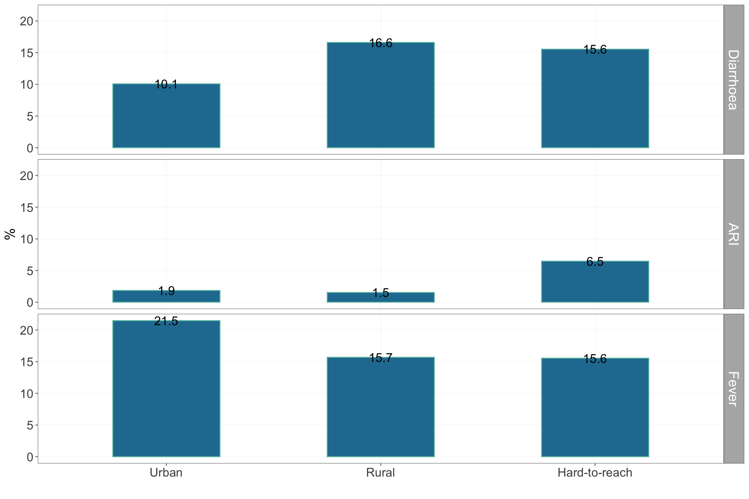

Figure 4.28: Period prevalence of childhood illnesses by location type

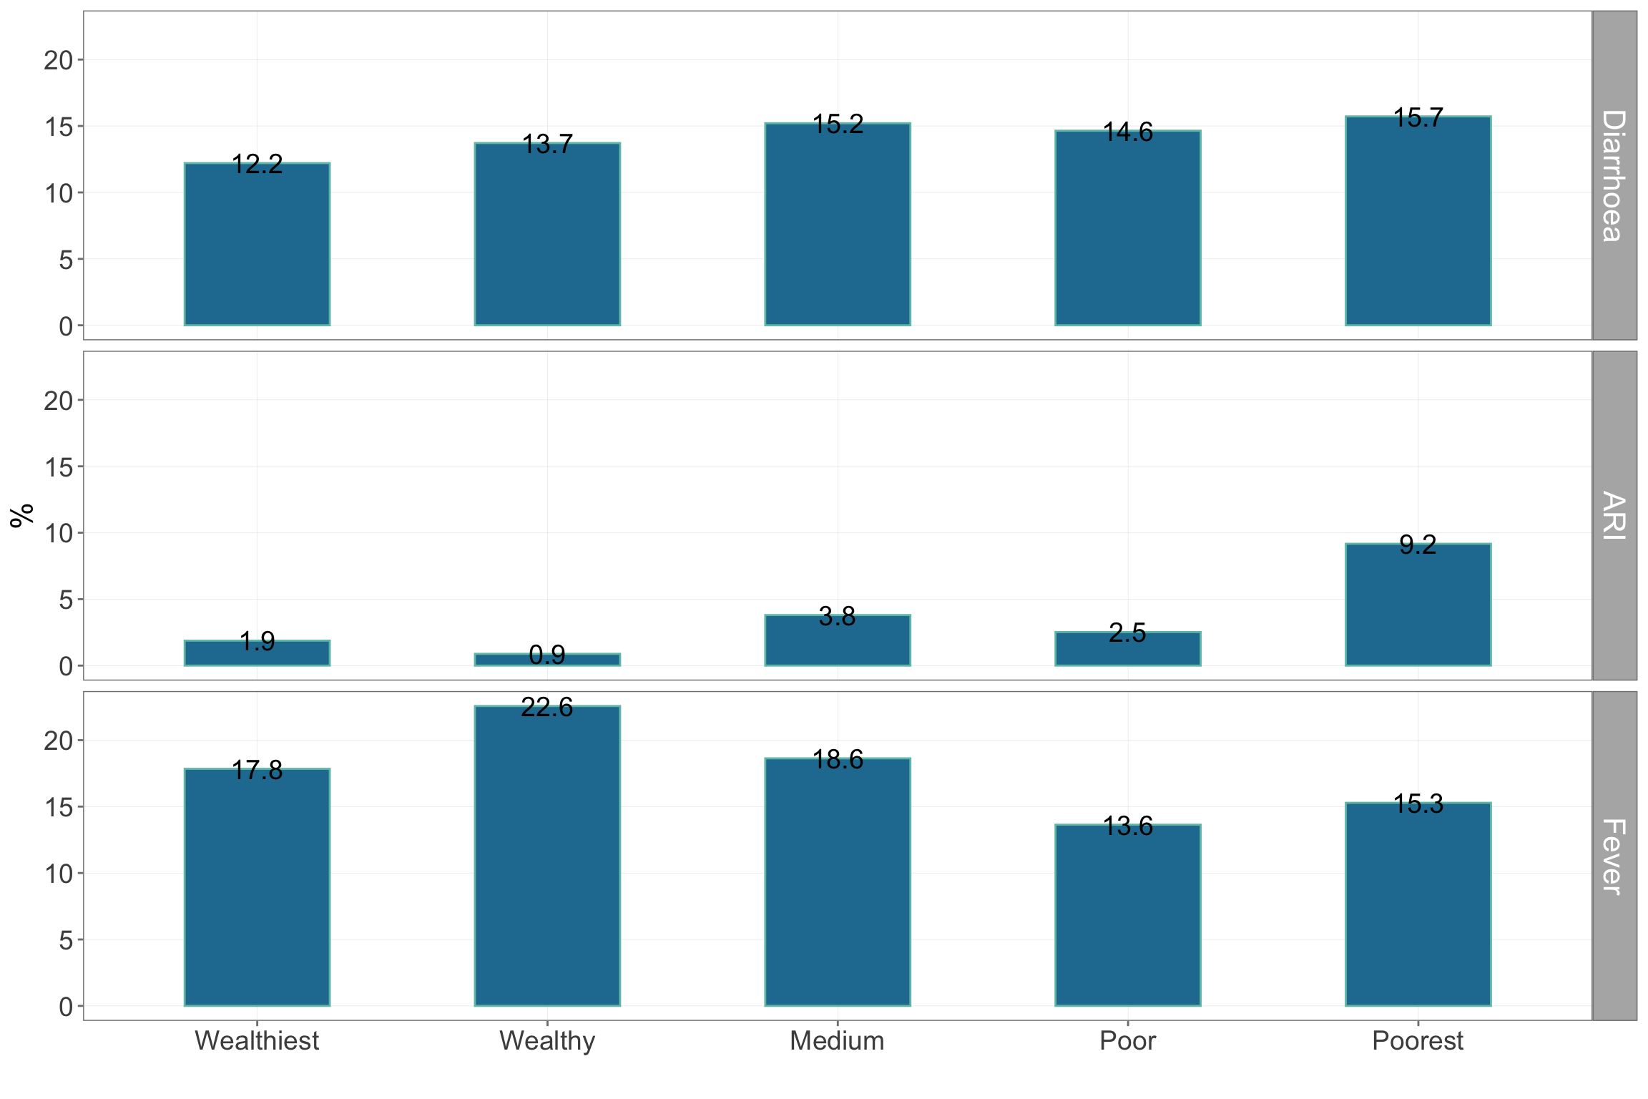

Figure 4.29: Period prevalence of childhood illnesses by wealth quintiles

### 4.1.9 Treatment-seeking behaviour

#### 4.1.9.1 Diarrhoea

Treatment-seeking for diarrhoea in Kayah state can be characterised by households in rural areas seeking treatment the most (100%) whilst those in urban and hard-to-reach areas seeking treatment significantly much less (see Figure 4.30). When asked why treatment was not sought for diarrhoea, those from the urban areas were advised not to seek treatment whilst those in hard-to-reach areas reported not having a facility as the reason for not seeking treatment (see Figure 4.31). Comparing these reasons, those from the urban areas seem to not seek care by choice (chose not to) rather than by circumstance (no choice as there is no facility from which to seek treatment). Time to treatment is usually longer for those in hard-to-reach areas compared to those in rural and urban areas and those who are poor and poorest compared to the wealthy and wealthiest (see Table 4.13).

Those from urban areas tended to either self-medicate (bought drug from shop) or went to a private doctor whilst those from rural and hard-to-reach areas predominantly went to their SRHC/midwife (see Figure **??**). Costs incurred for treatment were all for medications (see Table 4.15).

| Table 4.13: Treatment-seeking for diarrhoea | | | | | | | | | | |
| --- | --- | --- | --- | --- | --- | --- | --- | --- | --- | --- |
|  | | | | **Reasons for not seeking treatment** | | | | | | |
|  |  |  |  |  |  |  |  |  |  |  |
| **Geographic** | | | | | | | | | | |
| Kayah | Rural | 100.0 | 1.4 | 0.0 | 0.0 | 0.0 | 0.0 | 0 | 0.0 | 0 |
| Urban | 57.1 | 0.9 | 0.0 | 0.0 | 0.0 | 0.0 | 0 | 33.3 | 0 |
| Hard-to-reach | 66.7 | 3.7 | 11.8 | 41.2 | 17.6 | 5.9 | 0 | 0.0 | 0 |
| **Wealth** | | | | | | | | | |
| Wealthiest | 75.0 | 1.7 | 0.0 | 0.0 | 0.0 | 0.0 | 0 | 0.0 | 0 |
| Wealthy | 50.0 | 0.7 | 0.0 | 0.0 | 0.0 | 0.0 | 0 | 33.3 | 0 |
| Medium | 80.0 | 1.1 | 0.0 | 33.3 | 0.0 | 0.0 | 0 | 0.0 | 0 |
| Poor | 40.0 | 2.4 | 25.0 | 25.0 | 0.0 | 0.0 | 0 | 0.0 | 0 |
| Poorest | 71.4 | 4.2 | 8.3 | 41.7 | 25.0 | 8.3 | 0 | 0.0 | 0 |  |

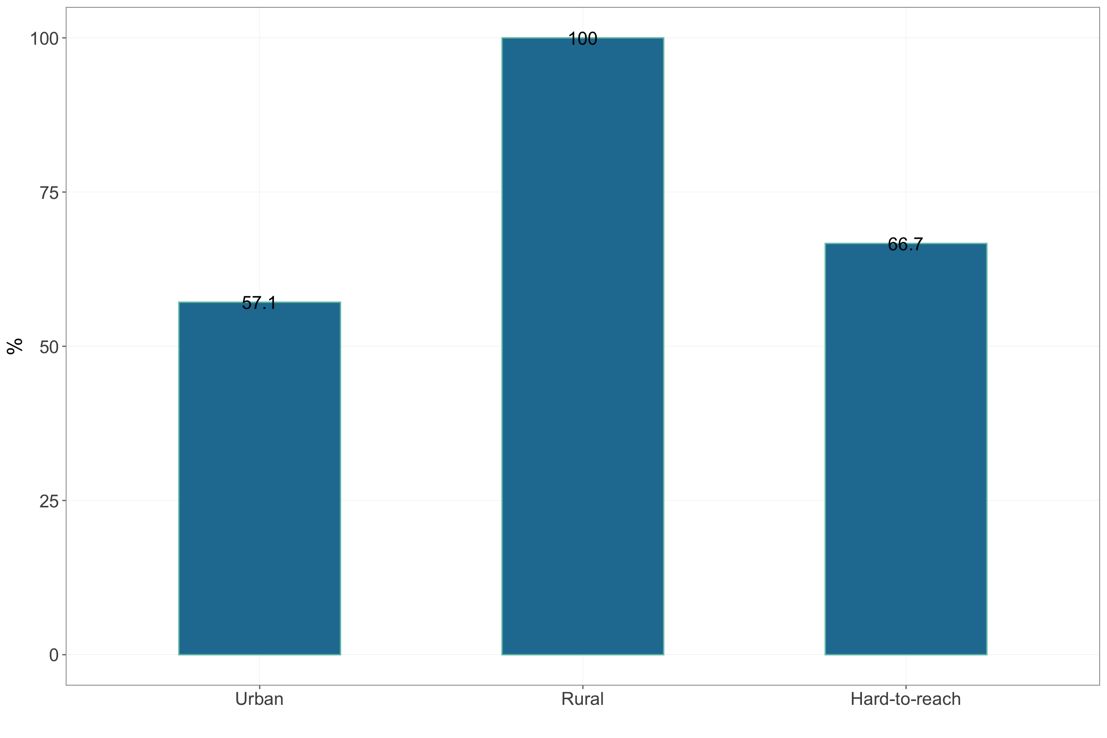

Figure 4.30: Treatment-seeking for diarrhoea by location type

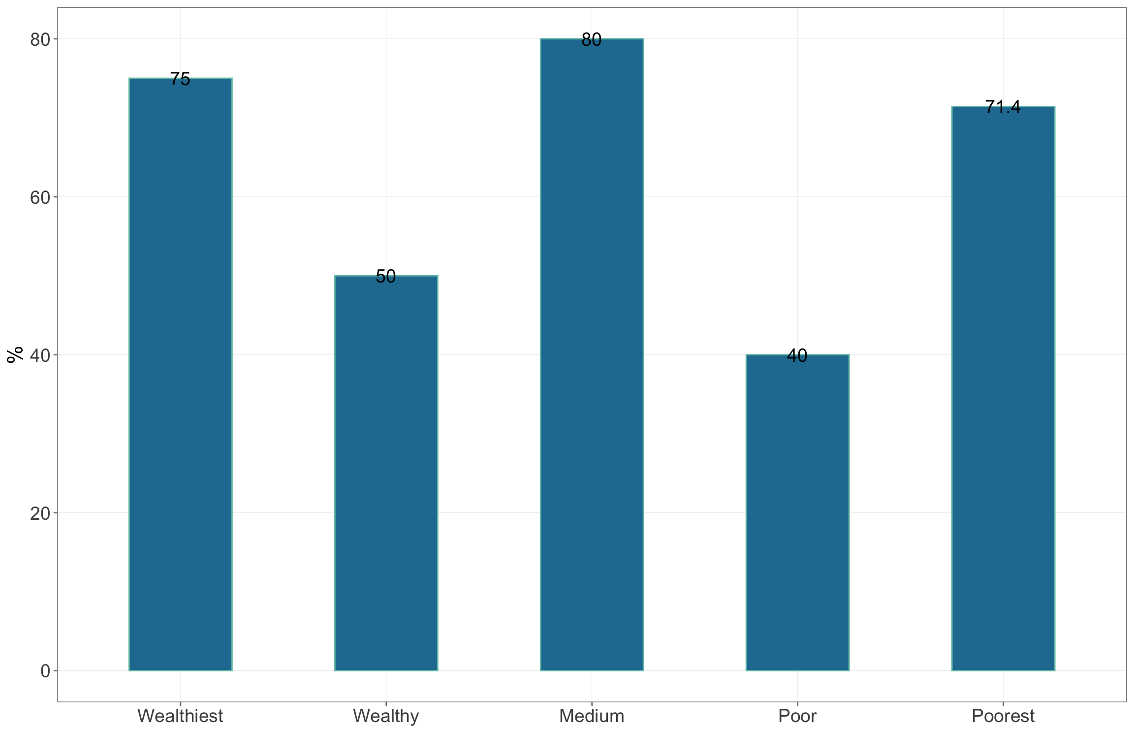

Figure 4.31: Treatment-seeking for diarrhoea by wealth quintiles

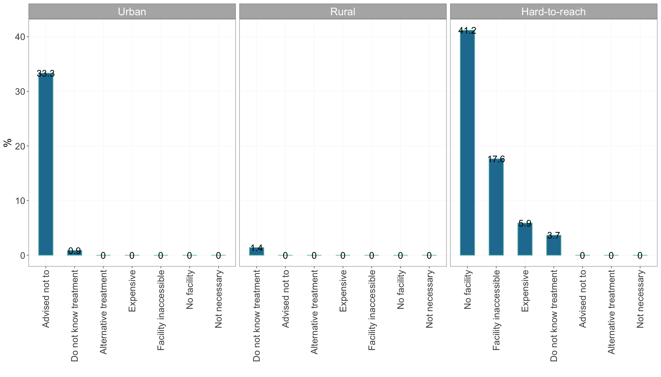

Figure 4.32: Reasons for not seeking treatment by location type

| Table 4.14: Where/who treatment is sought from | | | | | | | | | | | | | | |
| --- | --- | --- | --- | --- | --- | --- | --- | --- | --- | --- | --- | --- | --- | --- |
|  | | **Where/who treatment is sought from** | | | | | | | | | | | | |
|  |  |  |  |  |  |  |  |  |  |  |  |  |  |  |
| **Geographic** | | | | | | | | | | | | | | |
| Kayah | Rural | 17.6 | 5.9 | 11.8 | 41.2 | 0.0 | 0.0 | 0 | 0 | 17.6 | 0.0 | 0 | 5.9 | 0.0 |
| Urban | 12.5 | 0.0 | 0.0 | 0.0 | 25.0 | 0.0 | 0 | 0 | 25.0 | 12.5 | 0 | 0.0 | 0.0 |
| Hard-to-reach | 0.0 | 0.0 | 0.0 | 36.1 | 0.0 | 8.3 | 0 | 0 | 8.3 | 19.4 | 0 | 11.1 | 8.3 |
| **Wealth** | | | | | | | | | | | | | |
| Wealthiest | 28.6 | 0.0 | 14.3 | 42.9 | 0.0 | 0.0 | 0 | 0 | 0.0 | 0.0 | 0 | 0.0 | 0.0 |
| Wealthy | 0.0 | 0.0 | 0.0 | 14.3 | 14.3 | 0.0 | 0 | 0 | 28.6 | 14.3 | 0 | 14.3 | 0.0 |
| Medium | 9.1 | 9.1 | 9.1 | 36.4 | 9.1 | 0.0 | 0 | 0 | 18.2 | 0.0 | 0 | 0.0 | 0.0 |
| Poor | 10.0 | 0.0 | 0.0 | 20.0 | 0.0 | 10.0 | 0 | 0 | 10.0 | 0.0 | 0 | 10.0 | 20.0 |
| Poorest | 0.0 | 0.0 | 0.0 | 38.5 | 0.0 | 7.7 | 0 | 0 | 11.5 | 26.9 | 0 | 11.5 | 3.8 |  |

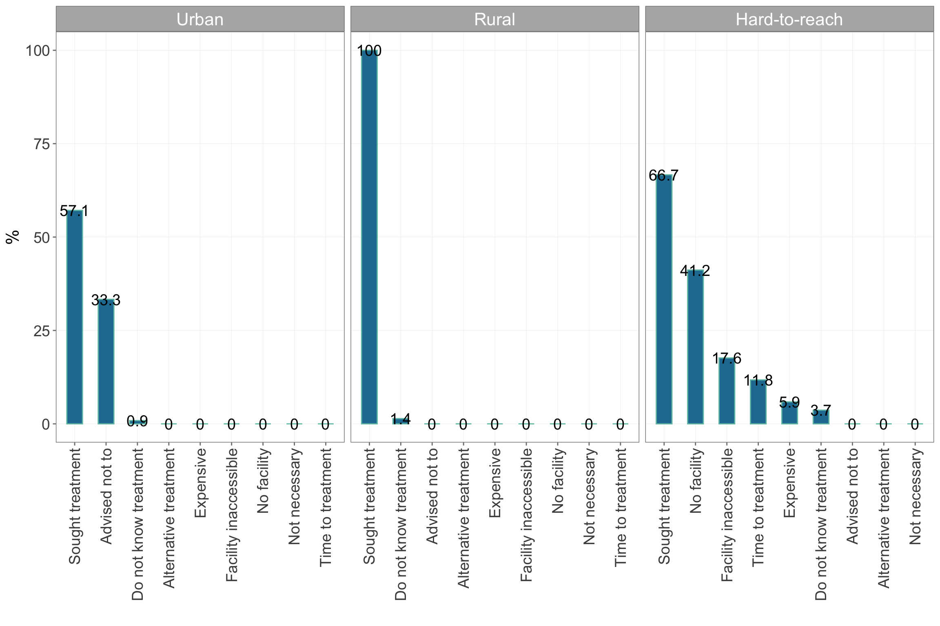

Figure 4.33: Where/who treatment is sought from by location type

| Table 4.15: Payment for treatment | | | | | | | | | |
| --- | --- | --- | --- | --- | --- | --- | --- | --- | --- |
|  | | | **Payment for** | | | | | |  |
|  |  |  |  |  |  |  |  |  |  |
| **Geographic** | | | | | | | | | |
| Kayah | Rural | 10823.5 | 0 | 0 | 100 | 0 | 0 | 0 | 50.0 |
| Urban | 5637.5 | 0 | 0 | 100 | 0 | 0 | 0 | 28.6 |
| Hard-to-reach | 458.3 | 0 | 0 | 100 | 0 | 0 | 0 | 0.0 |
| **Wealth** | | | | | | | | |
| Wealthiest | 13157.1 | NaN | NaN | NaN | NaN | NaN | NaN | 40.0 |
| Wealthy | 5928.6 | 0 | 0 | 100 | 0 | 0 | 0 | 33.3 |
| Medium | 8227.3 | 0 | 0 | 100 | 0 | 0 | 0 | 42.9 |
| Poor | 950.0 | 0 | 0 | 100 | 0 | 0 | 0 | 25.0 |
| Poorest | 461.5 | 0 | 0 | 100 | 0 | 0 | 0 | 0.0 |  |

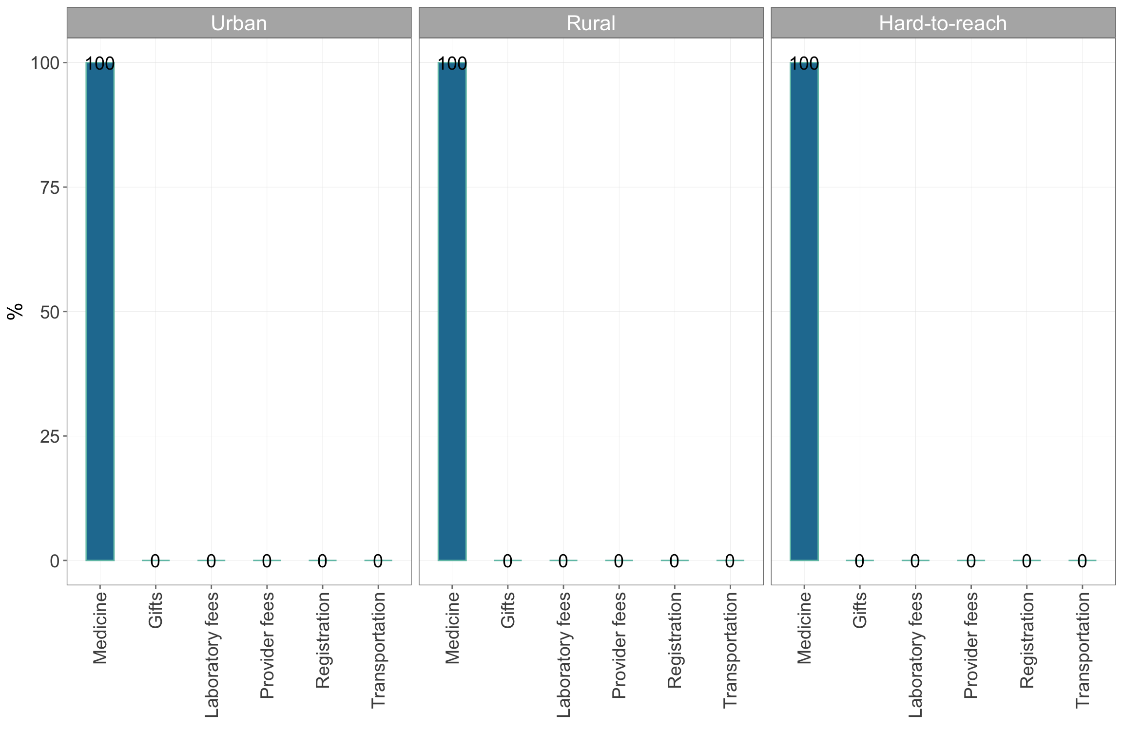

Figure 4.34: Costs incurred for treatment

#### 4.1.9.2 Acute respiratory infection

Treatment-seeking for ARI in Kayah state can be characterised by households in rural areas seeking treatment the most (88.9%) whilst those in urban and hard-to-reach areas seeking treatment less (see Figure 4.35). When asked why treatment was not sought for ARI, those from the urban areas were advised not to seek treatment and could not access the health facility whilst those in hard-to-reach areas reported not having a facility and not having access to facility as the reasons for not seeking treatment (see Figure 4.36). Comparing these reasons, those from the urban areas seem to not seek care by choice (chose not to) rather than by circumstance (no choice as there is no facility from which to seek treatment). Time to treatment is usually longer for those in hard-to-reach areas compared to those in rural and urban areas and those who are poor and poorest compared to the wealthy and wealthiest (see Table 4.16).

Those from urban areas tended to see a private doctor whilst those from rural and hard-to-reach areas predominantly went to their SRHC/midwife (see Figure **??**). Costs incurred for treatment were majority for medications (see Table 4.18).

| Table 4.16: Treatment-seeking for acute respiratory infection | | | | | | | | | | |
| --- | --- | --- | --- | --- | --- | --- | --- | --- | --- | --- |
|  | | | | **Reasons for not seeking treatment** | | | | | | |
|  |  |  |  |  |  |  |  |  |  |  |
| **Geographic** | | | | | | | | | | |
| Kayah | Rural | 88.9 | 1.1 | 0.0 | 0.0 | 6.2 | 0.0 | 0 | 0.0 | 0.0 |
| Urban | 71.1 | 1.2 | 0.0 | 0.0 | 15.0 | 0.0 | 0 | 15.0 | 0.0 |
| Hard-to-reach | 63.9 | 5.9 | 12.5 | 42.5 | 12.5 | 2.5 | 0 | 2.5 | 2.5 |
| **Wealth** | | | | | | | | | |
| Wealthiest | 69.2 | 1.2 | 0.0 | 0.0 | 0.0 | 0.0 | 0 | 22.2 | 0.0 |
| Wealthy | 83.9 | 1.1 | 0.0 | 0.0 | 0.0 | 0.0 | 0 | 8.3 | 0.0 |
| Medium | 72.5 | 1.5 | 0.0 | 5.9 | 23.5 | 0.0 | 0 | 0.0 | 0.0 |
| Poor | 79.3 | 2.6 | 7.7 | 69.2 | 23.1 | 0.0 | 0 | 0.0 | 0.0 |
| Poorest | 63.9 | 10.0 | 17.4 | 30.4 | 8.7 | 4.3 | 0 | 4.3 | 4.3 |  |

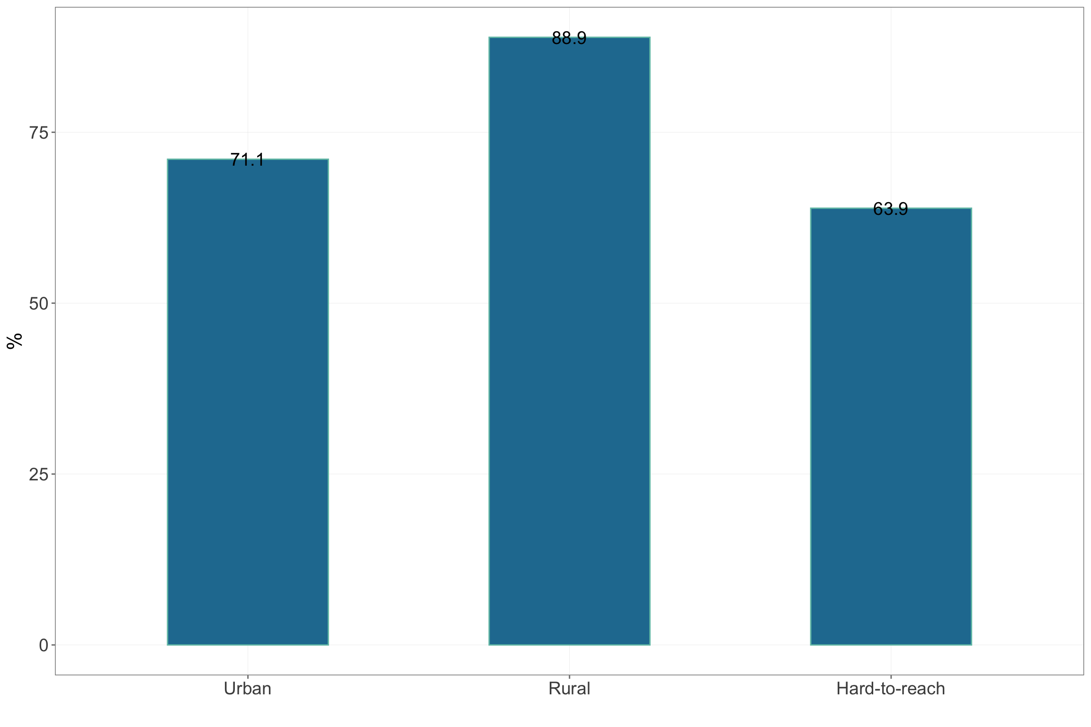

Figure 4.35: Treatment-seeking for acute respiratory infection by location type

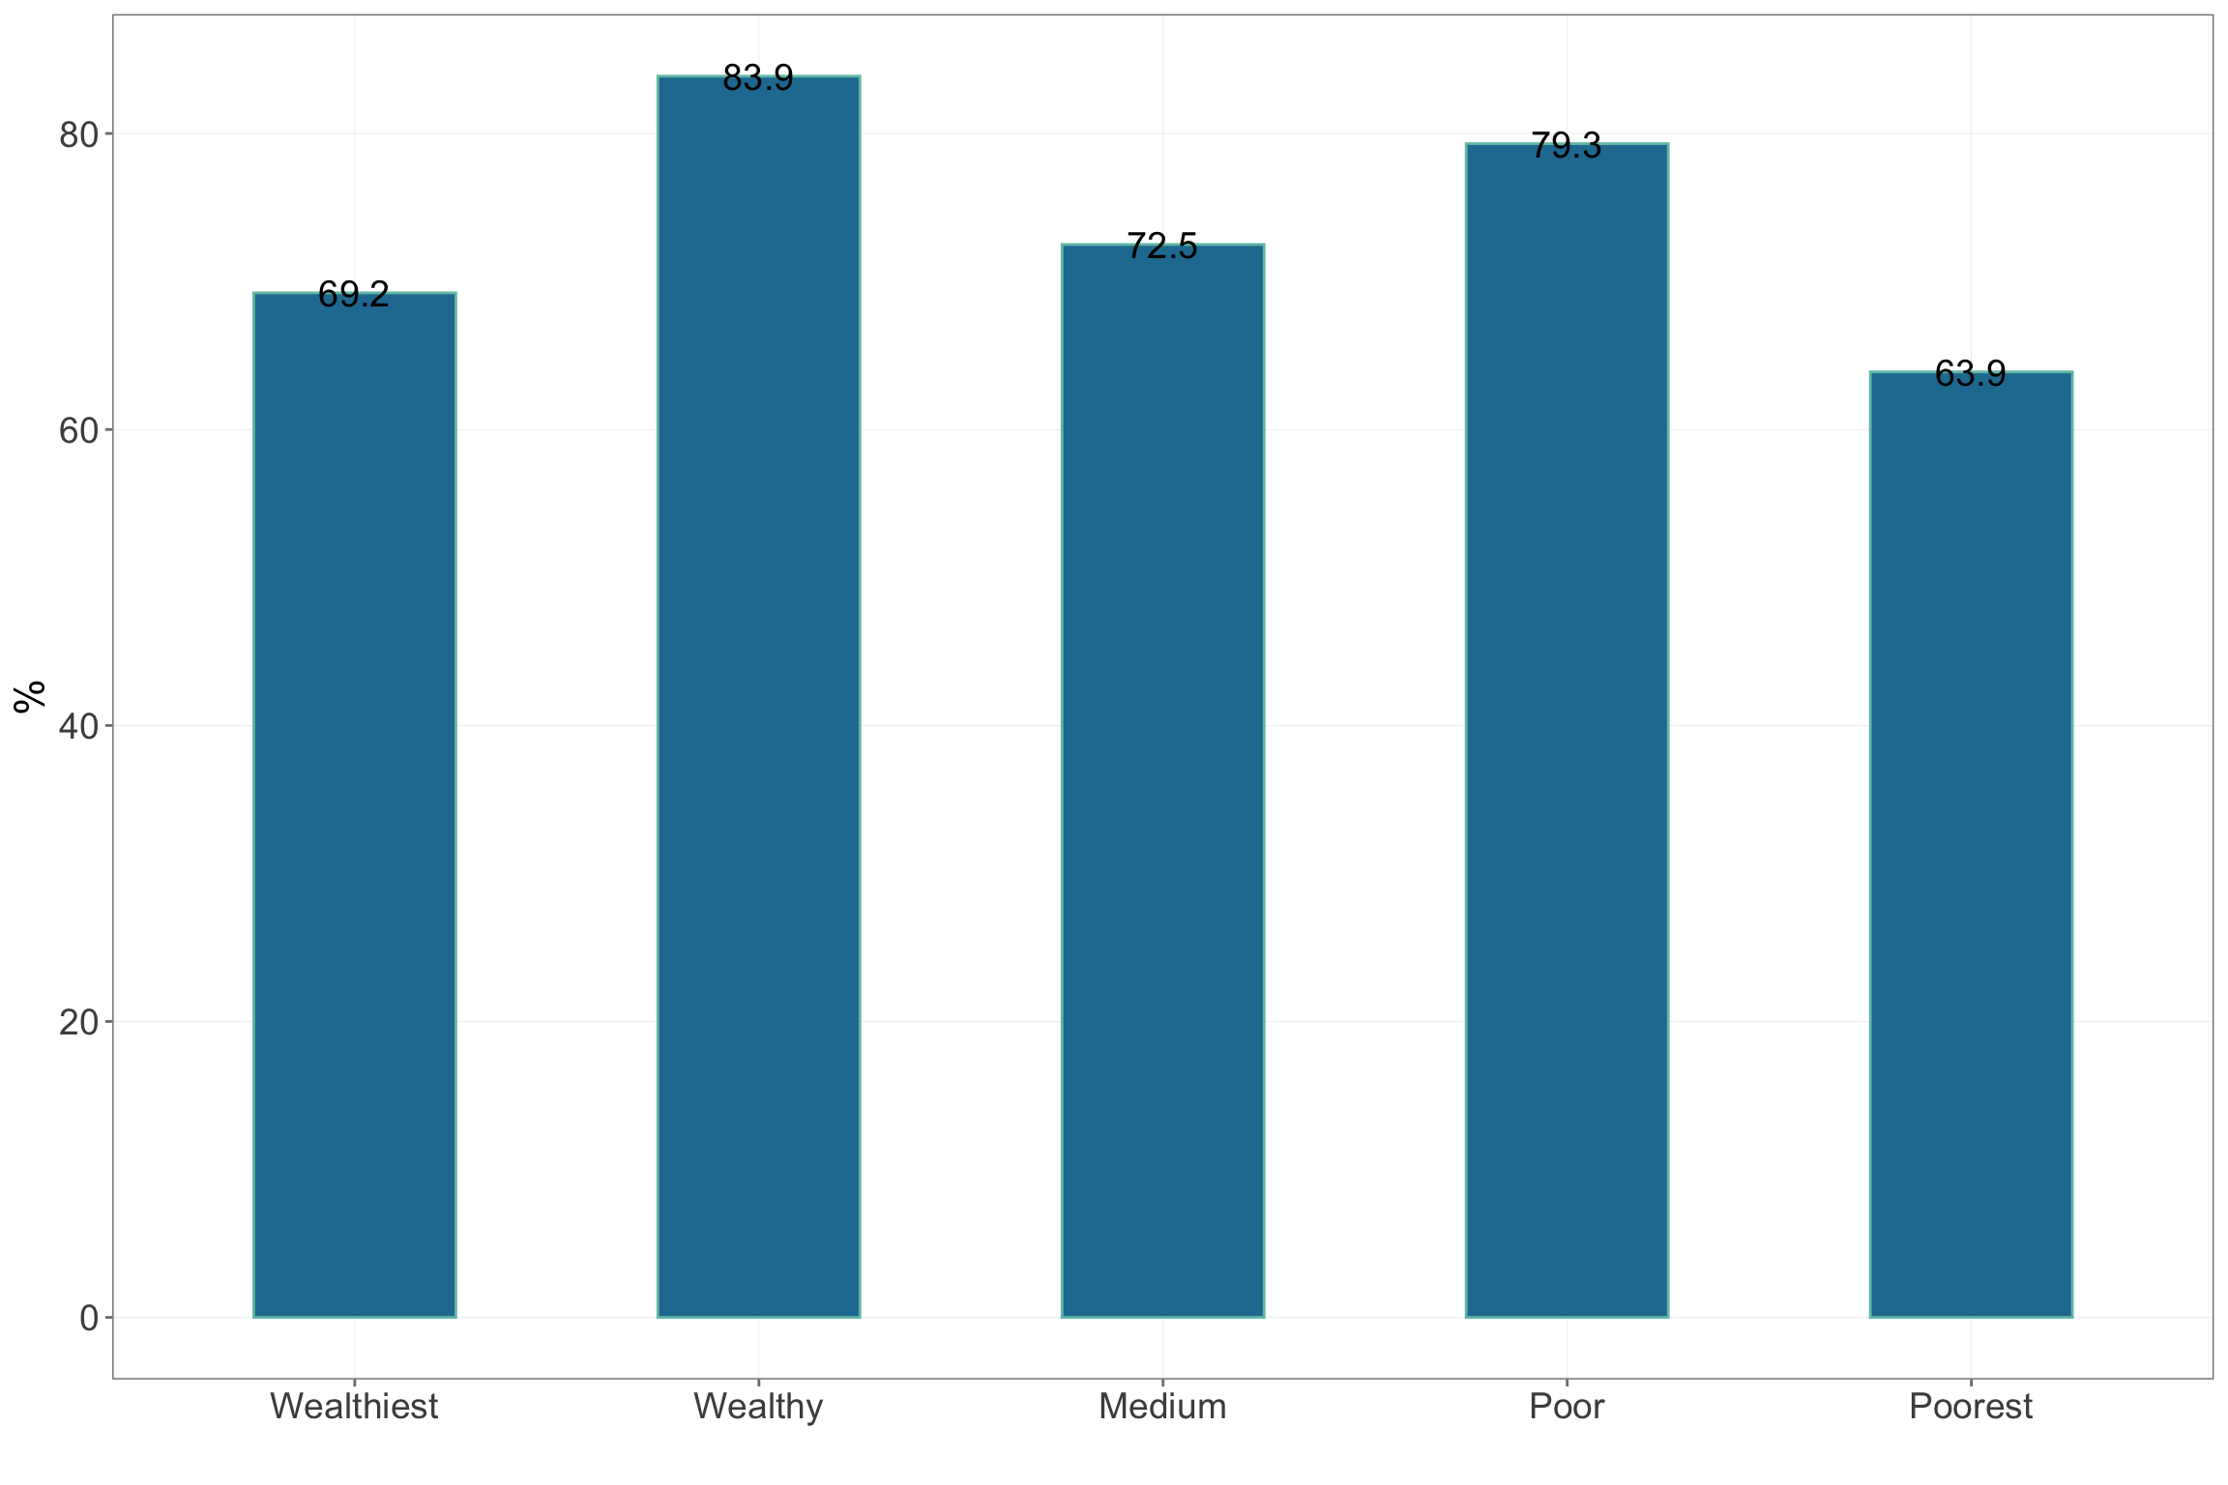

Figure 4.36: Treatment-seeking for acute respiratory infection by wealth quintiles

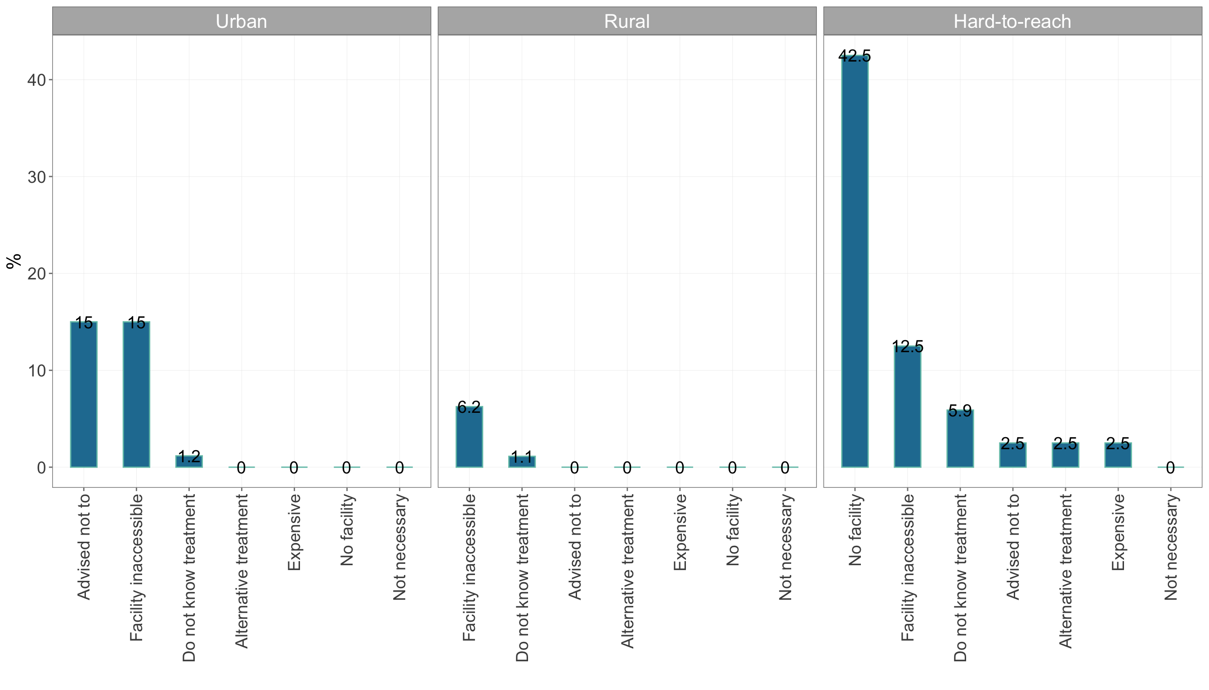

Figure 4.37: Reasons for not seeking treatment by location type

| Table 4.17: Where/who treatment is sought from | | | | | | | | | | | | | | |
| --- | --- | --- | --- | --- | --- | --- | --- | --- | --- | --- | --- | --- | --- | --- |
|  | | **Where/who treatment is sought from** | | | | | | | | | | | | |
|  |  |  |  |  |  |  |  |  |  |  |  |  |  |  |
| **Geographic** | | | | | | | | | | | | | | |
| Kayah | Rural | 3.6 | 7.1 | 11.9 | 32.1 | 17.9 | 1.2 | 0.0 | 0 | 14.3 | 0.0 | 2.4 | 2.4 | 1.2 |
| Urban | 23.4 | 8.5 | 0.0 | 4.3 | 48.9 | 0.0 | 0.0 | 0 | 6.4 | 0.0 | 4.3 | 0.0 | 0.0 |
| Hard-to-reach | 2.1 | 5.3 | 5.3 | 36.2 | 1.1 | 3.2 | 1.1 | 0 | 2.1 | 21.3 | 1.1 | 2.1 | 13.8 |
| **Wealth** | | | | | | | | | | | | | |
| Wealthiest | 11.5 | 7.7 | 11.5 | 7.7 | 46.2 | 0.0 | 0.0 | 0 | 0.0 | 0.0 | 3.8 | 0.0 | 0.0 |
| Wealthy | 9.3 | 5.6 | 5.6 | 29.6 | 22.2 | 0.0 | 0.0 | 0 | 16.7 | 0.0 | 3.7 | 1.9 | 1.9 |
| Medium | 11.3 | 11.3 | 3.8 | 32.1 | 18.9 | 0.0 | 0.0 | 0 | 9.4 | 3.8 | 0.0 | 1.9 | 3.8 |
| Poor | 2.1 | 2.1 | 10.4 | 33.3 | 2.1 | 4.2 | 0.0 | 0 | 4.2 | 16.7 | 4.2 | 2.1 | 8.3 |
| Poorest | 2.4 | 4.9 | 2.4 | 29.3 | 7.3 | 4.9 | 2.4 | 0 | 2.4 | 24.4 | 0.0 | 2.4 | 17.1 |  |

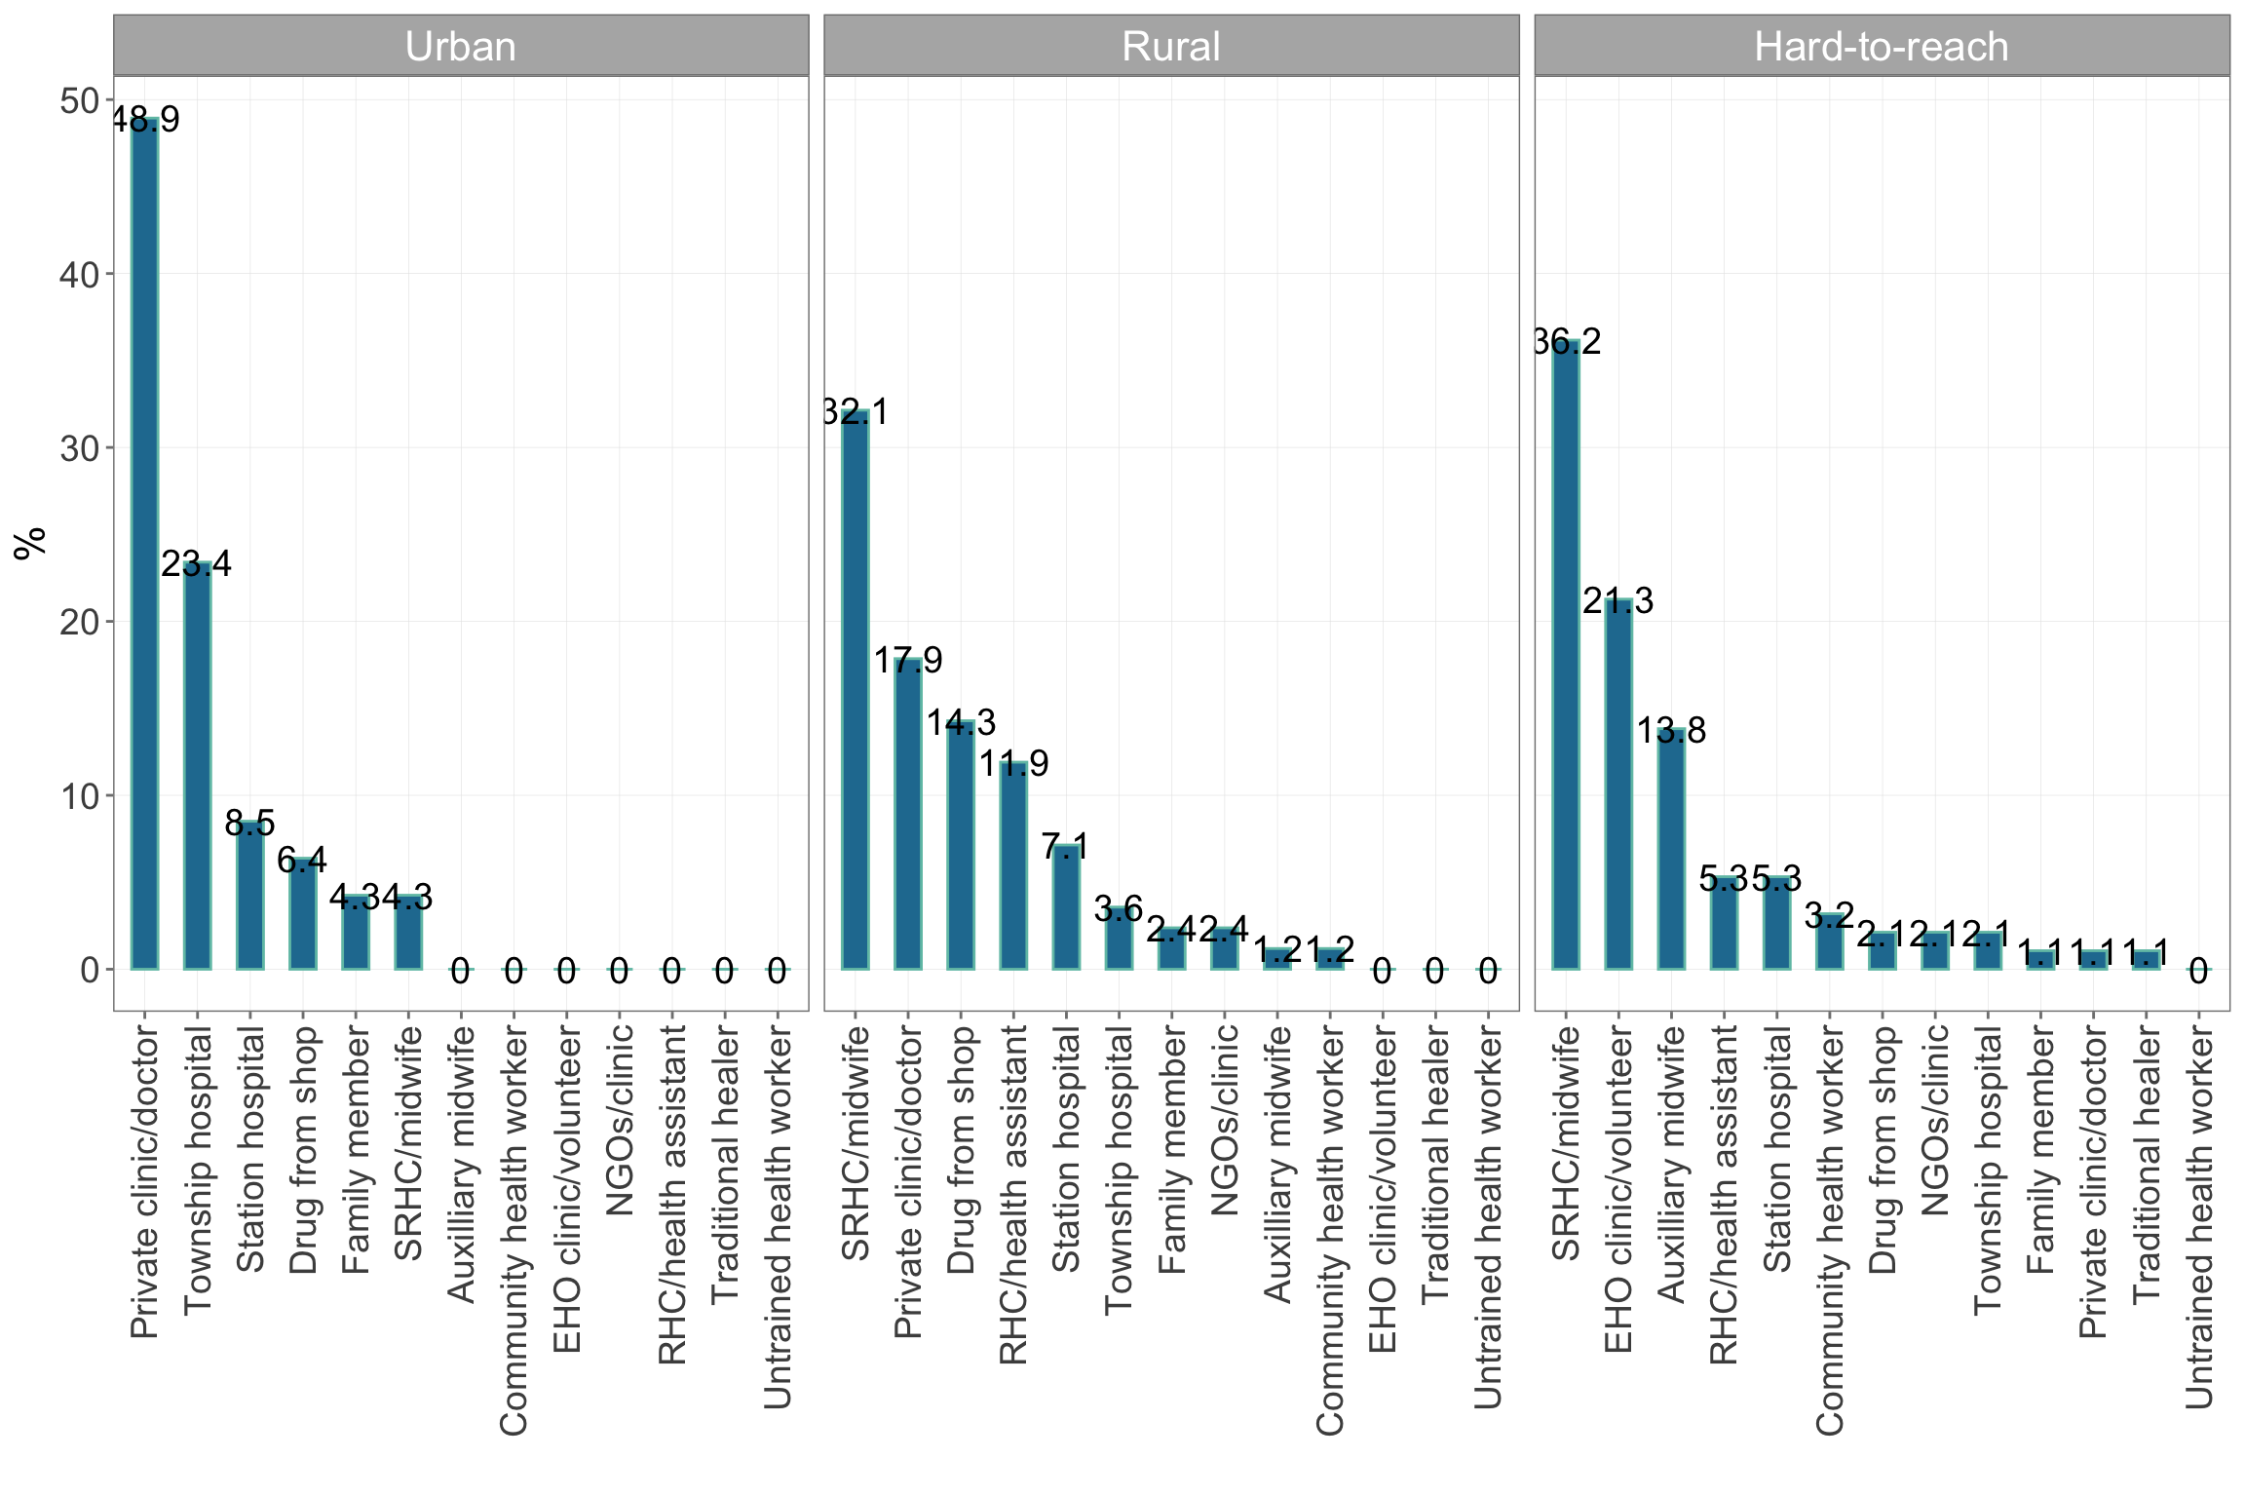

Figure 4.38: Where/who treatment is sought from by location type

| Table 4.18: Payment for treatment | | | | | | | | | |
| --- | --- | --- | --- | --- | --- | --- | --- | --- | --- |
|  | | | **Payment for** | | | | | |  |
|  |  |  |  |  |  |  |  |  |  |
| **Geographic** | | | | | | | | | |
| Kayah | Rural | 5264.3 | 0.0 | 2.5 | 77.5 | 0 | 2.5 | 2.5 | 21.9 |
| Urban | 8755.3 | 0.0 | 0.0 | 81.8 | 0 | 0.0 | 0.0 | 6.8 |
| Hard-to-reach | 22613.8 | 6.5 | 0.0 | 67.7 | 0 | 0.0 | 0.0 | 31.4 |
| **Wealth** | | | | | | | | |
| Wealthiest | 8403.8 | 0.0 | 0.0 | 75.0 | 0 | 0.0 | 0.0 | 0.0 |
| Wealthy | 5733.3 | 0.0 | 3.7 | 81.5 | 0 | 3.7 | 0.0 | 22.0 |
| Medium | 4162.3 | 0.0 | 0.0 | 64.0 | 0 | 0.0 | 4.0 | 23.7 |
| Poor | 45097.9 | 5.9 | 0.0 | 76.5 | 0 | 0.0 | 0.0 | 14.3 |
| Poorest | 1317.1 | 9.1 | 0.0 | 81.8 | 0 | 0.0 | 0.0 | 46.7 |  |

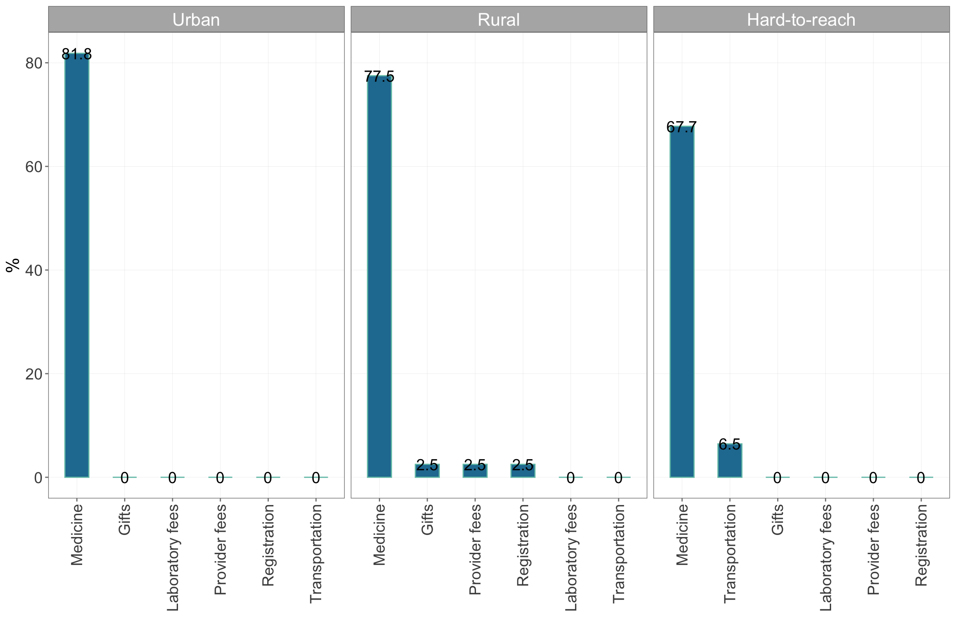

Figure 4.39: Costs incurred for treatment by location type

#### 4.1.9.3 Fever

Treatment-seeking for fever in Kayah state can be characterised by households in urban areas seeking treatment the most (85.2%) whilst those in urban and hard-to-reach areas seeking treatment slightly lesser (see Figure 4.40). When asked why treatment was not sought for fever, those from the urban areas were advised not to seek treatment and could not access the health facility whilst those in rural and hard-to-reach areas reported cost and not having a facility (see Figure 4.41). Comparing these reasons, those from the urban areas seem to not seek care by choice (chose not to) rather than by circumstance (no choice as there is no facility from which to seek treatment). Time to treatment is usually longer for those in hard-to-reach areas compared to those in rural and urban areas and those who are poor and poorest compared to the wealthy and wealthiest (see Table 4.19).

Those from urban and rural areas tended to see a private doctor whilst those from hard-to-reach areas predominantly went to their SRHC/midwife (see Figure **??**). Costs incurred for treatment were majority for medications (see Table 4.21).

| Table 4.19: Treatment-seeking for fever | | | | | | | | | | |
| --- | --- | --- | --- | --- | --- | --- | --- | --- | --- | --- |
|  | | | | **Reasons for not seeking treatment** | | | | | | |
|  |  |  |  |  |  |  |  |  |  |  |
| **Geographic** | | | | | | | | | | |
| Kayah | Rural | 76.5 | 1.4 | 0.0 | 0.0 | 5.0 | 5.0 | 0 | 0.0 | 0 |
| Urban | 85.2 | 1.1 | 0.0 | 0.0 | 14.3 | 0.0 | 0 | 19.0 | 0 |
| Hard-to-reach | 65.3 | 2.0 | 13.5 | 48.6 | 2.7 | 0.0 | 0 | 5.4 | 0 |
| **Wealth** | | | | | | | | | |
| Wealthiest | 76.3 | 1.2 | 0.0 | 0.0 | 0.0 | 0.0 | 0 | 9.1 | 0 |
| Wealthy | 84.3 | 1.1 | 0.0 | 0.0 | 0.0 | 6.7 | 0 | 6.7 | 0 |
| Medium | 73.5 | 1.6 | 0.0 | 31.2 | 6.2 | 0.0 | 0 | 18.8 | 0 |
| Poor | 70.4 | 1.8 | 17.6 | 35.3 | 23.5 | 0.0 | 0 | 5.9 | 0 |
| Poorest | 68.6 | 2.0 | 11.8 | 41.2 | 0.0 | 0.0 | 0 | 0.0 | 0 |  |

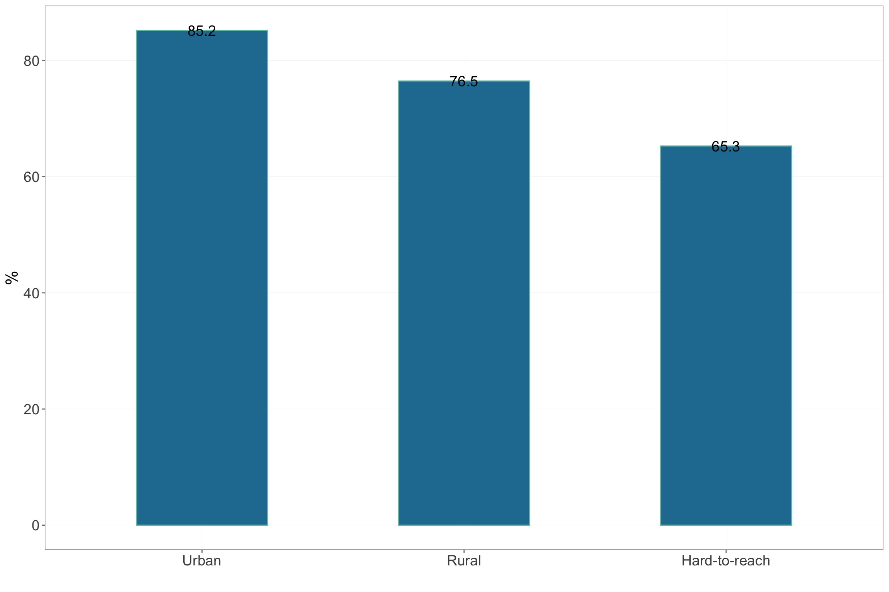

Figure 4.40: Treatment-seeking for fever by location type

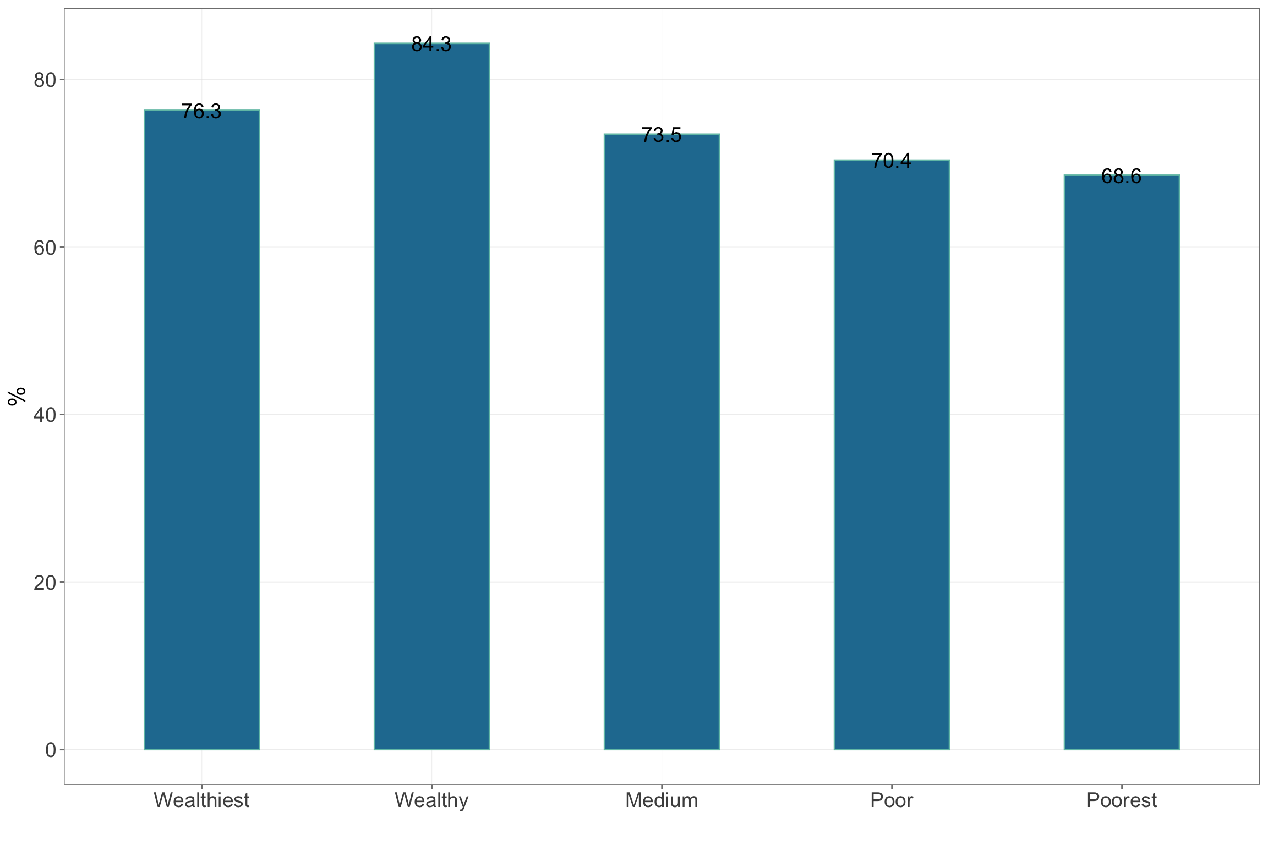

Figure 4.41: Treatment-seeking for fever by wealth quintiles

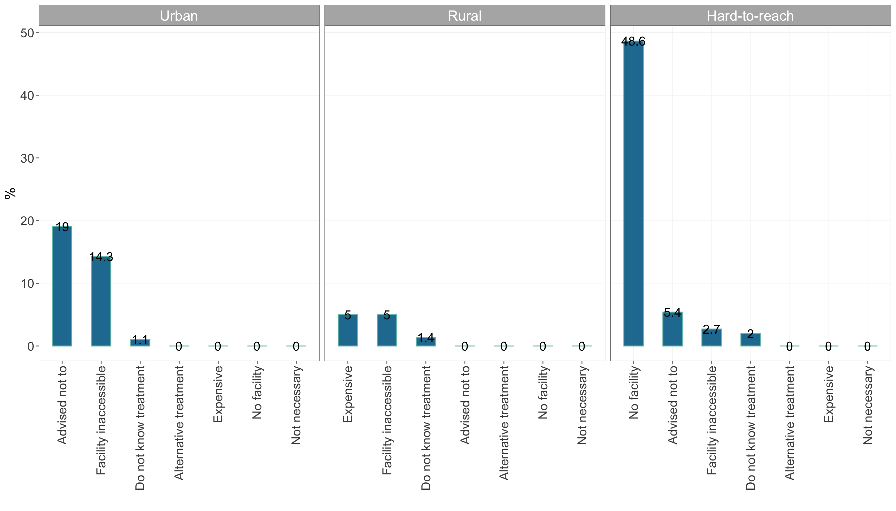

Figure 4.42: Reasons for not seeking treatment by location type

| Table 4.20: Where/who treatment is sought from | | | | | | | | | | | | | | |
| --- | --- | --- | --- | --- | --- | --- | --- | --- | --- | --- | --- | --- | --- | --- |
|  | | **Where/who treatment is sought from** | | | | | | | | | | | | |
|  |  |  |  |  |  |  |  |  |  |  |  |  |  |  |
| **Geographic** | | | | | | | | | | | | | | |
| Kayah | Rural | 8.3 | 1.2 | 15.5 | 26.2 | 28.6 | 1.2 | 0 | 0.0 | 9.5 | 1.2 | 2.4 | 1.2 | 0.0 |
| Urban | 32.2 | 3.3 | 0.0 | 3.3 | 45.6 | 0.0 | 0 | 2.2 | 3.3 | 2.2 | 2.2 | 0.0 | 0.0 |
| Hard-to-reach | 2.1 | 2.1 | 11.6 | 36.8 | 0.0 | 1.1 | 0 | 3.2 | 3.2 | 12.6 | 4.2 | 3.2 | 14.7 |
| **Wealth** | | | | | | | | | | | | | |
| Wealthiest | 22.5 | 2.5 | 2.5 | 7.5 | 55.0 | 0.0 | 0 | 0.0 | 0.0 | 2.5 | 5.0 | 0.0 | 0.0 |
| Wealthy | 16.7 | 1.4 | 8.3 | 23.6 | 33.3 | 1.4 | 0 | 0.0 | 8.3 | 1.4 | 0.0 | 0.0 | 0.0 |
| Medium | 20.0 | 4.6 | 15.4 | 24.6 | 16.9 | 0.0 | 0 | 0.0 | 4.6 | 1.5 | 3.1 | 1.5 | 4.6 |
| Poor | 4.3 | 2.2 | 8.7 | 23.9 | 6.5 | 0.0 | 0 | 8.7 | 2.2 | 6.5 | 4.3 | 2.2 | 15.2 |
| Poorest | 2.4 | 0.0 | 7.3 | 29.3 | 4.9 | 2.4 | 0 | 2.4 | 9.8 | 22.0 | 4.9 | 4.9 | 9.8 |  |

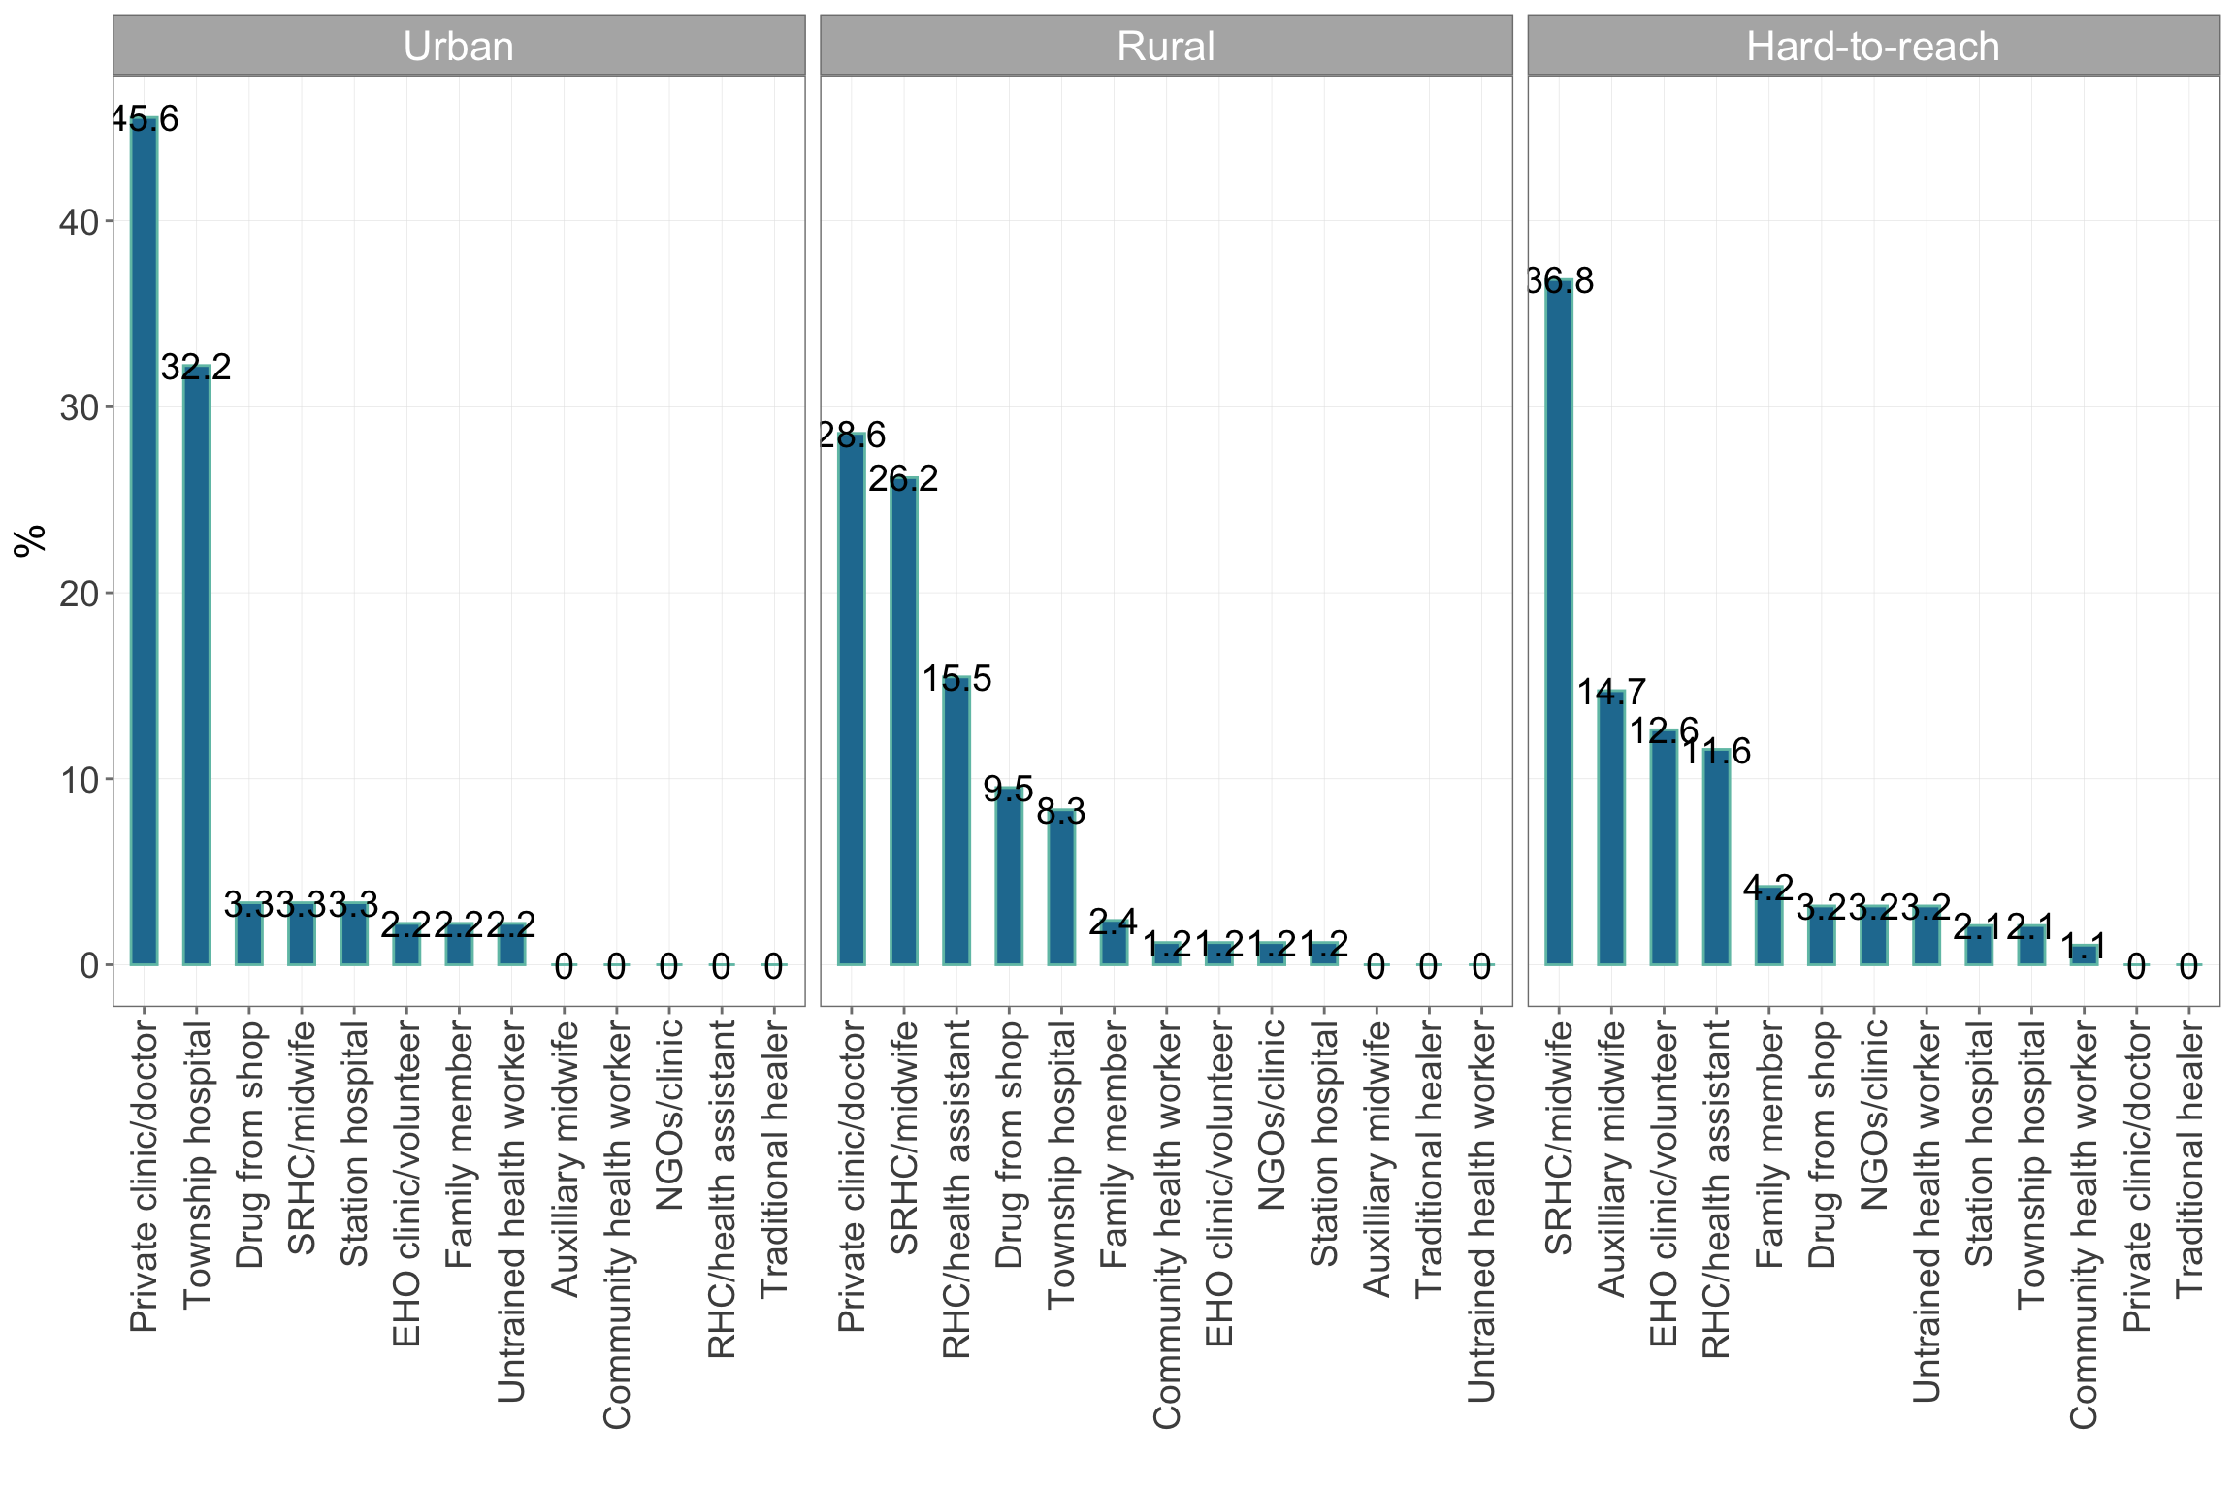

Figure 4.43: Where/who treatment is sought from by location type

| Table 4.21: Payment for treatment | | | | | | | | | |
| --- | --- | --- | --- | --- | --- | --- | --- | --- | --- |
|  | | | **Payment for** | | | | | |  |
|  |  |  |  |  |  |  |  |  |  |
| **Geographic** | | | | | | | | | |
| Kayah | Rural | 8614.3 | 2.9 | 0 | 82.9 | 0 | 0.0 | 2.9 | 30.8 |
| Urban | 9549.4 | 0.0 | 0 | 78.1 | 0 | 3.1 | 0.0 | 16.2 |
| Hard-to-reach | 1434.7 | 0.0 | 0 | 77.1 | 0 | 0.0 | 0.0 | 12.8 |
| **Wealth** | | | | | | | | |
| Wealthiest | 8989.5 | 0.0 | 0 | 66.7 | 0 | 0.0 | 0.0 | 18.2 |
| Wealthy | 10522.8 | 3.2 | 0 | 80.6 | 0 | 3.2 | 0.0 | 17.5 |
| Medium | 6789.2 | 0.0 | 0 | 74.2 | 0 | 0.0 | 3.2 | 27.5 |
| Poor | 1663.0 | 0.0 | 0 | 89.5 | 0 | 0.0 | 0.0 | 22.7 |
| Poorest | 1251.2 | 0.0 | 0 | 78.6 | 0 | 0.0 | 0.0 | 18.8 |  |



Figure 4.44: Costs incurred for treatment in Kayah state

### 4.1.10 Child nutrition

#### 4.1.10.1 Prevalence of childhood stunting/stuntedness

Global childhood stunting/stuntedness in Kayah state goes as high as 48% in hard-to-reach areas and as low as 17.4% in urban areas. There is a geographical gradient in the childhood stunting/stuntedness indicator such that urban areas tend to have the lowest prevalence whilst the hard-to-reach areas had the highest. This trend is consistent for moderate stunting/stuntedness and severe stunting/stuntedness (see Table 4.22).

| Table 4.22: Child stunting/stuntedness | | | | | |
| --- | --- | --- | --- | --- | --- |
|  |  |  |  |  |  |
| **Geographic** | | | | | |
| Kayah | Rural | -1.4 | 31.5 | 25.7 | 5.9 |
| Urban | -1.1 | 17.4 | 14.9 | 2.6 |
| Hard-to-reach | -1.6 | 47.9 | 30.1 | 17.9 |

#### 4.1.10.2 Prevalence of childhood underweight

Global childhood stunting/stuntedness in Kayah state goes as high as 25% in hard-to-reach areas and as low as 14.5% in urban and rural areas. There is a geographical gradient in the childhood underweight indicator such that urban areas tend to have the lowest prevalence whilst the hard-to-reach areas had the highest. This trend is consistent for moderate underweight and severe underweight (see Table 4.23).

| Table 4.23: Child underweight | | | | | |
| --- | --- | --- | --- | --- | --- |
|  |  |  |  |  |  |
| **Geographic** | | | | | |
| Kayah | Rural | -1.1 | 14.5 | 11.4 | 3.1 |
| Urban | -0.9 | 14.6 | 12.6 | 2.0 |
| Hard-to-reach | -1.1 | 24.8 | 20.4 | 4.3 |

#### 4.1.10.3 Prevalence of childhood wasting by weight-for-height z-score

Global acute malnutrition by WHZ in Kayah state goes as high as 6% in rural areas and as low as 3.8% in urban and rural areas. There is a geographical gradient in the childhood acute malnutrition indicator such that urban areas tend to have the lowest prevalence whilst the hard-to-reach areas had the highest. This trend is consistent for moderate acute malnutrition and severe acute malnutrition (see Table 4.24).

| Table 4.24: Child wasting by weight-for-height z-score | | | | | |
| --- | --- | --- | --- | --- | --- |
|  |  |  |  |  |  |
| **Geographic** | | | | | |
| Kayah | Rural | -0.4 | 5.9 | 4.6 | 1.2 |
| Urban | -0.5 | 3.8 | 2.6 | 1.3 |
| Hard-to-reach | -0.3 | 4.0 | 2.5 | 1.5 |

#### 4.1.10.4 Prevalence of childhood wasting by MUAC

Global acute malnutrition by MUAC in Kayah state goes as high as 4.7% in hard-to-reach areas and as low as 2.5% in urban and rural areas. There is a geographical gradient in the childhood acute malnutrition indicator such that urban areas tend to have the lowest prevalence whilst the hard-to-reach areas had the highest. This trend is consistent for moderate acute malnutrition and severe acute malnutrition (see Table 4.25).

| Table 4.25: Child wasting by MUAC | | | | | |
| --- | --- | --- | --- | --- | --- |
|  |  |  |  |  |  |
| **Geographic** | | | | | |
| Kayah | Rural | 15.2 | 2.7 | 2.2 | 0.5 |
| Urban | 15.1 | 2.5 | 1.0 | 1.5 |
| Hard-to-reach | 14.5 | 4.7 | 3.2 | 1.5 |

#### 4.1.10.5 Infant and young child feeding

Infant and young child feeding indicators show that most mothers initiated breastfeeding early when they gave birth to their children who is less than 24 months old. However, exclusivity of breastfeeding is not maintained hence the low levels of exclusive breastfeeding. Only up to 55% in rural areas and 50% in urban areas and 50% in wealthiest and wealthy households are children consuming the minimum meal frequency required with hard-to-reach areas having the lowest at 27.3% and the poorest having 26.1%. Minimum dietary diversity goes up to 54% in urban areas and 43.2% in rural areas but then dropping significantly in hard-to-reach areas to 14%. Only 5.9% of poorest households have their children consume minimally diverse diets. Given low minimum meal frequency and low minimum dietary diversity, children with minimum acceptable diets are also low with only up to 31% of those in urban areas, 24% in rural areas and less than 10% for hard-to-reach areas. Only 5.8% of poorest households feed their children with the minimum acceptable diet (see Table **??** and Figure 4.45 and Figure 4.46).

| Table 4.26: Infant and young child feeding | | | | | | |
| --- | --- | --- | --- | --- | --- | --- |
|  |  |  |  |  |  |  |
| **Geographic** | | | | | | |
| Kayah | Rural | 87.8 | 12.3 | 55.4 | 43.2 | 24.1 |
| Urban | 91.5 | 8.1 | 50.4 | 54.3 | 30.8 |
| Hard-to-reach | 76.3 | 4.2 | 27.3 | 14.0 | 9.3 |
| **Wealth** | | | | | |
| Wealthiest | 89.2 | 10.4 | 51.5 | 50.0 | 39.4 |
| Wealthy | 91.2 | 9.2 | 50.0 | 51.4 | 21.1 |
| Medium | 78.2 | 8.1 | 44.6 | 33.3 | 18.1 |
| Poor | 86.6 | 5.9 | 37.6 | 25.2 | 15.1 |
| Poorest | 76.6 | 5.0 | 26.1 | 5.9 | 5.8 |  |

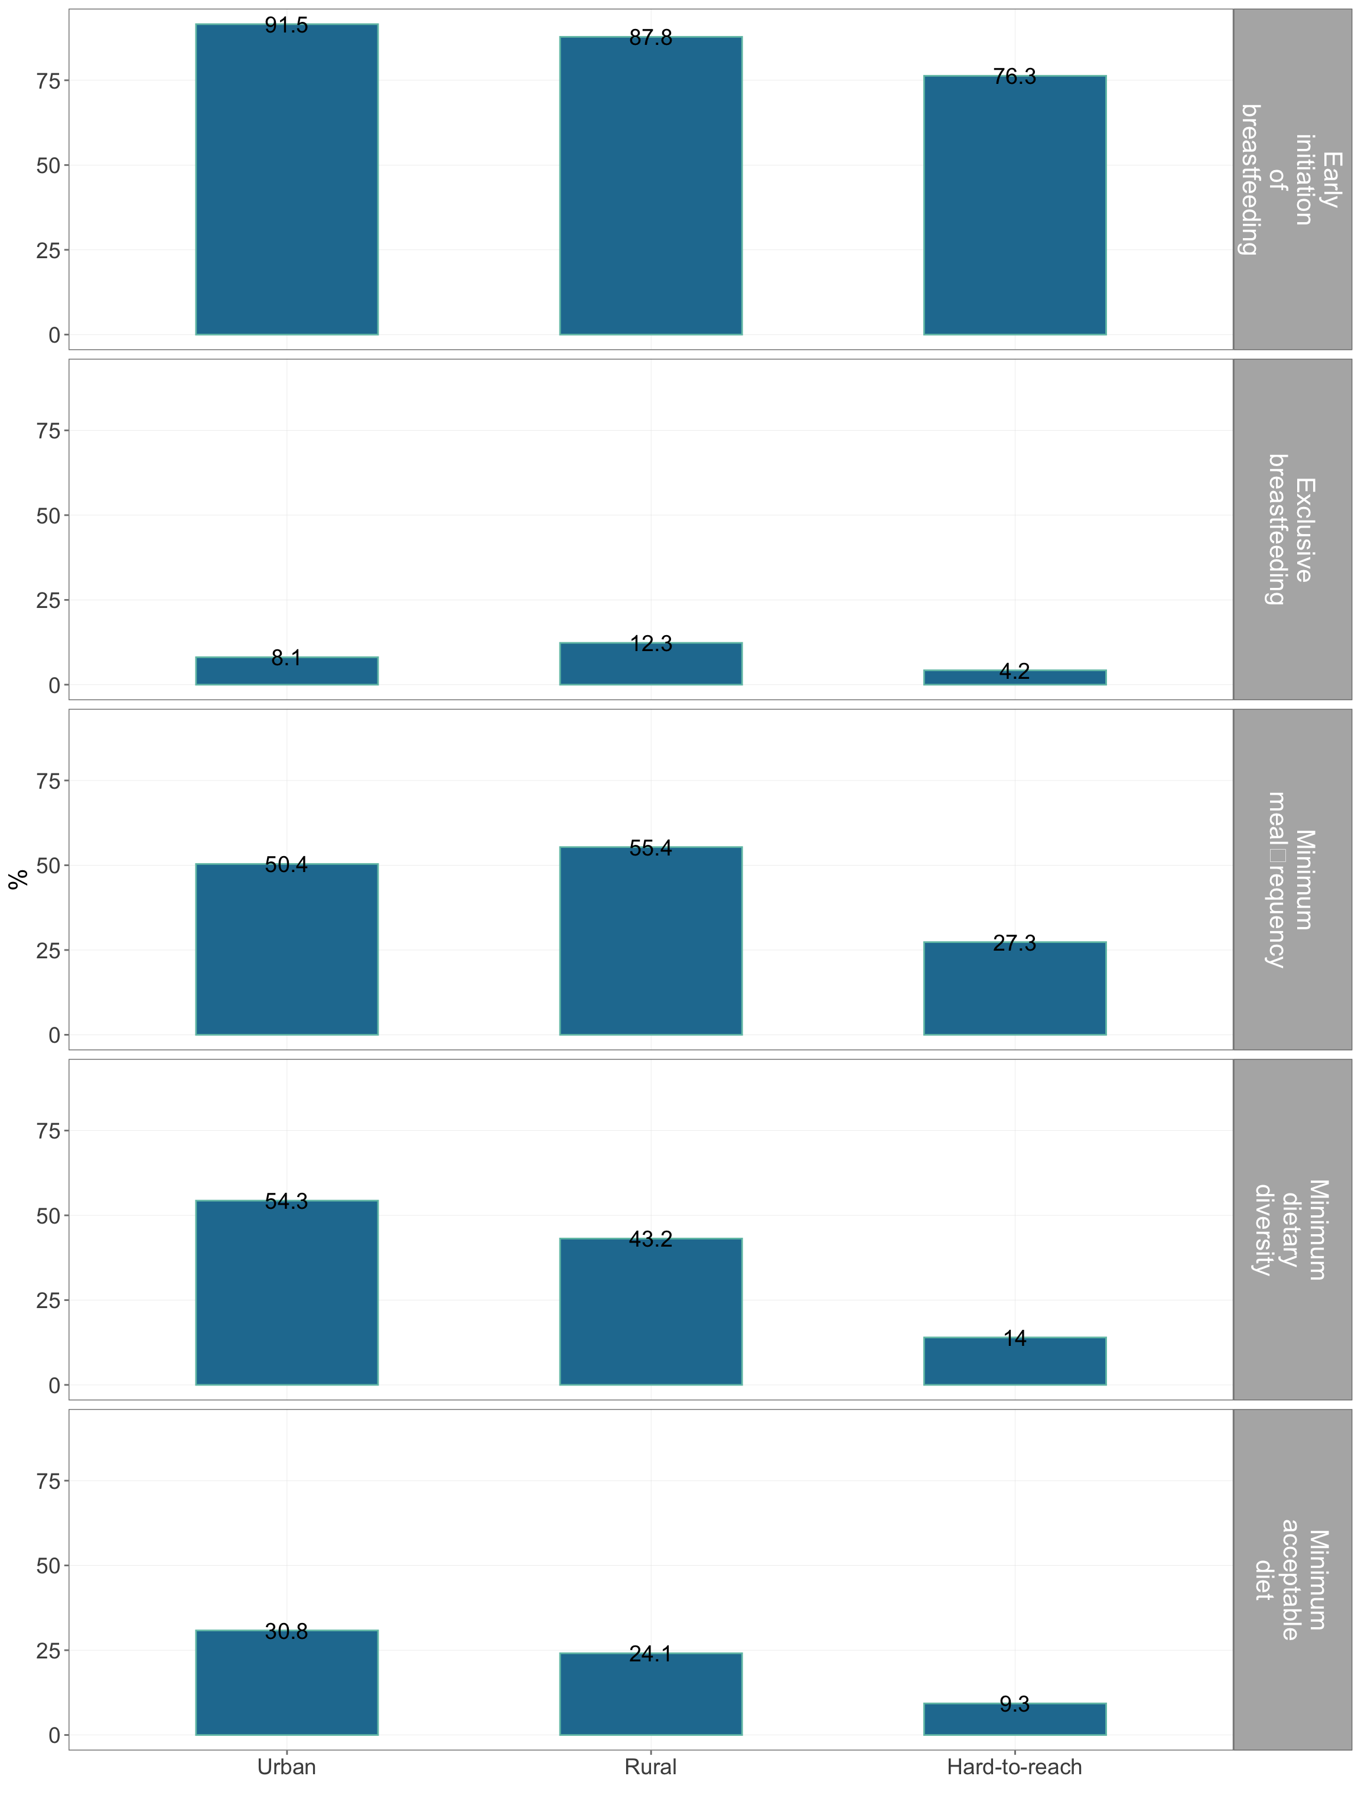

Figure 4.45: Infant and young child feeding by location type

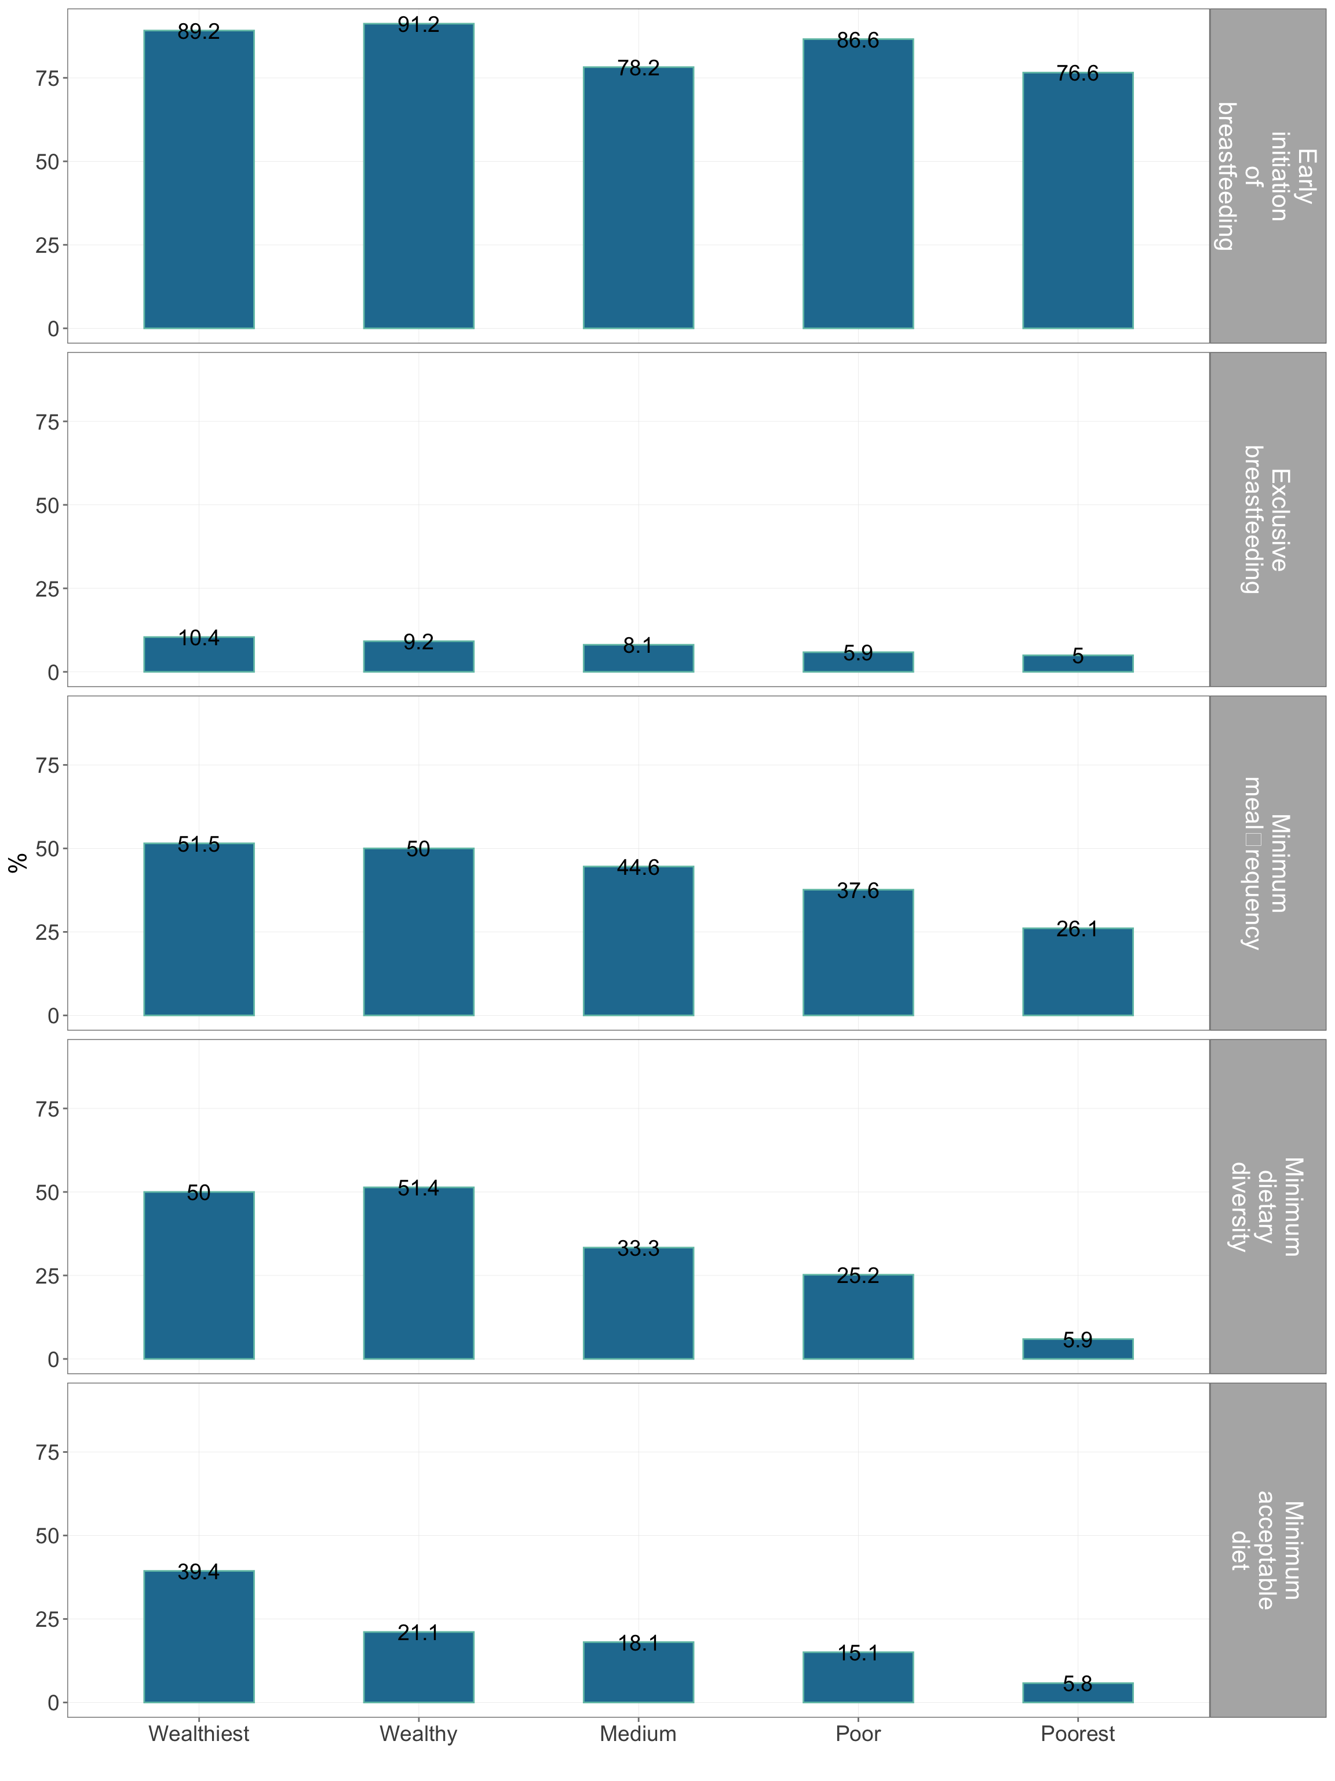

Figure 4.46: Infant and young child feeding by wealth quintiles

### 4.1.11 Maternal health

#### 4.1.11.1 Family planning

When asked about preferences of when to have next child, the range of responses from women and husbands was about 3.5 to 4 years with the lower end mostly being reported in hard-to-reach areas and in poor and poorest households (see Table 4.27).

Current contraception use is highest in urban areas at 71.6% followed by rural areas at 59.1%. Only 31.3% of hard-to-reach women and only 27.3% of the poorest women use are using contraception now. Of all contraceptive devices and methods, the injectables are the most commonly used by women in all areas and in all wealth classes followed by pills (see Table 4.28).

Majority of women using contraptives received family planning services from the government hospital and from the midwife with women from rural and urban areas and wealthiest and wealthy households tending to receive family planning services from the hospital whilst those from hard-to-reach areas receiving their services from the midwife (see Table 4.29).

A large proportion of women in urban and rural areas and wealthiest and wealthy households have received information on family planning. either from the hospital or from a midwife (see Table 4.30). Majority of women regardless of location and regardless of wealth class know basic family planning knoweldge (see Table 4.30).

| Table 4.27: Months to wait until next pregnancy | | | | |
| --- | --- | --- | --- | --- |
|  |  |  |  |  |
| **Geographic** | | | | |
| Kayah | Rural | 47.1 | 41.2 | 48.2 |
| Urban | 46.1 | 28.8 | 43.6 |
| Hard-to-reach | 39.9 | 23.6 | 37.8 |
| **Wealth** | | | |
| Wealthiest | 48.9 | 41.5 | 45.9 |
| Wealthy | 43.7 | 31.6 | 42.9 |
| Medium | 44.0 | 33.3 | 44.4 |
| Poor | 41.6 | 26.5 | 39.6 |
| Poorest | 40.5 | 22.8 | 39.0 |  |

| Table 4.28: Use of contraceptive methods | | | | | | | | | | | | | | | | | |
| --- | --- | --- | --- | --- | --- | --- | --- | --- | --- | --- | --- | --- | --- | --- | --- | --- | --- |
|  | | | | **Contraceptive methods** | | | | | | | | | | | | | |
|  |  |  |  |  |  |  |  |  |  |  |  |  |  |  |  |  |  |
| **Geographic** | | | | | | | | | | | | | | | | | |
| Kayah | Rural | 59.1 | 54.2 | 7.4 | 0.6 | 7.4 | 4.3 | 63.2 | 15.3 | 0.0 | 0 | 0 | 1.2 | 0.6 | 0 | 0 | 0 |
| Urban | 71.6 | 64.6 | 6.4 | 0.0 | 5.9 | 15.4 | 56.9 | 14.4 | 1.1 | 0 | 0 | 0.0 | 0.0 | 0 | 0 | 0 |
| Hard-to-reach | 31.3 | 31.3 | 0.8 | 0.0 | 0.8 | 18.3 | 62.7 | 16.7 | 0.0 | 0 | 0 | 0.8 | 0.0 | 0 | 0 | 0 |
| **Wealth** | | | | | | | | | | | | | | | | |
| Wealthiest | 68.7 | 64.1 | 5.0 | 0.0 | 7.9 | 11.4 | 57.1 | 15.7 | 1.4 | 0 | 0 | 0.7 | 0.7 | 0 | 0 | 0 |
| Wealthy | 69.5 | 62.7 | 8.4 | 0.0 | 6.3 | 10.5 | 60.0 | 14.7 | 0.0 | 0 | 0 | 0.0 | 0.0 | 0 | 0 | 0 |
| Medium | 55.2 | 51.2 | 4.5 | 0.0 | 3.4 | 8.0 | 69.3 | 13.6 | 0.0 | 0 | 0 | 1.1 | 0.0 | 0 | 0 | 0 |
| Poor | 46.9 | 39.0 | 4.4 | 1.1 | 3.3 | 14.4 | 58.9 | 16.7 | 0.0 | 0 | 0 | 1.1 | 0.0 | 0 | 0 | 0 |
| Poorest | 27.3 | 30.3 | 3.1 | 0.0 | 1.6 | 20.3 | 59.4 | 15.6 | 0.0 | 0 | 0 | 0.0 | 0.0 | 0 | 0 | 0 |  |

| Table 4.29: Where contraception services received | | | | | | | | | | | | |
| --- | --- | --- | --- | --- | --- | --- | --- | --- | --- | --- | --- | --- |
|  |  |  |  |  |  |  |  |  |  |  |  |  |
| **Geographic** | | | | | | | | | | | | |
| Kayah | Rural | 21.2 | 8.3 | 1.0 | 3.6 | 1.6 | 5.7 | 3.6 | 1.0 | 5.2 | 6.2 | 42.5 |
| Urban | 42.2 | 4.9 | 0.0 | 17.2 | 6.4 | 7.8 | 7.8 | 0.0 | 2.0 | 1.5 | 10.3 |
| Hard-to-reach | 8.0 | 4.5 | 7.1 | 3.6 | 0.0 | 1.8 | 0.0 | 4.5 | 20.5 | 17.0 | 33.0 |
| **Wealth** | | | | | | | | | | | |
| Wealthiest | 36.8 | 7.6 | 0.0 | 11.8 | 6.2 | 6.2 | 9.7 | 0.0 | 2.8 | 0.7 | 18.1 |
| Wealthy | 30.2 | 4.3 | 0.0 | 9.5 | 5.2 | 8.6 | 6.9 | 0.9 | 2.6 | 5.2 | 26.7 |
| Medium | 22.6 | 7.5 | 0.9 | 10.4 | 0.9 | 5.7 | 0.0 | 1.9 | 5.7 | 5.7 | 38.7 |
| Poor | 21.2 | 4.7 | 5.9 | 3.5 | 0.0 | 4.7 | 1.2 | 2.4 | 10.6 | 12.9 | 32.9 |
| Poorest | 10.3 | 5.2 | 6.9 | 6.9 | 0.0 | 0.0 | 0.0 | 3.4 | 25.9 | 17.2 | 24.1 |  |

| Table 4.30: Information on family planning/contraception | | | | | | | | | | | | | | |
| --- | --- | --- | --- | --- | --- | --- | --- | --- | --- | --- | --- | --- | --- | --- |
|  | | | **Source of family planning information** | | | | | | | | | | |  |
|  |  |  |  |  |  |  |  |  |  |  |  |  |  |  |
| **Geographic** | | | | | | | | | | | | | | |
| Kayah | Rural | 84.1 | 18.5 | 7.1 | 2.4 | 6.0 | 0.0 | 3.6 | 0 | 0.6 | 3.6 | 5.4 | 53.0 | 89.7 |
| Urban | 93.0 | 38.9 | 4.0 | 2.0 | 18.8 | 4.0 | 5.4 | 0 | 1.3 | 2.0 | 0.7 | 22.8 | 97.6 |
| Hard-to-reach | 64.6 | 5.8 | 2.2 | 5.8 | 2.2 | 0.0 | 0.0 | 0 | 2.9 | 23.7 | 7.2 | 50.4 | 84.8 |
| **Wealth** | | | | | | | | | | | | | |
| Wealthiest | 93.5 | 33.7 | 5.9 | 1.0 | 19.8 | 3.0 | 5.0 | 0 | 1.0 | 4.0 | 1.0 | 25.7 | 94.5 |
| Wealthy | 88.1 | 23.3 | 3.3 | 3.3 | 8.9 | 2.2 | 6.7 | 0 | 2.2 | 3.3 | 3.3 | 43.3 | 94.9 |
| Medium | 82.6 | 22.8 | 7.9 | 4.0 | 5.0 | 1.0 | 1.0 | 0 | 1.0 | 4.0 | 4.0 | 49.5 | 92.0 |
| Poor | 71.2 | 11.5 | 3.8 | 3.8 | 7.7 | 0.0 | 2.6 | 0 | 1.3 | 11.5 | 7.7 | 50.0 | 88.1 |
| Poorest | 64.1 | 11.6 | 1.2 | 4.7 | 2.3 | 0.0 | 0.0 | 0 | 2.3 | 25.6 | 7.0 | 45.3 | 83.3 |  |

### 4.1.12 Antenatal care

#### 4.1.12.1 Antenatal care coverage

Only up to a third of women in urban areas have had at least one ANC visit with a skilled/trained health professional. Slightly lesser proportion of women in rural and hard-to-reach areas have had at least one ANC visit with a skilled/trained health professional. Across wealth classess, about a third of women have had at least one ANC visit with a skilled/trained health professional. This proportion doesn’t improve with at least 4 ANC visits with any health professional or service provider. Incurring costs for ANC is dictated by location and by wealth with those in urban and rural areas most often having to pay for ANC-related costs whilst those in hard-to-reach areas rarely having to pay for costs. A similar pattern exist across wealth classes with wealthiest and wealthy women most often have to pay for ANC-related costs whilst poor and poorest women not as often with poorest women only incurring costs at about 4% of the times. However, with regard to amount of costs incurred, women in hard-to-reach areas pay on average more than those in urban or rural areas. This may indicate that women in hard-to-reach areas only consult when there is somehting seriously wrong with their pregnancy hence requiring more specialised and costly care. On the other hand, when assessed by wealth classes, mean costs incurred for ANC visits is highest for the wealthiest and for the poorest. This might indicate thate the wealthiest are spending over and above routine ANC care and services because they can afford it whilst the poorest only attend ANC when there is something seriously wrong with the pregnancy which necessitates much costly type of care.

| Table 4.31: Antenatal care coverage | | | | | | | | | | | | |
| --- | --- | --- | --- | --- | --- | --- | --- | --- | --- | --- | --- | --- |
|  | | | | | | **Costs incurred for ANC services** | | | | | |  |
|  |  |  |  |  |  |  |  |  |  |  |  |  |
| **Geographic** | | | | | | | | | | | | |
| Kayah | Rural | 28.4 | 28.4 | 51.9 | 53937.5 | 40.0 | 5.0 | 47.5 | 37.5 | 47.5 | 5.0 | 22.5 |
| Urban | 31.4 | 28.0 | 63.5 | 95016.4 | 34.4 | 4.9 | 77.0 | 47.5 | 78.7 | 1.6 | 14.8 |
| Hard-to-reach | 26.7 | 23.0 | 5.6 | 140500.0 | 66.7 | 16.7 | 66.7 | 16.7 | 16.7 | 0.0 | 16.7 |
| **Wealth** | | | | | | | | | | | |
| Wealthiest | 27.4 | 25.0 | 77.8 | 103285.7 | 31.4 | 5.7 | 68.6 | 57.1 | 77.1 | 0.0 | 8.6 |
| Wealthy | 31.9 | 29.7 | 60.4 | 59781.2 | 31.2 | 3.1 | 71.9 | 43.8 | 75.0 | 6.2 | 21.9 |
| Medium | 27.9 | 23.8 | 36.7 | 68888.9 | 50.0 | 0.0 | 61.1 | 38.9 | 55.6 | 5.6 | 16.7 |
| Poor | 28.7 | 27.9 | 22.8 | 49192.3 | 46.2 | 7.7 | 53.8 | 15.4 | 7.7 | 0.0 | 38.5 |
| Poorest | 28.7 | 25.0 | 4.3 | 103000.0 | 66.7 | 0.0 | 33.3 | 0.0 | 0.0 | 0.0 | 0.0 |  |

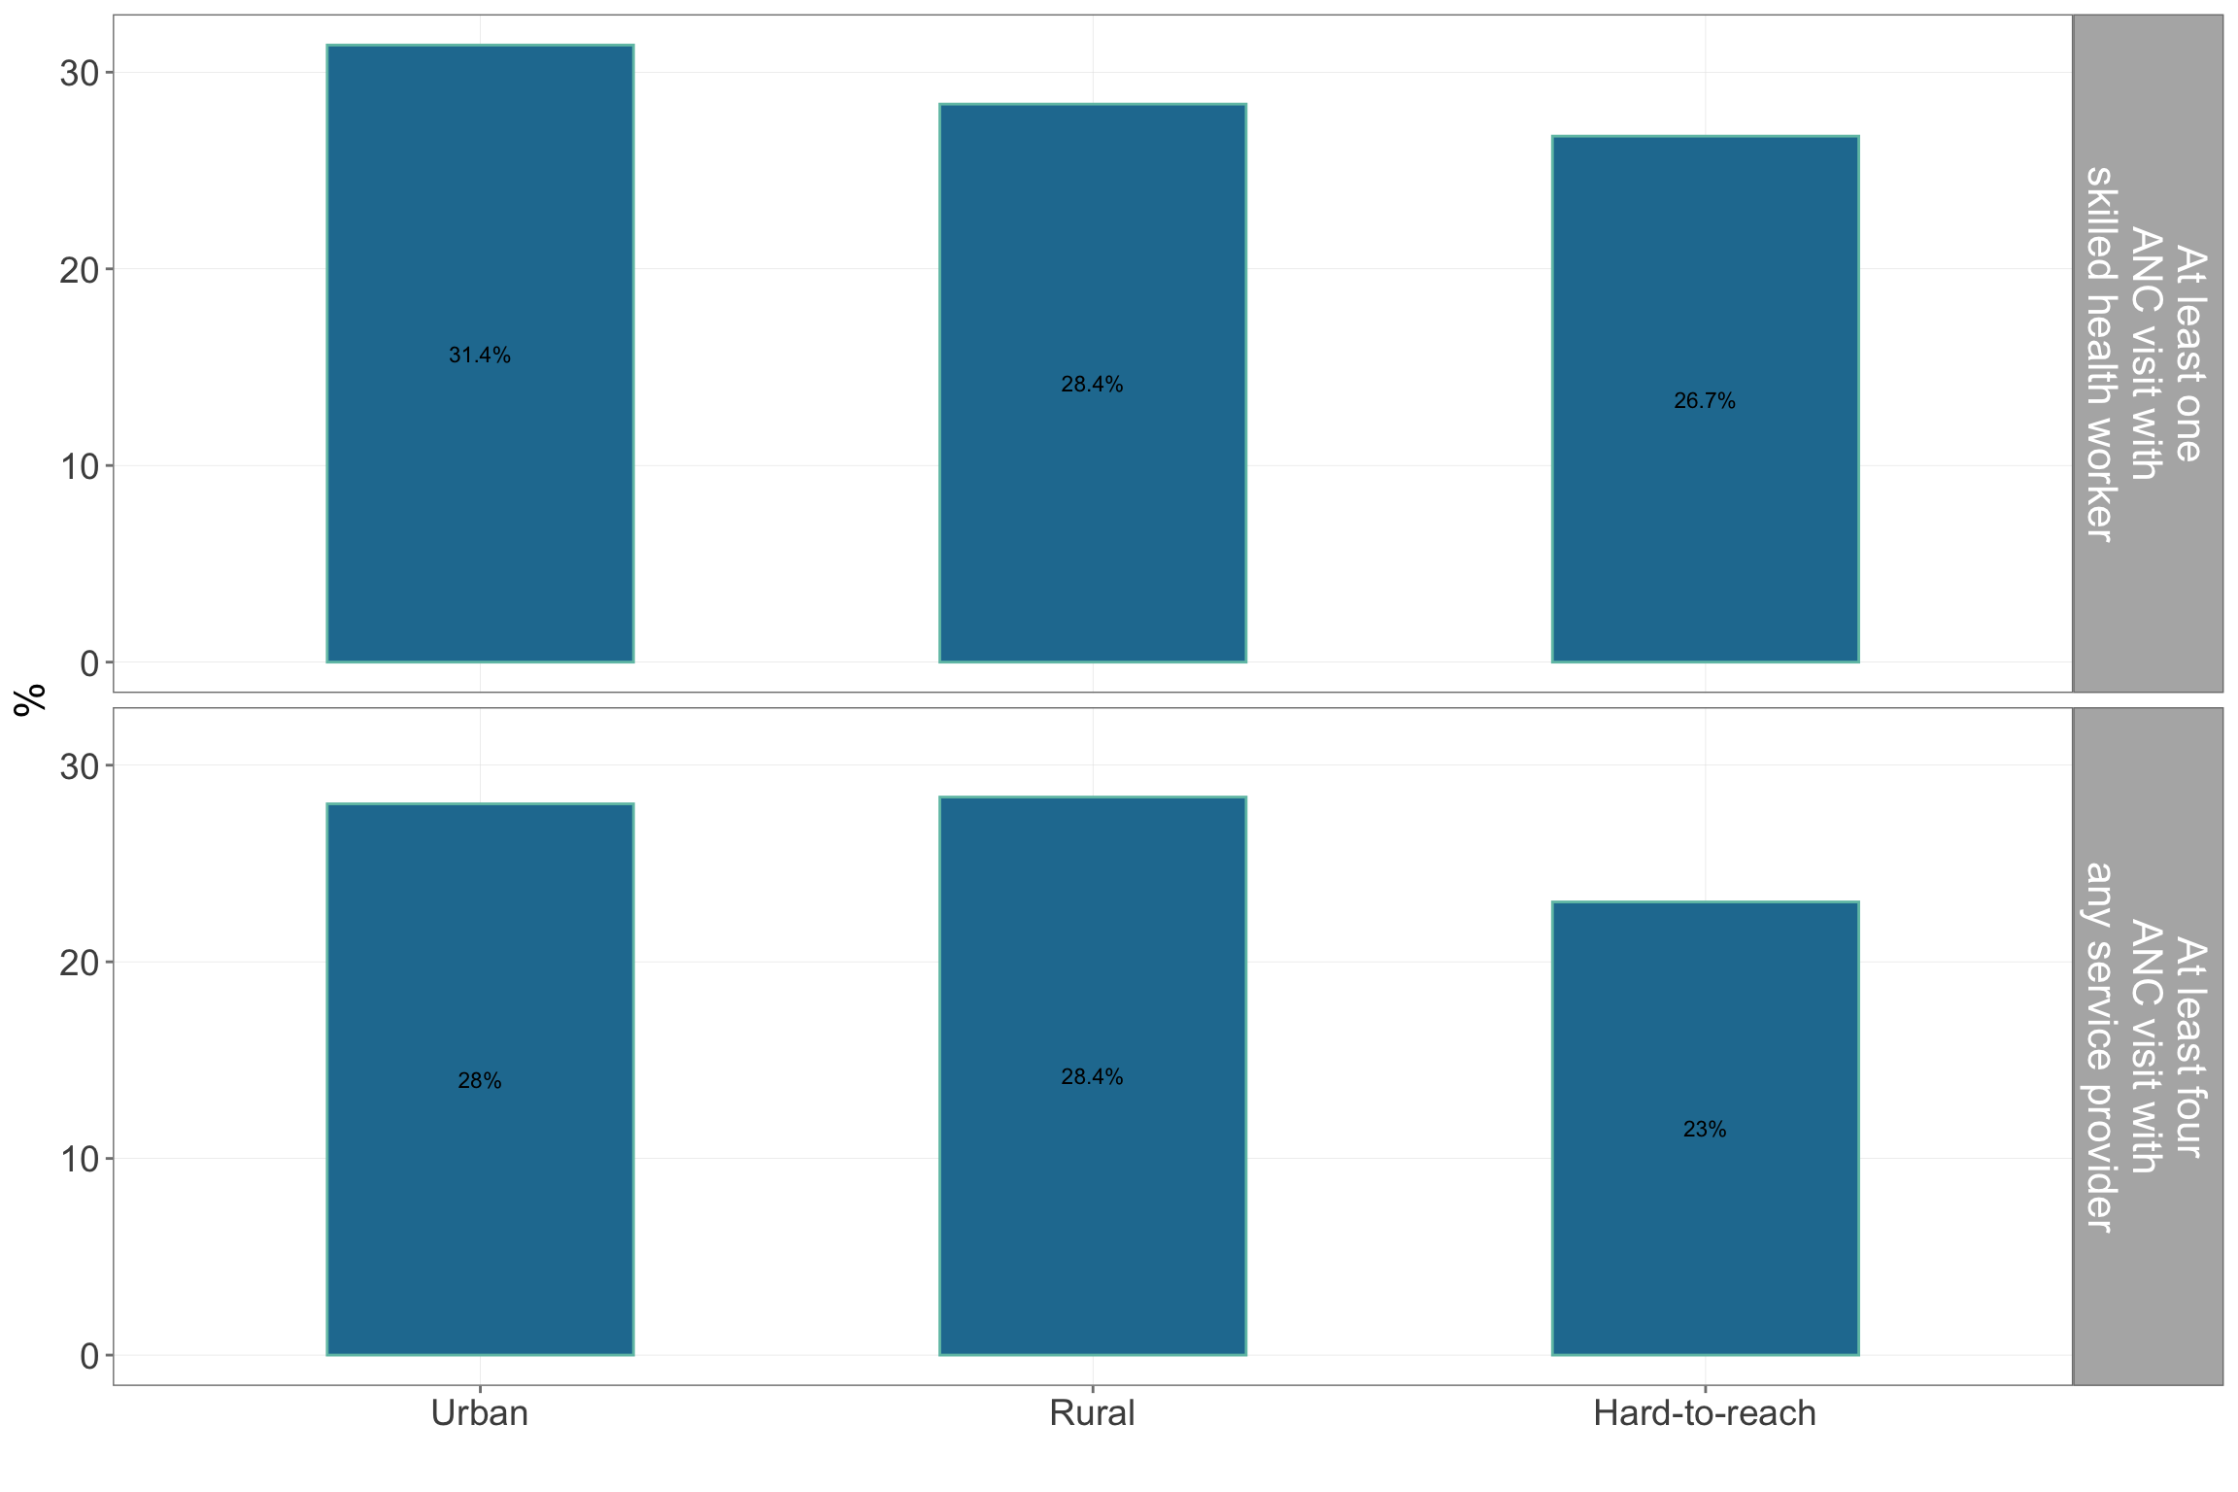

Figure 4.47: Antenatal care coverage by location type

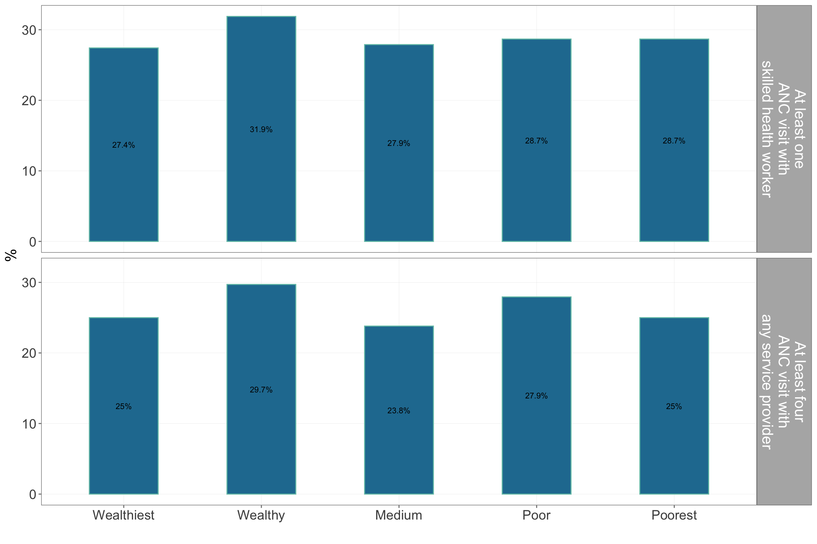

Figure 4.48: Antenatal care coverage by wealth quintiles

#### 4.1.12.2 Antenatal care counselling

Majority (93.5%) of women in rural areas received ANC counselling whilst only 79% and 72% of women from urban and hard-to-reach areas do attend. A third of women in hard-to-reach areas and 44% of poorest women restricted eating meat during their most recent pregnancy. On the other hand, 25% of the wealthiest women restricted eating fruits and fish and 37% restricted eating vegetables (see Table 4.32).

| Table 4.32: Antenatal care counselling | | | | | | | | | |
| --- | --- | --- | --- | --- | --- | --- | --- | --- | --- |
|  | | | | **Restricted eating…** | | | | | |
|  |  |  |  |  |  |  |  |  |  |
| **Geographic** | | | | | | | | | |
| Kayah | Rural | 93.5 | 18.3 | 13.3 | 13.3 | 0.0 | 6.7 | 20.0 | 0.0 |
| Urban | 79.2 | 19.8 | 10.5 | 21.1 | 5.3 | 15.8 | 15.8 | 5.3 |
| Hard-to-reach | 72.2 | 19.7 | 14.3 | 25.0 | 3.6 | 32.1 | 10.7 | 3.6 |
| **Wealth** | | | | | | | | |
| Wealthiest | 93.3 | 17.8 | 37.5 | 25.0 | 0.0 | 0.0 | 25.0 | 0.0 |
| Wealthy | 81.1 | 26.4 | 7.1 | 14.3 | 7.1 | 7.1 | 14.3 | 0.0 |
| Medium | 71.4 | 13.0 | 14.3 | 14.3 | 0.0 | 0.0 | 0.0 | 0.0 |
| Poor | 82.5 | 17.6 | 16.7 | 33.3 | 0.0 | 16.7 | 25.0 | 0.0 |
| Poorest | 74.3 | 19.4 | 5.6 | 11.1 | 5.6 | 44.4 | 5.6 | 5.6 |  |

#### 4.1.12.3 Antenatal care supplementation

Most women in rural areas (98.8%) took vitamin B1 supplementation during their pregnancy whilst only 85.4% of women in urban areas and 74.6% of women in hard-t-reach areas took the supplement. Only 73.1 of the poorest women took the supplementat. Only 70% of women in hard-to-reach areas took IFA during their latest pregnancy whilst almost all of those from urban and rural areas took IFA. Only 68.8% of the poorest women took IFA tablets compared to almomst all of the wealthiest and wealthy women taking the IFA tablets. The number of days IFA tablet was taken was at least more than 100 days with length of consumption highest in urban areas and amonts wealthy and wealthiest women. Those in urban areas got their IFA supplements mainly from the government hospital while those from urral and hard-to-reach areas got theirs from the SRHC/RHC (see Table 4.33).

| Table 4.33: Antenatal care supplementation | | | | | | | | | | |
| --- | --- | --- | --- | --- | --- | --- | --- | --- | --- | --- |
|  | | | | | | **Source of iron-folic acid tablets** | | | | |
|  |  |  |  |  |  |  |  |  |  |  |
| **Geographic** | | | | | | | | | | |
| Kayah | Rural | 98.8 | 96.3 | 176.5 | 1124.9 | 6.3 | 0.0 | 6.3 | 73.4 | 16.5 |
| Urban | 85.4 | 95.8 | 164.9 | 5610.8 | 28.3 | 1.1 | 12.0 | 17.4 | 17.4 |
| Hard-to-reach | 74.6 | 69.7 | 113.2 | 671.2 | 2.0 | 23.2 | 0.0 | 45.5 | 34.3 |
| **Wealth** | | | | | | | | | |
| Wealthiest | 88.9 | 100.0 | 166.1 | 2383.8 | 15.6 | 0.0 | 17.8 | 26.7 | 11.1 |
| Wealthy | 96.2 | 94.3 | 175.1 | 1701.8 | 24.0 | 2.0 | 10.0 | 38.0 | 16.0 |
| Medium | 88.9 | 90.7 | 152.9 | 9.2 | 18.4 | 4.1 | 2.0 | 61.2 | 22.4 |
| Poor | 82.4 | 80.9 | 160.3 | 186.3 | 7.3 | 16.4 | 0.0 | 45.5 | 27.3 |
| Poorest | 73.1 | 68.8 | 112.4 | 1031.2 | 0.0 | 18.8 | 0.0 | 46.9 | 37.5 |  |

#### 4.1.12.4 Antenatal care testing

Only 37.3% of women in urban areas and 35.3% in rural areas had tests done during their ANC whilst only 21.5% of women in hard-to-reach areas had tests done. The poor and poorest women had the least testing done at 17.6% and 22.4% respectively. Majority of the tests done is for HIV/AIDS in rural and urban areas and among wealthiest and wealthy women. STD testing was highest among hard-to-reach and poorest women.The SRHC was the predominant provider of ANC teseting services. About 40% and 54% of women from rural and urban areas incurred costs for ANC testing while only 7.5% of women from hard-to-reach areas had to pay for ANC testing. Women from poorest households also incurred the least costs for ANC testing compared to women in wealthiest and wealthy households.

| Table 4.34: Antenatal care testing | | | | | | | | | | | | | |
| --- | --- | --- | --- | --- | --- | --- | --- | --- | --- | --- | --- | --- | --- |
|  | | | **Type of test** | | | | **Location test was done** | | | | |  | |
|  |  |  |  |  |  |  |  |  |  |  |  |  |  |
| **Geographic** | | | | | | | | | | | | | |
| Kayah | Rural | 35.3 | 8.8 | 0 | 20.6 | 0.0 | 0.0 | 0.0 | 8.8 | 26.5 | 8.8 | 40.0 | 4091.7 |
| Urban | 37.0 | 0.0 | 0 | 25.9 | 3.7 | 7.4 | 3.7 | 3.7 | 11.1 | 3.7 | 54.4 | 7580.8 |
| Hard-to-reach | 21.5 | 0.0 | 0 | 0.8 | 13.1 | 2.3 | 6.2 | 0.0 | 7.7 | 7.7 | 7.5 | 1886.1 |
| **Wealth** | | | | | | | | | | | | |
| Wealthiest | 37.5 | 0.0 | 0 | 37.5 | 0.0 | 12.5 | 0.0 | 0.0 | 25.0 | 0.0 | 57.5 | 9486.0 |
| Wealthy | 50.0 | 9.1 | 0 | 27.3 | 0.0 | 4.5 | 0.0 | 13.6 | 31.8 | 9.1 | 50.0 | 5558.2 |
| Medium | 30.4 | 4.3 | 0 | 8.7 | 13.0 | 0.0 | 0.0 | 4.3 | 17.4 | 8.7 | 34.2 | 3118.4 |
| Poor | 17.6 | 0.0 | 0 | 3.9 | 7.8 | 2.0 | 3.9 | 0.0 | 9.8 | 3.9 | 19.2 | 653.8 |
| Poorest | 22.4 | 0.0 | 0 | 1.2 | 12.9 | 2.4 | 7.1 | 0.0 | 4.7 | 9.4 | 11.1 | 2794.2 |  |

### 4.1.13 Birth/delivery

About 36 week gestational age was the average when women gave birth in Kayah state. Women in urban areas mostly gave birth in government hospitals while women from rural areas gave birth either at home or in government hospital. Almost all of women in hard-to-reach areas delivered at home. Women from poor and poorest households mostly delivered at home.

| Table 4.35: Gestational age at birth (weeks) | | |
| --- | --- | --- |
|  |  |  |
| **Geographic** | | |
| Kayah | Rural | 35.8 |
| Urban | 36.5 |
| Hard-to-reach | 36.6 |
| **Wealth** | |
| Wealthiest | 36.4 |
| Wealthy | 36.3 |
| Medium | 35.7 |
| Poor | 36.6 |
| Poorest | 36.6 |  |

| Table 4.36: Location of birth/delivery | | | | | | | |
| --- | --- | --- | --- | --- | --- | --- | --- |
|  |  |  |  |  |  |  |  |
| **Geographic** | | | | | | | |
| Kayah | Rural | 46.2 | 41.0 | 0.0 | 12.8 | 0 | 0 |
| Urban | 16.5 | 82.4 | 1.1 | 0.0 | 0 | 0 |
| Hard-to-reach | 90.1 | 7.0 | 0.0 | 2.8 | 0 | 0 |
| **Wealth** | | | | | | |
| Wealthiest | 14.3 | 78.6 | 2.4 | 4.8 | 0 | 0 |
| Wealthy | 29.4 | 62.7 | 0.0 | 7.8 | 0 | 0 |
| Medium | 41.2 | 52.9 | 0.0 | 5.9 | 0 | 0 |
| Poor | 76.5 | 17.6 | 0.0 | 5.9 | 0 | 0 |
| Poorest | 91.4 | 7.5 | 0.0 | 1.1 | 0 | 0 |  |

| Table 4.37: Reason for choosing birth/delivery location | | | | | | |
| --- | --- | --- | --- | --- | --- | --- |
|  |  |  |  |  |  |  |
| **Geographic** | | | | | | |
| Kayah | Rural | 11.0 | 1.4 | 5.5 | 50.7 | 12.3 |
| Urban | 11.8 | 0.0 | 4.4 | 69.1 | 1.5 |
| Hard-to-reach | 26.0 | 34.6 | 0.0 | 9.4 | 22.0 |
| **Wealth** | | | | | |
| Wealthiest | 8.8 | 0.0 | 2.9 | 76.5 | 0.0 |
| Wealthy | 14.6 | 0.0 | 2.4 | 56.1 | 4.9 |
| Medium | 14.6 | 8.3 | 8.3 | 43.8 | 10.4 |
| Poor | 27.6 | 20.7 | 0.0 | 24.1 | 17.2 |
| Poorest | 21.0 | 35.8 | 1.2 | 7.4 | 25.9 |  |

| Table 4.38: Who assisted in birth/delivery | | | | | | | | | | |
| --- | --- | --- | --- | --- | --- | --- | --- | --- | --- | --- |
|  |  |  |  |  |  |  |  |  |  |  |
| **Geographic** | | | | | | | | | | |
| Kayah | Rural | 37.8 | 0.0 | 2.4 | 37.8 | 4.9 | 7.3 | 2.4 | 0.0 | 1.2 |
| Urban | 69.8 | 3.1 | 1.0 | 20.8 | 2.1 | 2.1 | 0.0 | 0.0 | 0.0 |
| Hard-to-reach | 5.6 | 0.7 | 0.0 | 11.3 | 6.3 | 34.5 | 14.1 | 21.8 | 2.1 |
| **Wealth** | | | | | | | | | |
| Wealthiest | 64.4 | 4.4 | 2.2 | 26.7 | 0.0 | 0.0 | 0.0 | 0.0 | 0.0 |
| Wealthy | 54.7 | 1.9 | 0.0 | 34.0 | 1.9 | 3.8 | 0.0 | 0.0 | 1.9 |
| Medium | 46.3 | 1.9 | 1.9 | 22.2 | 7.4 | 5.6 | 3.7 | 9.3 | 0.0 |
| Poor | 14.7 | 0.0 | 1.5 | 22.1 | 1.5 | 30.9 | 5.9 | 13.2 | 1.5 |
| Poorest | 6.5 | 0.0 | 0.0 | 10.8 | 9.7 | 33.3 | 17.2 | 18.3 | 2.2 |  |

| Table 4.39: Birth/delivery method | | | | | |
| --- | --- | --- | --- | --- | --- |
|  |  |  |  |  |  |
| **Geographic** | | | | | |
| Kayah | Rural | 81.7 | 18.3 | 0 | 0 |
| Urban | 54.2 | 45.8 | 0 | 0 |
| Hard-to-reach | 95.8 | 4.2 | 0 | 0 |
| **Wealth** | | | | |
| Wealthiest | 48.9 | 51.1 | 0 | 0 |
| Wealthy | 75.5 | 24.5 | 0 | 0 |
| Medium | 70.4 | 29.6 | 0 | 0 |
| Poor | 94.1 | 5.9 | 0 | 0 |
| Poorest | 95.7 | 4.3 | 0 | 0 |  |

| Table 4.40: Costs incurred for birth/delivery | | | | |
| --- | --- | --- | --- | --- |
|  |  |  |  |  |
| **Geographic** | | | | |
| Kayah | Rural | 84.1 | 9786765 | 39.1 |
| Urban | 93.8 | 17384444 | 27.0 |
| Hard-to-reach | 50.7 | 8976056 | 18.1 |
| **Wealth** | | | |
| Wealthiest | 95.6 | 17255814 | 20.9 |
| Wealthy | 92.5 | 14514286 | 33.3 |
| Medium | 81.5 | 15482954 | 43.2 |
| Poor | 63.2 | 6460714 | 25.6 |
| Poorest | 48.4 | 7922727 | 15.6 |  |

### 4.1.14 Postnatal care

| Table 4.41: Postnatal care coverage | | | | | | | | | | | |
| --- | --- | --- | --- | --- | --- | --- | --- | --- | --- | --- | --- |
|  | | | | **Provider of postnatal care** | | | | | | | |
|  |  |  |  |  |  |  |  |  |  |  |  |
| **Geographic** | | | | | | | | | | | |
| Kayah | Rural | 75.6 | 84.6 | 30.4 | 4.3 | 2.2 | 60.9 | 0.0 | 0 | 0.0 | 2.2 |
| Urban | 63.5 | 119.0 | 72.7 | 9.1 | 2.3 | 15.9 | 0.0 | 0 | 0.0 | 0.0 |
| Hard-to-reach | 26.1 | 450.2 | 8.3 | 13.9 | 0.0 | 38.9 | 16.7 | 0 | 2.8 | 19.4 |
| **Wealth** | | | | | | | | | | |
| Wealthiest | 68.9 | 185.1 | 56.0 | 8.0 | 4.0 | 32.0 | 0.0 | 0 | 0.0 | 0.0 |
| Wealthy | 58.5 | 95.0 | 52.0 | 8.0 | 0.0 | 36.0 | 0.0 | 0 | 0.0 | 4.0 |
| Medium | 61.1 | 123.9 | 40.0 | 16.0 | 0.0 | 44.0 | 0.0 | 0 | 0.0 | 0.0 |
| Poor | 47.1 | 396.3 | 25.0 | 8.3 | 4.2 | 41.7 | 4.2 | 0 | 0.0 | 16.7 |
| Poorest | 29.0 | 69.5 | 16.7 | 0.0 | 0.0 | 45.8 | 20.8 | 0 | 4.2 | 12.5 |  |

| Table 4.42: Vitamin B1 supplementation | | |
| --- | --- | --- |
|  |  |  |
| **Geographic** | | |
| Kayah | Rural | 148.2 |
| Urban | 102.1 |
| Hard-to-reach | 55.6 |
| **Wealth** | |
| Wealthiest | 101.6 |
| Wealthy | 97.8 |
| Medium | 117.0 |
| Poor | 116.9 |
| Poorest | 66.2 |  |

| Table 4.43: Costs of postnatal care | | | | | | | | |
| --- | --- | --- | --- | --- | --- | --- | --- | --- |
|  | | | **Reason for costs** | | | | | |
|  |  |  |  |  |  |  |  |  |
| **Geographic** | | | | | | | | |
| Kayah | Rural | 0.5 | 0.1 | 0 | 75.0 | 0.0 | 0 | 12.5 |
| Urban | 0.5 | 0.6 | 0 | 28.6 | 0.0 | 0 | 14.3 |
| Hard-to-reach | 0.1 | 0.7 | 0 | 0.0 | 33.3 | 0 | 0.0 |
| **Wealth** | | | | | | | |
| Wealthiest | 0.5 | 0.3 | 0 | 66.7 | 0.0 | 0 | 0.0 |
| Wealthy | 0.5 | 0.0 | 0 | 33.3 | 0.0 | 0 | 66.7 |
| Medium | 0.5 | 0.6 | 0 | 20.0 | 20.0 | 0 | 0.0 |
| Poor | 0.4 | 0.3 | 0 | 66.7 | 0.0 | 0 | 0.0 |
| Poorest | 0.1 | 0.5 | 0 | 50.0 | 0.0 | 0 | 0.0 |  |

### 4.1.15 Newborn care

| Table 4.44: Newborn care coverage | | | | | | | | | | | |
| --- | --- | --- | --- | --- | --- | --- | --- | --- | --- | --- | --- |
|  | | | | **Provider of newborn care** | | | | | | | |
|  |  |  |  |  |  |  |  |  |  |  |  |
| **Geographic** | | | | | | | | | | | |
| Kayah | Rural | 87.8 | 91.5 | 32.7 | 2.0 | 2.0 | 53.1 | 6.1 | 0.0 | 0.0 | 2.0 |
| Urban | 90.6 | 93.8 | 70.8 | 6.2 | 2.1 | 18.8 | 2.1 | 0.0 | 0.0 | 0.0 |
| Hard-to-reach | 21.8 | 28.9 | 8.3 | 5.6 | 0.0 | 44.4 | 25.0 | 5.6 | 2.8 | 8.3 |
| **Wealth** | | | | | | | | | | |
| Wealthiest | 95.6 | 97.8 | 61.5 | 3.8 | 3.8 | 30.8 | 0.0 | 0.0 | 0.0 | 0.0 |
| Wealthy | 94.3 | 94.3 | 50.0 | 3.3 | 0.0 | 40.0 | 3.3 | 0.0 | 0.0 | 3.3 |
| Medium | 74.1 | 79.6 | 46.4 | 7.1 | 0.0 | 35.7 | 10.7 | 0.0 | 0.0 | 0.0 |
| Poor | 39.7 | 45.6 | 23.8 | 4.8 | 4.8 | 47.6 | 4.8 | 4.8 | 0.0 | 4.8 |
| Poorest | 24.7 | 33.3 | 11.5 | 0.0 | 0.0 | 42.3 | 30.8 | 3.8 | 3.8 | 7.7 |  |

| Table 4.45: Costs of newborn care | | | | | | | | | | |
| --- | --- | --- | --- | --- | --- | --- | --- | --- | --- | --- |
|  | | | | **Reason for costs** | | | | | |  |
|  |  |  |  |  |  |  |  |  |  |  |
| **Geographic** | | | | | | | | | | |
| Kayah | Rural | 24.0 | 10147059 | 0 | 0 | 40.0 | 0 | 0.0 | 0.0 | 61.1 |
| Urban | 23.6 | 10916667 | 0 | 0 | 22.2 | 0 | 11.1 | 11.1 | 38.1 |
| Hard-to-reach | 2.4 | NaN | 0 | 0 | 0.0 | 0 | 0.0 | 0.0 | 100.0 |
| **Wealth** | | | | | | | | | |
| Wealthiest | 20.9 | 8277778 | 0 | 0 | 0.0 | 0 | 20.0 | 20.0 | 22.2 |
| Wealthy | 20.0 | 9494444 | 0 | 0 | 0.0 | 0 | 0.0 | 0.0 | 80.0 |
| Medium | 20.9 | 11700000 | 0 | 0 | 75.0 | 0 | 0.0 | 0.0 | 22.2 |
| Poor | 22.6 | 6250000 | 0 | 0 | 33.3 | 0 | 0.0 | 0.0 | 71.4 |
| Poorest | 6.5 | 3250000 | 0 | 0 | 0.0 | 0 | 0.0 | 0.0 | 50.0 |  |

| Table 4.46: Fed colostrum to newborn | | |
| --- | --- | --- |
|  |  |  |
| **Geographic** | | |
| Kayah | Rural | 96.3 |
| Urban | 89.6 |
| Hard-to-reach | 85.9 |
| **Wealth** | |
| Wealthiest | 95.6 |
| Wealthy | 88.7 |
| Medium | 92.6 |
| Poor | 89.7 |
| Poorest | 86.0 |  |

| Table 4.47: Knowledge of danger signs | | | | | | | | | |
| --- | --- | --- | --- | --- | --- | --- | --- | --- | --- |
|  | | **Danger signs** | | | | | | |  |
|  |  |  |  |  |  |  |  |  |  |
| **Geographic** | | | | | | | | | |
| Kayah | Rural | 0.0 | 5.9 | 3.9 | 0.0 | 2 | 3.9 | 33.3 | 51.0 |
| Urban | 6.5 | 0.0 | 10.9 | 0.0 | 0 | 4.3 | 41.3 | 37.0 |
| Hard-to-reach | 5.4 | 0.8 | 3.9 | 0.8 | 0 | 1.6 | 6.2 | 81.4 |
| **Wealth** | | | | | | | | |
| Wealthiest | 8.0 | 0.0 | 8.0 | 0.0 | 0 | 0.0 | 52.0 | 32.0 |
| Wealthy | 3.2 | 9.7 | 3.2 | 0.0 | 0 | 9.7 | 32.3 | 41.9 |
| Medium | 3.0 | 3.0 | 6.1 | 0.0 | 3 | 0.0 | 30.3 | 54.5 |
| Poor | 3.8 | 0.0 | 7.5 | 0.0 | 0 | 3.8 | 5.7 | 79.2 |
| Poorest | 4.9 | 0.0 | 3.7 | 1.2 | 0 | 1.2 | 7.3 | 81.7 |  |

| Table 4.48: Care of cord and delivery wound | | | |
| --- | --- | --- | --- |
|  |  |  |  |
| **Geographic** | | | |
| Kayah | Rural | 49.3 | 36.8 |
| Urban | 53.5 | 26.5 |
| Hard-to-reach | 52.3 | 75.9 |
| **Wealth** | | |
| Wealthiest | 50.0 | 26.3 |
| Wealthy | 43.8 | 26.5 |
| Medium | 52.0 | 43.5 |
| Poor | 53.2 | 67.8 |
| Poorest | 57.5 | 73.6 |  |

## 4.2 Maternal nutrition

### 4.2.1 Minimum dietary diversity for women

Up to 90% of women achieved minimum dietary diversity of consuming 5 out of 10 food groups in the past day. This is true for all areas and wealth classess in Kayah state.

| Table 4.49: Minimum dietary diversity for women | | |
| --- | --- | --- |
|  |  |  |
| **Geographic** | | |
| Kayah | Rural | 89.7 |
| Urban | 89.2 |
| Hard-to-reach | 83.7 |
| **Wealth** | |
| Wealthiest | 89.6 |
| Wealthy | 87.6 |
| Medium | 92.8 |
| Poor | 80.6 |
| Poorest | 86.3 |  |

## 4.3 Cohort study

For the results of the cohort study, the regression discontinuity was demonstrated through a regression plot of children’s anthropometric indices and MUAC for those who were born a month before the start of recruitment for the MCCT programme (control programme) and those who were born a month after the start of the recruitment for the MCCT programme (intervention).

An intention-to-treat analysis was applied with intervention cases were identified purely based on their eligibility for the programme. Further analysis of acutal receipt of benefits from MCCT should be included at endline. Following are the results.

### 4.3.1 Child anthropometric indicators

Figure 4.49, Figure 4.50, Figure 4.51 and Figure 4.52 show regression plots of weight-for-age z-score, height-for-age z-score, weight-for-height z-score and MUAC for children in the control and the intervention groups. Control data is for those before 1 October on the x-axis (left-side of red line on the plot) and the intervention data is for those on and after 1 October on the x-axis (right-side of red line on the plot). In all these cases, no regression discontinuity can be appreciated that is both control and intervention cases are anthropometrically similar groups. It should be appreciated that this is about a year after intervention where it would have been possible that some discontinuity would have already been observed.

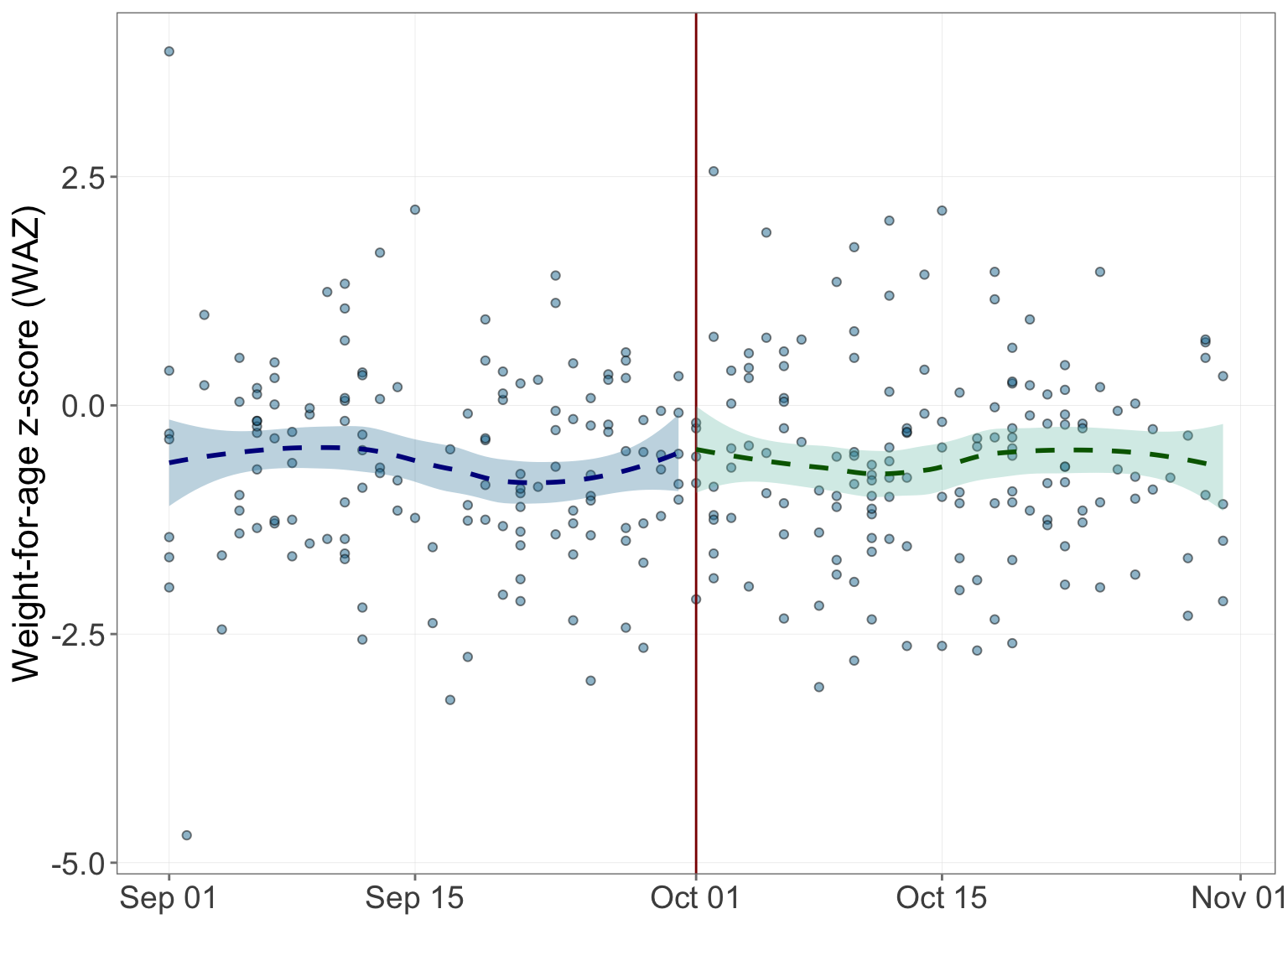

Figure 4.49: Weight-for-age z-score regression discontinuity

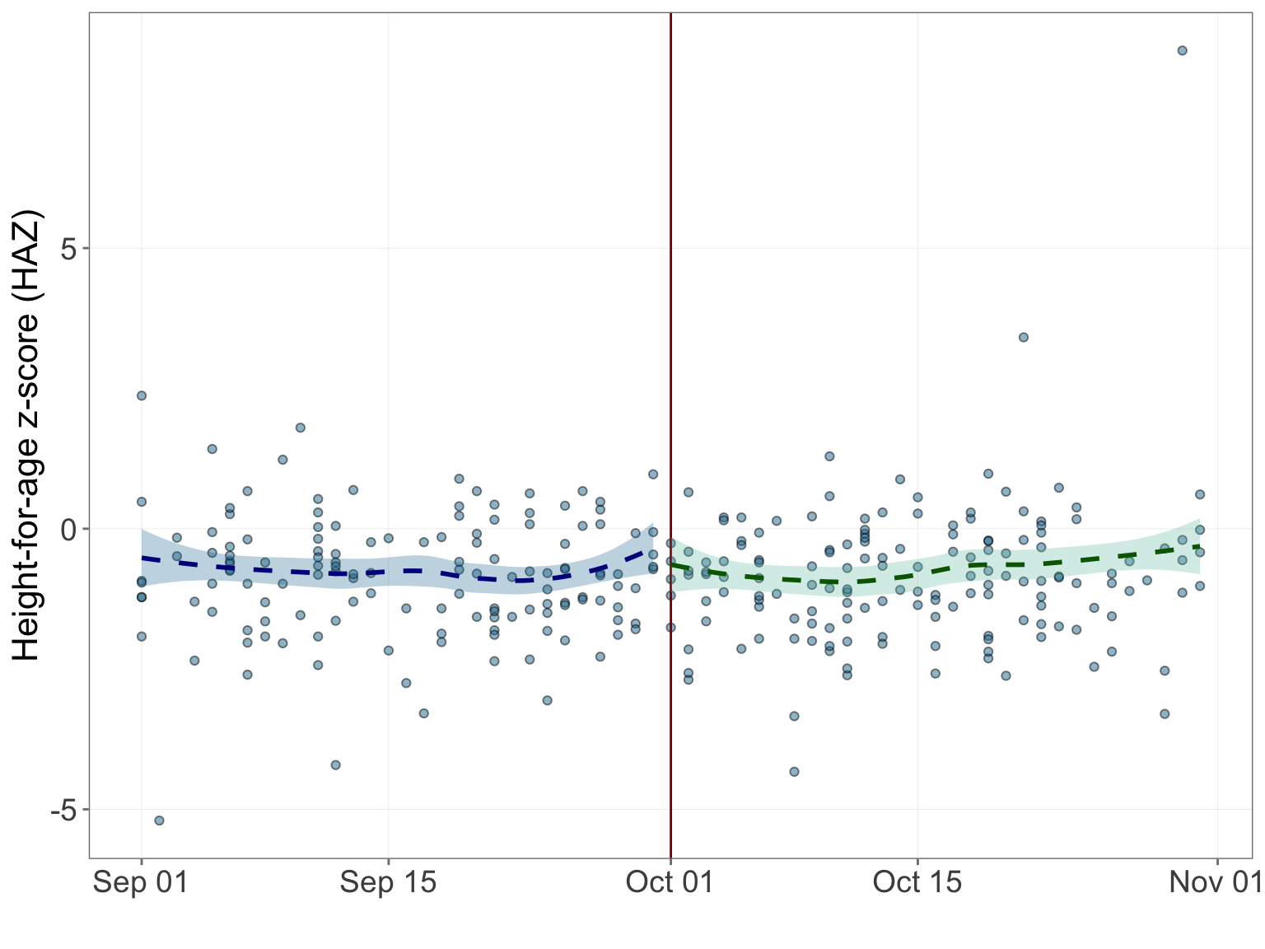

Figure 4.50: Height-for-age z-score regression discontinuity

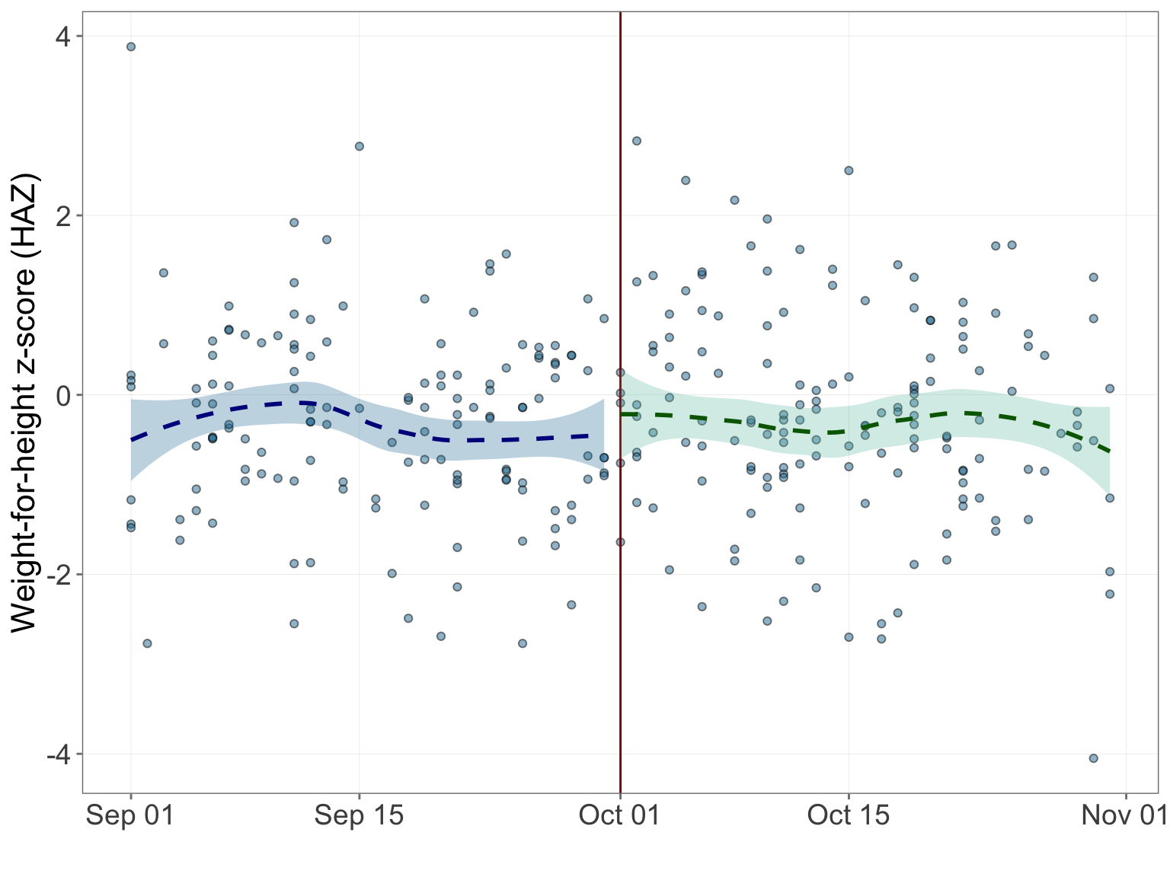

Figure 4.51: Weight-for-height z-score regression discontinuity

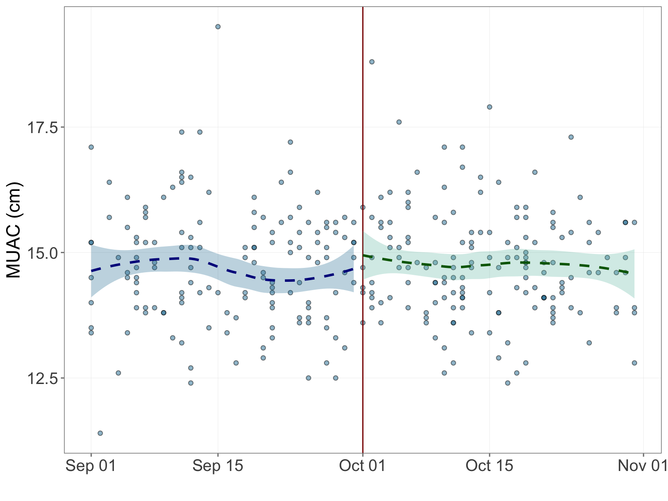

Figure 4.52: MUAC regression discontinuity

# References

Bor, Jacob, Ellen Moscoe, Portia Mutevedzi, Marie Louise Newell, and Till Bärnighausen. 2014. “Regression discontinuity designs in epidemiology: Causal inference without randomized trials.” Epidemiology 25 (5): 729–37. <https://doi.org/10.1097/EDE.0000000000000138>.

Central Expanded Programme on Immunization, Ministry of Health, Republic of the Union of Myanmar. 2016. “Expanded Program on Immunization Multi Year Plan 2017-2021 Revised January 2016.”

Guevarra, Ernest. 2019a. Nutricheckr: Tools for Nutrition Assessment and Analysis.

———. 2019b. Ppitables: Lookup Tables to Generate Poverty Likelihoods and Rates Using the Poverty Probability Index (Ppi). <https://CRAN.R-project.org/package=ppitables>.

Guevarra, Ernest, and Abdoul-Aziz Goza. 2019. MyanmarMCCTdata: Myanmar Mother and Child Cash Transfer (Mcct) Programme Evaluation Data Handler. <https://github.com/validmeasures/myanmarMCCTdata>.

Innovations for Poverty Action. 2019. “Myanmar 2015 PPI User Guide.” August.

Ismail, L Cheikh, H E Knight, E O Ohuma, L Hoch, and W C Chumlea. 2013. “Anthropometric standardisation and quality control protocols for the construction of new , international , fetal and newborn growth standards : the INTERGROWTH-21 st Project,” 48–55. <https://doi.org/10.1111/1471-0528.12127>.

Kelly, A, J Kevany, M deOnis, and P M Shah. 1997. “A WHO collaborative study of maternal anthropometry and pregnancy outcomes (Reprinted from International Journal of Gynecology and Obstetrics, vol 53, pg 219-233, 1996).” International Journal of Gynaecology and Obstetrics: The Official Organ of the International Federation of Gynaecology and Obstetrics 57 (1): 1–15.

Maxwell, Daniel, and Richard Caldwell. 2008. The Coping Strategies Index: A tool for rapid measurement of household food security and the impact of food aid in programs in humanitarian emergencies Field Methods Manual. CARE USA.

Ministry of Health and Sports - MoHS/Myanmar, and ICF. 2017. “Myanmar Demographic and Health Survey 2015-16.” Nay Pyi Taw, Myanmar: MoHS; ICF. <http://dhsprogram.com/pubs/pdf/FR324/FR324.pdf>.

Ministry of Social Welfare, Relief and Resettlement, and Livelihoods and Food Security Trust Fund. 2018. “Maternal and child cash transfer programme in Chin State (MCCT) Baseline Survey Report.” Yangon: Livelihoods; Food Security Trust Fund.

Myatt, Mark. 2019. NipnTK: NiPN Anthropometric Data Toolkit. <https://github.com/nutriverse/nipnTK>.

Myatt, Mark, and Ernest Guevarra. 2019. Zscorer: Child Anthropometry Z-Score Calculator. <https://CRAN.R-project.org/package=zscorer>.

Onis, Mercedes de, Adelheid W Onyango, Jan Van den Broeck, W C Chumlea, and Reynaldo Martorell. 2004. “Measurement and standardization protocols for anthropometry used in the construction of a new international growth reference.” Food and Nutrition Bulletin 25 (supplement 1).

R Core Team. 2019. R: A Language and Environment for Statistical Computing. Vienna, Austria: R Foundation for Statistical Computing. <https://www.R-project.org/>.

Schochet, Peter Z. 2009. “Statistical Power for Regression Discontinuity Designs in Education Evaluations” 34 (2): 238–66. <https://doi.org/10.3102/1076998609332748>.

Ulijaszek, Stanley J., and Deborah A. Kerr. 1999. “Anthropometric Measurement Error and the Assessment of Nutritional Status.” British Journal of Nutrition 82 (3). Cambridge University Press: 165–77. <https://doi.org/10.1017/S0007114599001348>.

Ververs, Mija-tesse, Annick Antierens, Anita Sackl, Nelly Staderini, and Valerie Captier. 2013. “Which Anthropometric Indicators Identify a Pregnant Woman as Acutely Malnourished and Predict Adverse Birth Outcomes in the Humanitarian Context?” PLoS Currents.

Vulnerability Assessment and Mapping World Food Programme. 2008. “Food consumption analysis: Calculation and use of the food consumption score in food security analysis.”

WHO/UNICEF Joint Monitoring Programme for Water Supply and Sanitation. 2018. “Core questions on water, sanitation and hygiene for household surveys 2018 Update.” Geneva.

Woertman, Willem, Esther de Hoop, Mirjam Moerbeek, Sytse U Zuidema, Debby L Gerritsen, and Steven Teerenstra. 1993. “Use of a simple anthropometric measurement to predict birth weight. WHO Collaborative Study of Birth Weight Surrogates.” Bulletin of the World Health Organization 71 (2): 157–63.

World Food Programme. 2015. “Food Consumption Score Nutritional Quality Analysis (FCS-N).” Rome.

World Health Organization. 2006. “Core Questions on Drinking-water and Sanitation for Household Surveys.” Geneva: World Health Organization.

———. 2008. Indicators for assessing infant and young child feeding practices: conclusions of a consensus meeting held 68 November 2007. Washington, DC: World Health Organization.

World Health Organization (WHO). 2006. WHO Child Growth Standards: Length/height-for-age, weight-for-age, weight-for-length, weight-for-height and body mass index-for-age: Methods and development. Geneva: World Health Organization. <https://doi.org/10.1037/e569412006-008>.

Xie, Yihui, J.J. Allaire, and Garrett Grolemund. 2018. R Markdown: The Definitive Guide. Boca Raton, Florida: Chapman; Hall/CRC. <https://bookdown.org/yihui/rmarkdown>.

1. Based on the earlier Chin assessment and based on feedback from various stakeholders.↩
2. Based on 2015 Myanmar Demographic and Health Survey (Ministry of Health and Sports - MoHS/Myanmar and ICF 2017)↩
3. Based on 2015 Myanmar Demographic and Health Survey (Ministry of Health and Sports - MoHS/Myanmar and ICF 2017)↩
4. See <https://ona.io>↩
5. See <https://validmeasures.io/myanmarMCCTchecks>↩
6. Can be downloaded from the [Comprehensive R Archive Network](https://cran.r-project.org) where guidance on installing R is also available.↩
7. See <https://validmeasures.org/myanmarMCCTdata> to learn more about the **myanmarMCCTdata** package and how data is handled and processed using this package.↩
8. For a full list of other R packages that **myanmarMCCTdata** depends on, see <https://validmeasures.org/myanmarMCCTdata>↩
9. Time to collect water from reported water source was not collected in baseline survey. The access to improved drinking water sources indicator does not take time into account. This indicator can be reframed as at least limited access to improved drinking water sources taking into account the definitions for limited and basic drinking water service.↩
10. This is termed as access to **basic** sanitation facilities as per current indicator definitions.↩
11. This is termed as access to **limited** sanitation facilities as per current indicator definitions.↩
12. This is termed as access to **basic** handwashing facilities as per current indicator definitions.↩
13. This is termed as access to **limited** handwashing facilities as per current indicator definitions.↩
14. Fever is used as a proxy for illnesses due to an infection such as malaria↩
15. Cough is used as a proxy for an acute respiratory infection (ARI)↩
16. See <https://nutriverse.io/zscorer> for details on how the z-scores are calculated↩
17. See <https://nutriverse.io/nutricheckr> for details on how the flagging criteria is applied↩
18. See <https://nutriverse.io/nipnTK> for details on how anthropometric data quality check is performed using the **nipnTK** R package↩